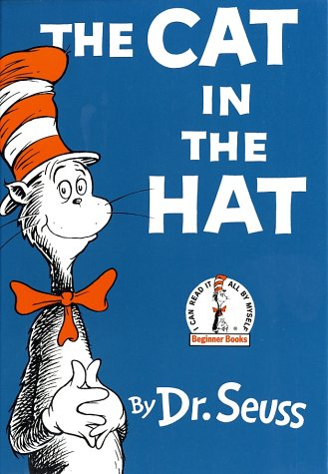
In a single file, run a weave pattern around 3 cones- simulating Thing 1 and Thing 2. Repeat.
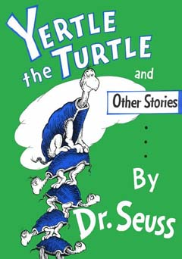
Crawl on hands and knees across two tumbling mats- moving like Yurtle.
Repeat.
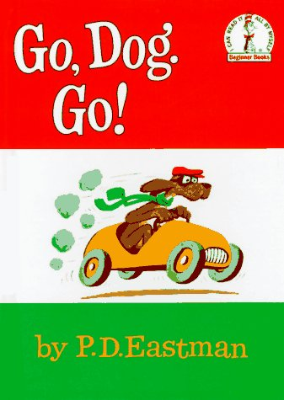
Ride the scooter around a cone and back (driving like the dogs in the story).

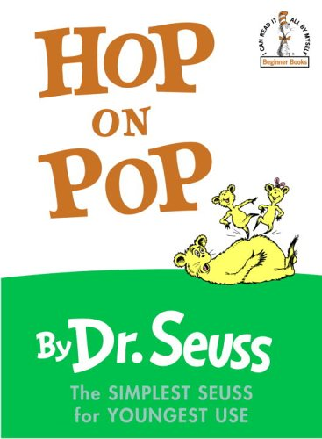
Bounce four times on the mini tramp/hopper. The 2nd time, bounce 5 times. The 3rd time, bounce 6 times.
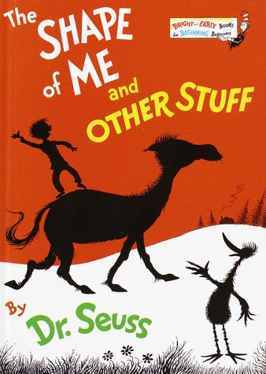
Run around the circle, then the square, then the triangle.
Repeat.
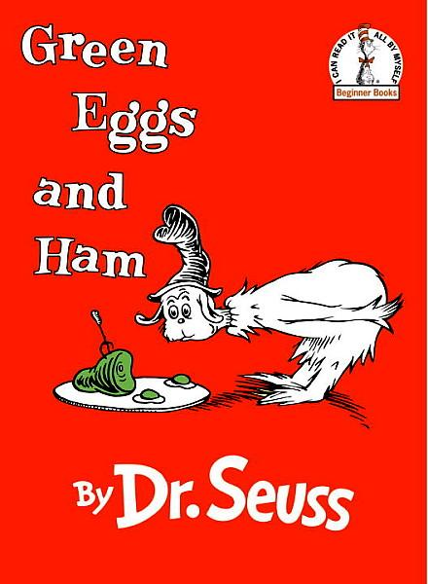
Carry and/or balance a Frisbee (upside down) that contains 2 green bags and a small green ball. Go down and around the cone and back. Repeat.
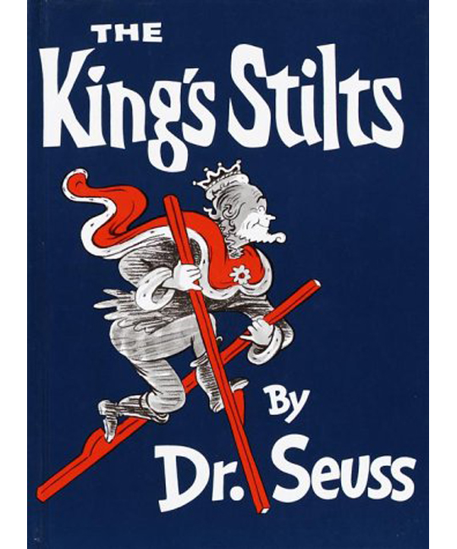
Walk on stilts/hi-steppers to the cone and back.
Repeat.

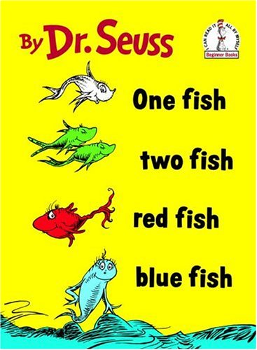
Ride on your scooter face down and pretend to swim (using arms and legs) to the cone and back.
Repeat.

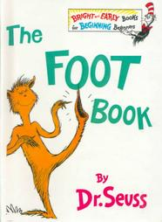
Use your feet to dribble a soccer ball to the cone and back. Repeat.
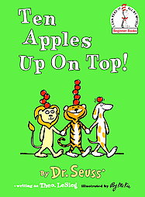
Place a red bean bag on your head and walk across the balance beam. On your 2nd turn, place 2 beanbags on your head. On your 3rd attempt, try balancing 3 beanbags while you walk.

