Name______________________________ Block____

Doppler Effect Worksheet

In astronomy the Doppler effect is used to determine whether a star is moving towards or away from Earth, and as a result has provided us with an abundant amount of information about our universe, and how it may have formed.

Directions: Using the electromagnetic spectrum as needed, complete the following exercises in order to become familiar with the Doppler effect and its applications for understanding the universe.
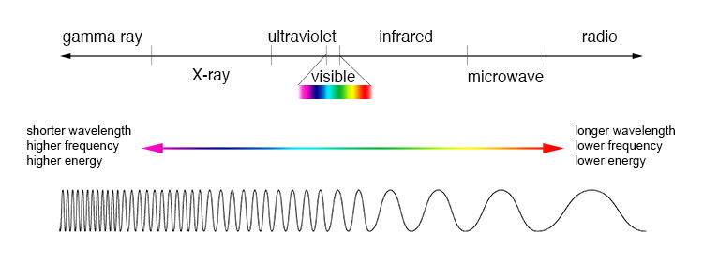
Exercise #1
Description: The figure below shows a train traveling toward the right and sounding its horn.
Three people are shown at locations A, B, and C. Assume that all three people can hear the train blowing its horn.
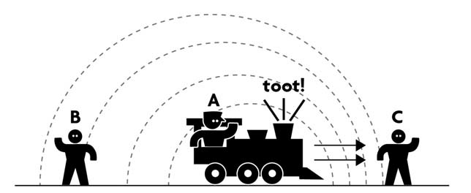

- Ranking Instructions: Rank the pitch of the horn from highest pitch (or frequency) to lowest pitch (or frequency) as heard by each person (A – C)

Ranking Order: Highest 1_______ 2_______ 3_______ Lowest

Or, the pitch heard by each person would be the same. ______ (indicate with check mark).

Carefully explain your reasoning for ranking this way:

- Ranking Instructions: Rank the wavelength (from longest to shortest) of the sound of the horn as heard by each person (A – C).

Ranking Order: Longest 1_______ 2_______ 3_______ Shortest

Or, the wavelength heard is the same for each person.____ (indicate with check mark).

Carefully explain your reasoning for ranking this way:

Exercise #2
Description: The figure below shows the motion of five distant stars (A - E) relative to a stationary observer (telescope). The speed and direction of each star is indicated by the length and direction of the arrows shown. (Longer arrow indicates that the star is moving faster.)
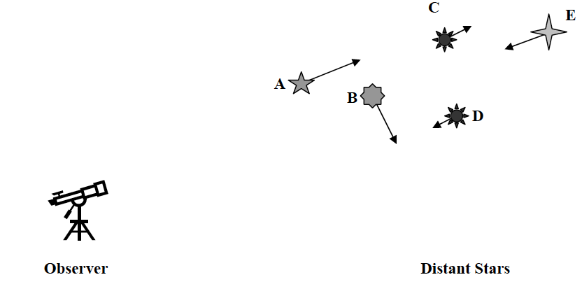
Ranking Instructions: Rank the Doppler shift of the light observed from each star (A – E) from greatest “blueshift”, through no shift, to greatest “redshift”.

Ranking Order:
Greatest blueshift 1_______, 2_______, 3_______ 4 _______ 5 ________ Greatest redshift

Or, the Doppler shift for each star is the same. ______ (indicate with check mark).

Carefully explain your reasoning for ranking this way:

Exercise #3
Description: The first spectrum shown below is of an element as it appears in a laboratory here on Earth. In addition, the spectra of five stars (A - E) as seen from Earth are shown. Assume that the left end of each spectrum corresponds to shorter wavelengths (blue light) and that the right end of each spectrum corresponds with longer wavelengths (red light).
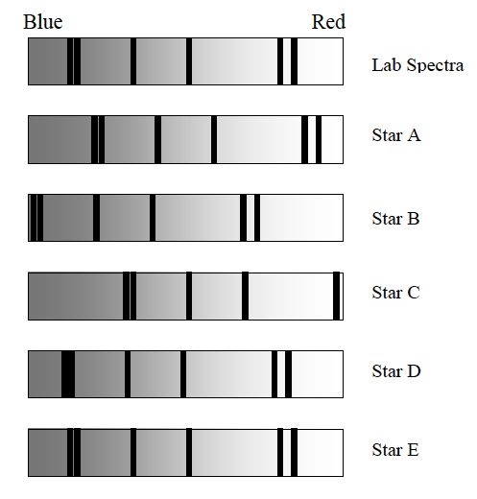
- Ranking instructions: Rank the size of the Doppler shift (from largest to smallest) for the light from each star (A – E).

Ranking Order: Largest 1 ____ 2 ____ 3 ____ 4 _____ 5 _____ Smallest

Or, the Doppler shift of the light from the stars would all be the same. _____ (indicate with a check mark)

Carefully explain your reasoning for ranking this way:

- Ranking instructions: Rank the speed of the stars (A – E) from moving fastest toward the Earth to moving fastest away from Earth.

Ranking Order: Moving fastest toward 1 ____ 2 ____ 3 ____ 4 _____ 5 _____ Moving fastest away

Or, all the stars have the same speed. _____ (indicate with a check mark)

Carefully explain your reasoning for ranking this way:

Exercise #4
Description: An important line in the absorption spectrum of stars occurs at a wavelength of 656nm for stars at rest. Imagine that you study five stars (A-E) from Earth and discover that this absorption line is observed at the wavelength shown in the table below for each of the five stars.

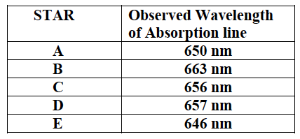

- Ranking instructions: Rank the size of the Doppler shift (from largest to smallest) observed above for the light from each star (A – E).

Ranking Order: Largest 1 ____ 2 ____ 3 ____ 4 _____ 5 _____ Smallest

Or, the Doppler shift of the light from the stars would all be the same. _____ (indicate with a check mark)

Carefully explain your reasoning for ranking this way:

- Ranking instructions: Rank the speed of the stars (A – E) from moving fastest toward the Earth to moving fastest away from Earth.

Ranking Order: Moving fastest toward 1 ____ 2 ____ 3 ____ 4 _____ 5 _____ Moving fastest away

Or, all the stars have the same speed. _____ (indicate with a check mark)

Carefully explain your reasoning for ranking this way:

