DNA, RNA and Protein Review

Instructions: Answers the questions with a word or words on your OWN SHEET OF PAPER!

1. What are all living things made of?

2. In what organelle is the genetic material located?

3. What is the name of the molecule that is the genetic material for all life?

4. What is the shape of the DNA molecule?

5. The monomer of DNA is called _____________.

6. What are the three parts that make up the DNA monomer?

7. Name the four DNA nucleotides.

8. How do the nucleotides pair?

9. How many strands are in a DNA molecule?

10. If a DNA coding sequence is GGATCAG, the complimentary DNA will be _______

11. What kind of bond holds the DNA bases together?

12. A three nucleotide sequence of DNA is called a _______________.

13. How many different amino acids are there?

14. State three differences between DNA and RNA.

15. The base uracil pairs with what DNA nucleotide

16. If the DNA coding strand is GTCAAT, the mRNA strand would be

17. A protein contains 100 amino acids. How many nucleotides are in the gene for that protein?

18. What is the name of the organelle where proteins are synthesized (made)?

19. If DNA is going to make a protein, it must first do what?

20. What does m-RNA do after it is produced?

21. What are the two important parts of a t-RNA molecule?

22. What happens when the m-RNA molecule binds with a ribosome?

23. What is the name of the reaction in which amino acids are joined?

24. How does the ribosome know when to stop adding amino acids to a polypeptide chain?

25. What is the name for a change in the genetic code?

26. What is the difference between a point mutation and a frame shift mutation?

27. What is the difference between a germ cell mutation and a somatic cell mutation?

28. What is the function of m-RNA?

29. What is the function of t-RNA?

30. What happens to the number of chromosomes after DNA replication?

31. If the DNA coding sequence is GGA CTC CTC TTC, what is the sequence of m-RNA, and t-RNA?

32. Use the table below to write the sequence of amino acids that are coded for in question 31.
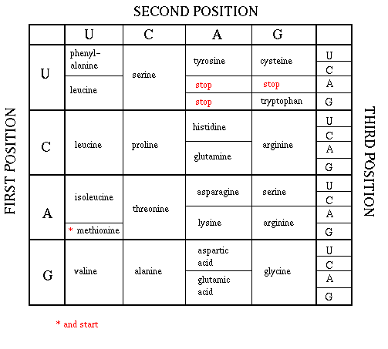
33. Place the following steps of protein synthesis in correct order.

a) When the next amino acid is in place, the two are joined in a condensation reaction
b) The process is repeated until a stop code is read and a complete protein is formed
c) Free floating RNA nucleotides pair with the DNA strand forming m-RNA (Transcription)
d) The m-RNA codon matches with the t-RNA anticodon bringing the amino acid into its proper place
e) A specific t-RNA delivers a specific amino acid to the ribosome (Translation)
f) The m-RNA leaves the nucleus and goes to a ribosome
g) DNA molecule unzip where the desired gene is located

