DIGITAL PHOTOGRAPHY GOOGLE DIGITAL TOOLS LESSON

We will be using many different Google tools in our class this year, so I want to make sure that you understand how to use them before we get started.

Please complete the following tasks in order, and type an X in the “Done” box as you finish. If you have any questions about the task or need help, explain in the box at the far right.

Tool | Task | Done | If you have any questions about this task or need help, please explain here.
Google Classroom | Scroll down in the “Stream” on Google Classroom and read the first post. Click on the link to open the syllabus.
Google Docs | Once the syllabus document opens, click “Share” at the top right corner, and share the syllabus with your parent by typing in their email address.
Google Classroom | Go to Google Classroom and click on “Classwork” at the top. Click on the “Who Are You?” survey assignment. Fill out the Google Form if you haven’t already. If you already filled it out, make sure you have clicked “Mark as done.”
Google Drive | Open your Google Drive.  You can get there by going to Google Classroom, clicking this square icon in the top right corner, then clicking “Google Drive.”
Google Drive | Click on “My Drive” on the left side of the screen. This will show you all of the folders and documents that you have ever created or that have been shared with you.  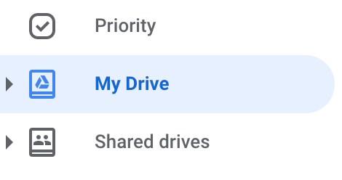  Change your view from List view to Grid view by clicking this icon at the top right corner of the screen. Choose which one you like best (I prefer list view--it’s easier to read).
Google Drive | Click on “New” at the top left side of the screen and select “New Folder.” Name it “Old Stuff.”  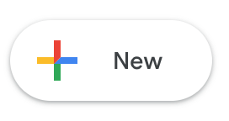  Move anything that is no longer relevant to you this school year into the Old Stuff folder to clean up your Drive. You can either click and drag it into the folder or right click on it, select “Move to,” and then choose the Old Stuff folder.  NOTE: If something was shared with you and you are not the “owner” of the document, it will probably not let you move it. You can either leave it where it is or just delete it from your drive.
Google Drive | Click on “New” at the top left side of the screen and select “New Folder.” Name it “[Your Name] Digital Photography Folder.”  This is where you will upload and store the images that you take for class.  Click on the name of the folder, click Share, then share it with me at lstine@bryantschools.org.  Inside the new folder, make another new folder. Name it “Personal Photos.”
Google Drive App | If you have a cell phone, go to the App Store and add the Google Drive app to your phone. Once it has installed, sign in to your school email.  Find or take a picture on your phone, then upload it to your “Personal Photos” folder using the Google Drive app.
Gmail | Set up an email signature. This will automatically appear at the end of every email you send. Click on the gear button at the top right side of your email screen, then click “See all settings.” Scroll down until you see the section for “Signature,” then click “+ Create new.”  In your signature, include your first and last name, what grade/class you are in, and Bryant High School. A lot of people also add a meaningful or inspirational quote at the end of their email signature.  Once you’re done, scroll to the bottom of the page and click “Save.”  Here is an example:  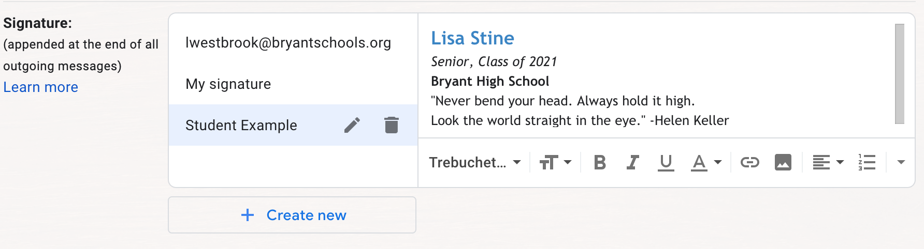
Gmail | Go back to your main Gmail screen and click “Compose.”  Send an email to one of your former or current teachers that you appreciate. You can start typing their name, and it should appear.  Click on “CC” on the top right corner of the email and type lstine@bryantschools.org. This will copy me on your email so that I get it too.  Make the subject of your email “Have a Good Semester” or something similar.  Start your email “Dear [Person’s Name].” Then, send the person a brief email to say hi, let them know you appreciate them, and tell them to have a good semester. Click “Send.”

