Desktop Publishing Exercises

Assignment 1: You work for Trump Advertising, Inc., and you are assigned the task of designing a mouse pad for _?_ (This could be a company, sports team, college, movie star, music star, etc.). This mouse pad will be distributed free to people attending the _?_ (convention, professional game, college event, movie premier, etc.). Use the picture, drawing, and Word Art ribbons to design a creative mouse pad. You must include the following in your design:

- Graphic from the Internet
- Word Art
- Features from the Drawing Toolbar
- Professional design

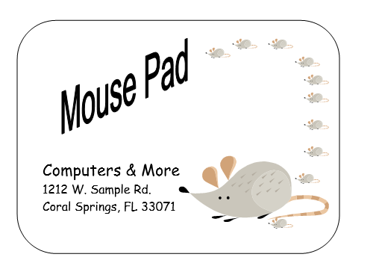

Part II

Your position in the advertising department at Trump Advertising, Inc., requires you do design the following documents for the same company that you designed the mouse pad for. Don't confuse your reader by including too much information, graphics, etc. Put your name in a small textbox in the lower right corner of the document. Be creative and professional--not tacky! Remember, sometimes less is more!!!

Guidelines to follow when creating documents:
- Avoid using underlining because this distracts the reader.
- Do not use more that two different font styles (WORD ART would be considered one font style)
- Reduce your top, bottom, left and right margins to .5 so that you have more space to work with.
- Put your name in a small textbox in the lower right corner of the document.

You are expected to display REAL computer skills when creating these documents. These exercises should demonstrate your skill in using the picture, word art, shapes, and formatting ribbons.

Assignment 2: Design a ½ page flyer (8 ½ x 5 ½) in portrait orientation; Save as CoFlyer1. Create a promotion/sale that will be offered to valued customers. This promotional flyer will be handed to customers that visit the business and must include some sort of coupon that the customer will tear out to take advantage of the promotional offer/sale. When you are finished with the ½ page flyer, highlight and group your flyer so that you can copy and paste the flyer on the bottom of your page in the blank space. You should be able to print two flyers on one page.

Assignment 3: Design a flyer; Save as CoFlyer2. Pick a product or product line to advertise/feature in this flyer. This promotional flyer will be mailed to local residents. The flyer's goal will be to get people to visit the business and purchase the particular product featured in your flyer. Be sure to include the company name, local address (street address, city, and state), phone number, and dates of the promotion.

Assignment 4: The company you selected is sponsoring a fund raising event for a nonprofit organization (a charity such at The American Cancer Society). Create an advertisement to publicize the event (you may select any nonprofit organization, and make-up your own fund raising event). This advertisement will be published in the local newspaper and posters/billboards will be made of the advertisement to publicize the event throughout the county. The full page ad should include the following:
- Name of the event
- Date and time of the event
- Cost of the event
- Location of the event
- Purpose of the event
- Company sponsoring the event
- Charity that will benefit from the event proceeds

Keep in mind that you should not write paragraphs of information on the ad. People will not want to read the ad if it contains too much writing. Keep to the facts--attract attention to the ad and give the details. Space the information out to fill the page (you decide on the orientation of the ad--portrait or landscape). Put your name in a small textbox in the lower right corner of the document.

Staple Assignment 1-4 and submit for a grade (You have five days to complete this assignment).

