Photoshop Filter Grid
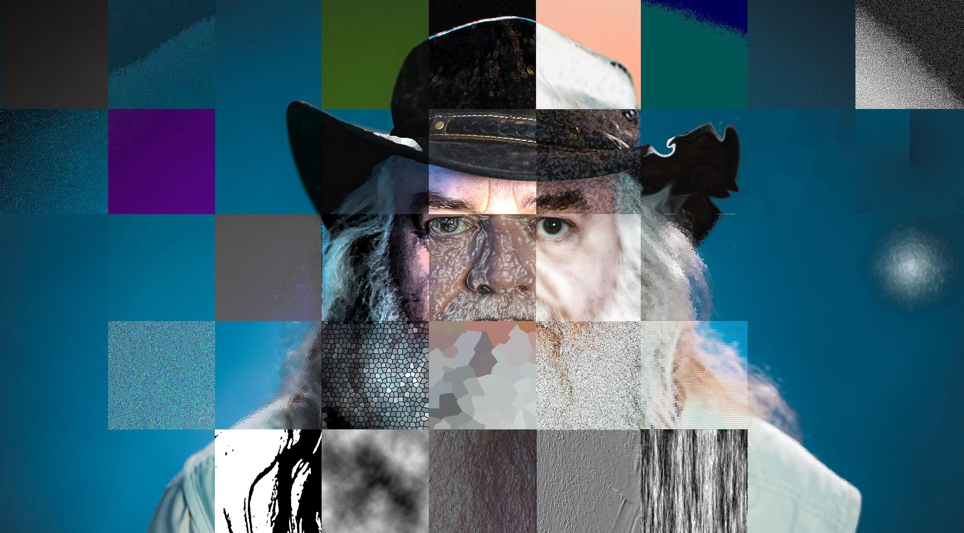

- Find a portrait of a person. It could be a celebrity or it could be from the link we usually use (search “portrait”) : https://burst.shopify.com/

- Download and open in photoshop

- Open your ruler guides: View > Rulers or Command + R

- Crop your image so the measurements are even numbers

- Click on the left side ruler and drag the guideline 2 inches to the right, (you can tell they’re 2” because a dotted line follows you on the top ruler, and also a rectangular box appears next to your guideline as you move it, indicating how far over you are)
  - Repeat this step until you have vertical guidelines at every 2 inches on your image

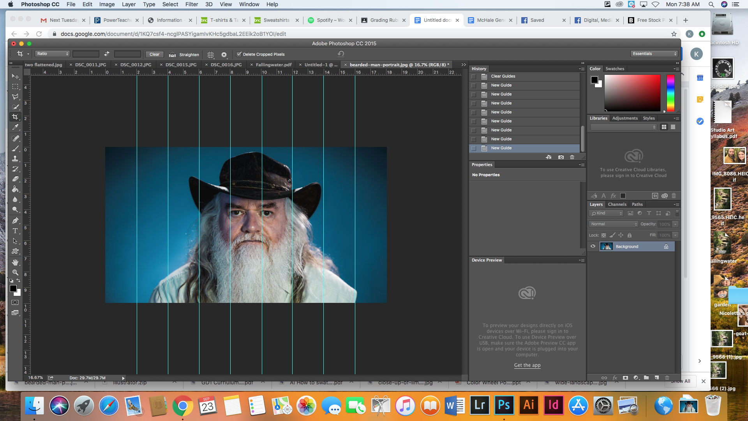

- Click on the top ruler and drag the guideline 2 inches down.
  - Repeat this step until you have horizontal guidelines at every 2 inches on your image (creating a grid).
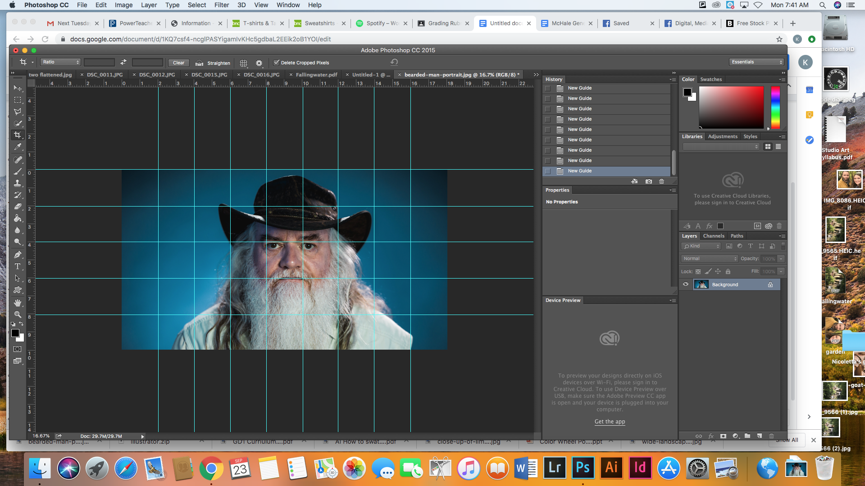
Continue on next page
- Choose the square marquee tool (2nd tool down on the left side tool panel. You may have to change it to a square by clicking, holding down, and releasing to open the marquee choices, select square).

- Using this tool, select the first square in your grid. Change the look of this square by going to Layers> New Adjustment Layer> And choose one to use. Repeat this step for all squares in your grid. Switch between different adjustment layers and the filter gallery we used last week. You can also use anything under the filter menu, it doesn’t have to be inside the filter gallery. Try out Liquify, it’s pretty cool!

- Make sure the background layer (the one with your picture on it) is selected every time you go to change your square, otherwise it won’t work!!!
- When you are done go to View> Clear Guides to get rid of your lines

- Submit to Google Classroom when finished.

