AP Physics - What have They Done to My Lens Lab
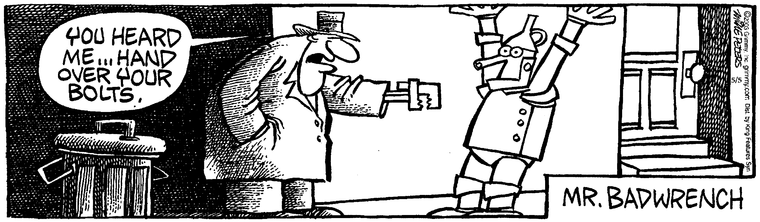

Where the telescope ends, the microscopes begins. Which of the two has the grander view? -- Victor Hugo

Converging lenses can produce both real and virtual images. In this, most excellent Kahuna Institute Lab, you will explore the generation of real images. Real images can, of course, be projected onto a screen.

Your mission in this lab will be to determine the focal length of a lens and confirm that the thin lens equation actually works.

Please treat the lenses with care as they are expensive and can easily be scratched.

For an object you will use a folder that has a rice paper window with a dark design drawn on it. When placed in front of a light bulb, the rice paper window will serve as the object. Much of the lab, certainly the data collection part of it, will be done in the dark. BEHAVE YOURSELVES!

Project your images onto an index card, which will serve as a screen.

Devise an experimental procedure that will let you come up with a focal length for the lens and that will prove that the thin lens equation is a keeper.

