AP Physics - Exciting Conservation of Energy Lab

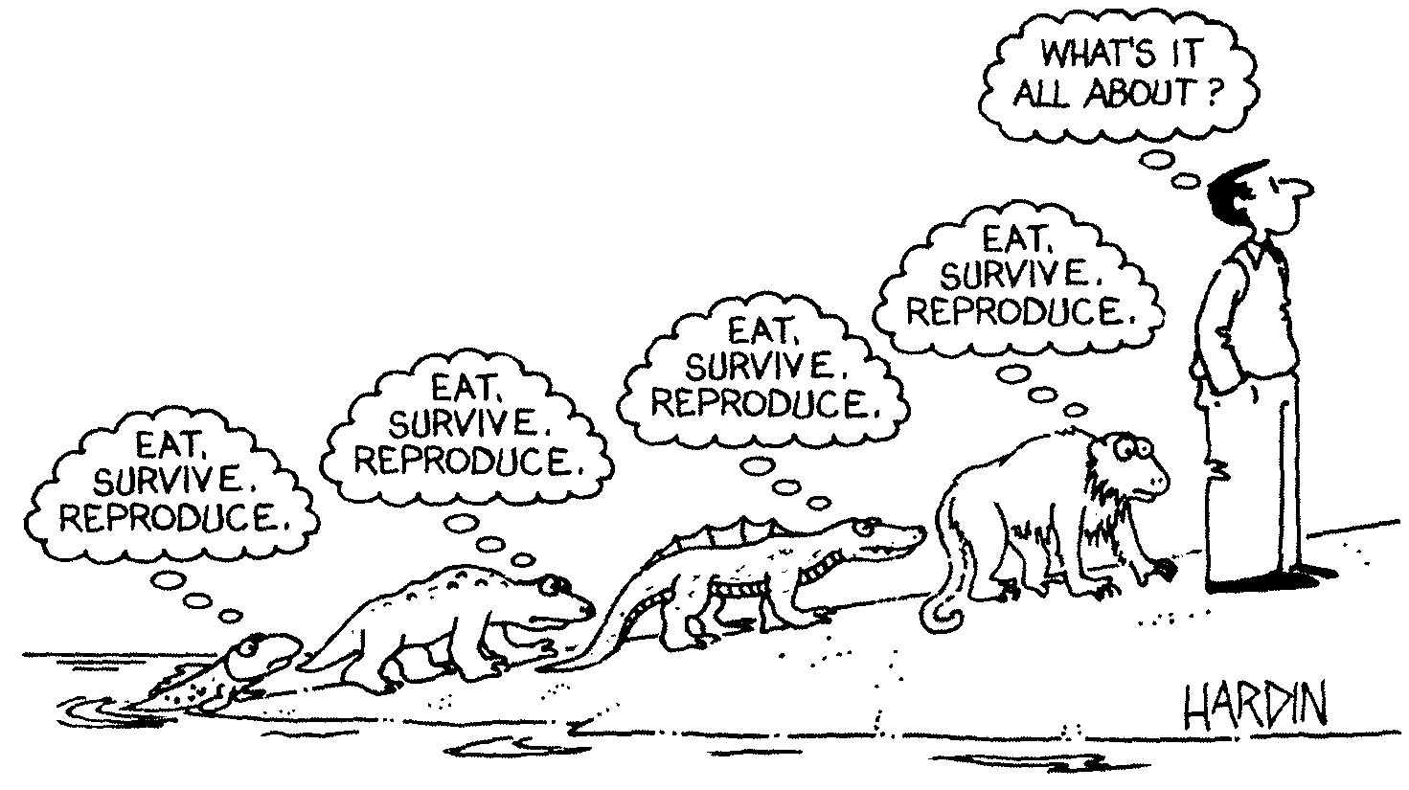
A hen is only an egg's way of making another egg. -- Samuel Butler

In this ever so loverly lab, you are going to confirm the universality of the good old law of conservation of energy.

Tie a bunch or washers (10 – 12 of them) together into a single lump kind of deal. Then, note that the washers are fit to be tied to the end of the thread. So tie them to the end of a piece of thread. The other end of the thread is tied to the ring at the top of the ring stand.

Allow the washers to hang vertically and measure the height of the washers above the tabletop. This is shown as y₁ in the drawing above. You want the razor blade to be above the washers, so the washers won't hit it, just the string. But it should be fairly close to the washers so that the string when in a straight, up-and-down position, will hit the razor blade. Fix the razor blade in a clamp below the ring. Now, does the Physics Kahuna really have to remind you that the razor blade is sharp, so be careful that you don't cut yourself? Naw, probably not.

Do you need to measure the mass of the washers?

Tie another thread to the washers and use it to pull the washers back to some height, y₂, above the tabletop. You should measure this height also. The washers are then released – cut the string! The washers swing forward until the razor blade cuts the thread. The washers will travel some horizontal distance x before they hit the tabletop. Mark where they hit and measure the value of x.

Now, before you released the washers they had potential energy with respect to y₁. When they got to the bottom of the swing where the razor blade cut the string, they had kinetic energy. Solve the thing for v, which gives you the horizontal speed of the washers when they are released. Of course, once the razor blade cuts the string, the washers will fall. Calculate the distance they should travel and compare to what actually happened.

Hey, you could figure out an experimental error, couldn't you?

Anyway, get busy and do the lab. Stop goofing around. Turn to!

