Computer Parts Name: __________________

Label the parts of the computer by using the following words:

CD/DVD
CPU
Disk Drive
External Hard Drive
Headset
Internet
Keyboard
Monitor
Mouse
Power Button
Speakers
Screen
URL/Web Address
USB Port
USB Drive

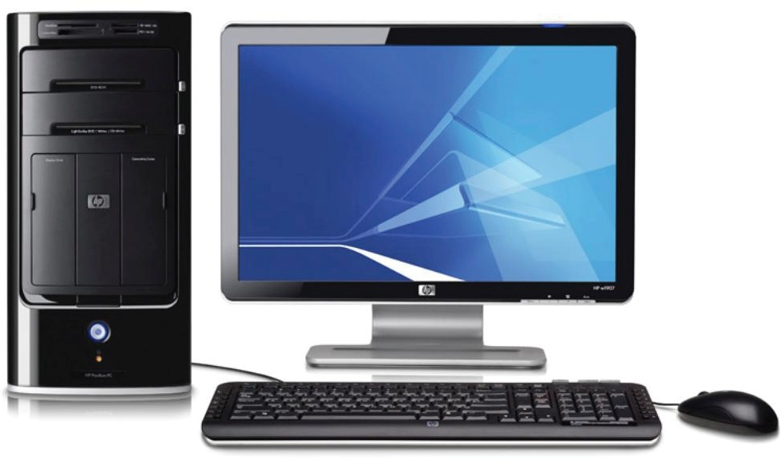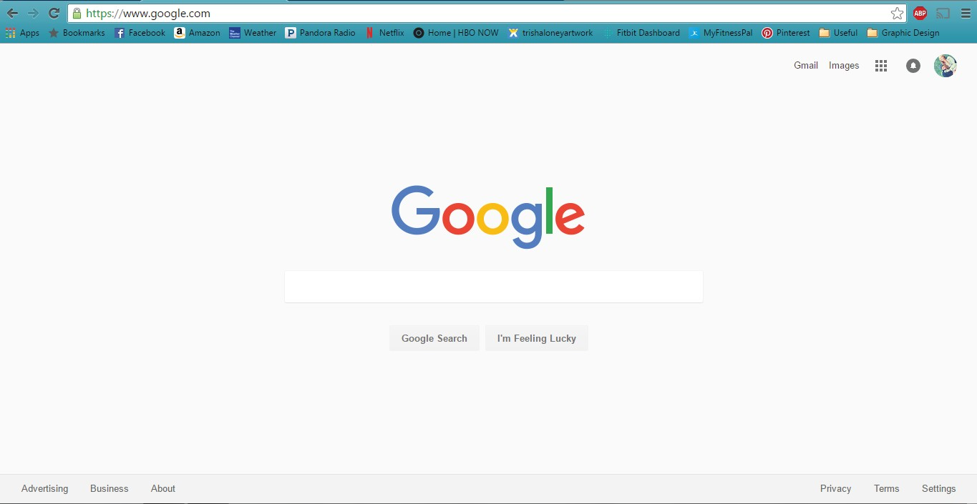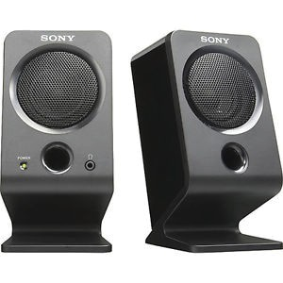1
2
5
6
7
8
9
3
11
4
10

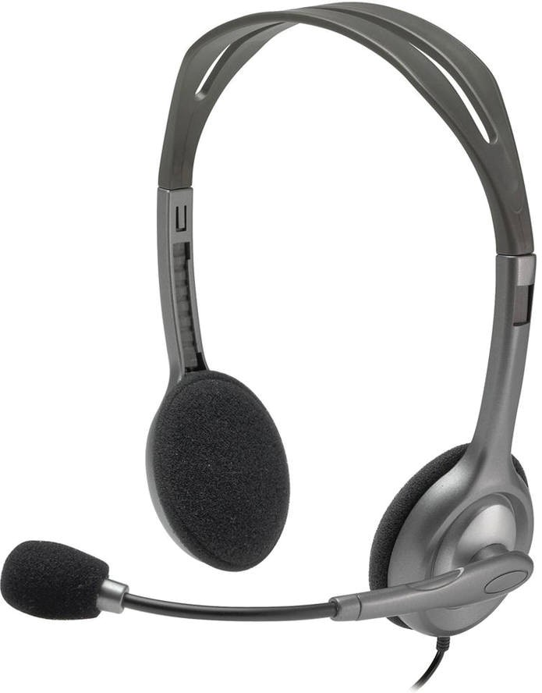
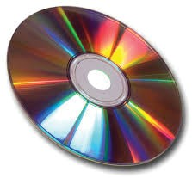
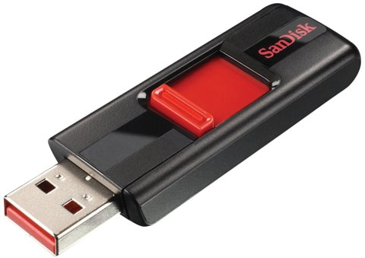
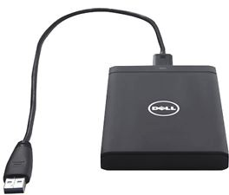
12 13 14 15

