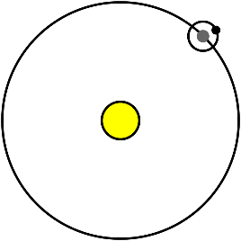
Computer: Orbit Simulator

Go to: http://lasp.colorado.edu/education/outerplanets/orbit_simulator/
Read & click through the directions!
Below are the questions from the simulator notebook. Answer them in complete sentences.
----------------------------------------------------------------------------------------------------------------------------------------------------------------

Observe Comet Borrelly
- How does the eccentricity of the comet compare to the other solar system bodies?

- What changes occur in the comet as it approaches the Sun? Describe the interaction.

- Describe the velocity of Comet Borrelly close to and far from the Sun.

- How does the inclination of Comet Borrelly compare to the other Solar System bodies?

Explore changing the average distance and eccentricity of Planet X
- What happens to the velocity of the planet when the eccentricity is high or low? Explain in detail.

- What shape does Planet X make when the eccentricity is zero?

- How does the average distance of Planet X affect the velocity and period?

- How do the velocities of the outer planets compare to the inner planets?

- How does the velocity of Pluto compare to the velocity of Jupiter? Why do you think the velocities are different?

Using the plotting window, explore plotting variables on the x and yaxis
- Which plots of the Solar System bodies have definite trends and what are those trends? Describe.

- Which plots do not have any apparent trend? Why?

- What happens to the plots when you change the eccentricity and/or average distance of Planet X? Explore a variety of plots and describe your results.

- How does Comet Borrelly compare to the other planets you’ve plotted?

- Did any plot surprise you? Why? Explore a variety of plots and describe your results.

- How does distance from the central body (the Sun) affect the velocity of an orbiting body?

- How does distance from the central body affect the period of an orbiting body?

- Does eccentricity affect the period of the orbiting body? Why/ why not?

- Does inclination affect the velocity or period of the orbiting body? Why/ why not

