Compositional Rules
Kelly Moncure

SUBJECT: Digital Photography

GRADE LEVEL: 10- 12th

LESSON TOPIC: Compositional Rules

ACADEMIC CONTENT STANDARDS:
California Academic Standard

1.0 ARTISTIC PERCEPTION
Processing, Analyzing, and Responding to Sensory Information Through the Language and Skills Unique to the Visual Arts
Students perceive and respond to works of art, objects in nature, events, and the environment. They also use the vocabulary of the visual arts to express their observations.

2.0 CREATIVE EXPRESSION
Creating, Performing, and Participating in the Visual Arts

CTE Standard
A2.0 Apply artistic skills and processes to solve a variety of industry-relevant problems in a variety of traditional and electronic media.
A2.6 Create an artistic product that involves the effective use of the elements of art and the principles of design.
A8.0 Understand the key technical and technological requirements applicable to various segments of the Media and Design Arts Pathway.
A8.2 Use technology to create a variety of audio, visual, written, and electronic products and presentations.

LEARNING OBJECTIVES/OUTCOMES: Students will learn about compositional techniques through the work of Ansel Adams. They will take photographs after seeing his work of landscapes and manipulate them to become Black and White in Photoshop.

LANGUAGE OBJECTIVES/OUTCOMES: Students will understand the compositional vocabulary of leading line, rule of thirds, framing, symmetry and crop. They will be able to write about what they experienced firsthand.

INTRO ACTIVITIES:
- Background/Summary- Students are familiar with the basics of camera settings (ISO, Aperture Priority and Shutter Priority), downloading their images onto their desktop, and how to create a Padlet.
- Entry/Anticipatory: Teacher will do a lecture on Compositional Techniques using the work of Ansel Adams. She will explain about Adams’ background, his work with the National Park Service, and what he did to create his work through a view camera. Students will take notes and do miniature drawings based on the photographs for further comprehension.

THROUGH ACTIVITIES

- Students will sign out cameras. Teacher will go over what settings to set the camera, based on what they want to achieve- specifically, ISO 200, Aperture Priority f/16 for a deep depth of field. Teacher will remind them that if they go in the shade, to change the ISO to 400.
- Students will read out loud as a class the photography shot list while the teacher explains the assignment further. Specifically, they will be shooting three angles (eye level, kneeling and worm’s eye view) of the five compositional techniques, which are leading line, framing, rule of thirds, symmetry, and crop.
- I show specifically what they will be creating- a visual diary of Compositional Techniques so that they can understand what it looks like, which will be created into their own Padlet.

GUIDED PRACTICE

- Teacher will reiterate what the various techniques are, based on student examples.
- Teacher will hand out a shot list directing students what is expected of them, as well as a visual of the final product they are creating. She will have the students read out loud the shot list and elaborate on specifics.
- Teacher will demonstrate how to take the photos at various angles and “work” the camera to get the best images.
- Teacher will direct students on how to change the aperture on their cameras to f/16. She will direct them on how to change the ISO on their camera, from 400 to 200, according to the light conditions.
- Students will take photographs of the compositional techniques with the teacher walking around and helping as needed.
- Once the photographs are taken, the students will go back to the room to download their photographs.
Day Two
- Students will have a “Do Now” where they will analyze a photograph from Ansel Adams and use their notes to figure out the compositional rule, what setting the camera is on, and whether it is shallow or deep depth of field. They will pair and share what they believe and then they will have a class discussion on it.
- Teacher will have the students read out loud the project from the class website on Compositional Rules, elaborating as they go along as needed.
- Teacher will demonstrate how to take a photograph and open it up in Photoshop.
- The teacher will demonstrate how to use the Black and White and Brightness/Contrast options in Photoshop to get a good quality photograph.
- Teacher will go over how to save their work and put in the common drive.
- Teacher will go over how to create their own Padlet after they have read the instructions. They have created several previously, on Shutter Speed, Aperture, and the Elements and Principles of Art.
- Students will work independently on editing their photographs in Photoshop and then create a Padlet on Composition, showing an example of each composition and writing the technical information from the Photos application of what the Aperture, Shutter Speed and ISO is, as well as a sentence or two describing how the photograph is that compositional rule.

BEYOND ACTIVITIES:
- Independent practice – Students will work on completing their visual diary in Padlet.
- Assessment/Evaluation – Students will be assessed on the visuals, technical information and reflection, research, time on task, and teamwork.
- Closure – I assess whether the project was successful based on making sure all students participated and how thorough they were with the reflection.

Shot list for Landscape photography

Take three photos each of the following composition techniques- at eye level, kneeling down, and worm’s eye view.

ISO: 400
Aperture: f/16
If you’re in a shady spot and the shutter speed goes down to 1/30th of a second or slower, either find something to put the camera on to stabilize it (like a bench), or bring the aperture to f/11.

- Leading line- something (like a path etc) leads your eye through the frame. Make sure it’s the most prominent thing in the photo.
- Symmetrical Balance (fully balanced on left and right side, like a butterfly)
- Rule of thirds- subject in third quadrant of photo (like you folded a sheet in thirds and the subject is in the far left or right fold)
- Framing- something “frames” the subject like a gazebo or looking through something to photograph the subject.
- Crop- something close up- zoom in or get close (but not too close you can’t focus!)

BE SURE with all photographs you are taking, that you are looking at all edges of the frame within the viewfinder before taking the shot.

Make sure you’re not getting extemporaneous objects within the background (like, a car or garbage can etc) and really take the time to compose your photographs.

Make sure there’s a variety of places you are taking your photographs and that the composition is very clear!

Landscape Compositional Rules Self Evaluation
Name: Period:

Please complete your evaluation for the project & total the points below:

Classwork- 5 points
Time on task (not goofing off or distracting others) 0/1 point __________
Participated in class with a good attitude 0/1 point __________
Respectful to teacher 0/1 point __________
Not on cell phones while should be working 0/1 point __________
Not late to class on any day 0/1 point _________

Photographs – 10 points
One photo for leading line 0/1 point _________
One photo for framing 0/1 point _________
One photo for symmetry 0/1 point _________
One photo for rule of thirds 0/1 point _________
One photograph for crop 0/1 point _________
Horizon lines are straight 0/1 point __________
No random junk or cars in the background 0/1 point __________
Each photograph in focus 0/1 point __________
Each photograph not too dark or light 0/1 point __________
Each photograph changed to black and white 0/1 point __________

Padlet- 4 points
Title of Padlet First & Last Name and Compositional Rules 0/1 point __________
Each photograph has a title of which compositional rule it is 0/1 point __________
Each photo has technical information of
Aperture, Shutter Speed, and ISO 0/1 point __________
Each photograph has a sentence or more describing it 0/1 point __________

Common Drive- 1 point
Each photograph is named as the compositional rule ie 0/1 point __________
lastname-firstname-leading line.jpg
and placed in common drive
RBV-Class1 >231Common > Period# > 10-19-2017 Compositional Rules

Total points:__________/ 20
Please answer the following questions in COMPLETE SENTENCES
- I was proudest of:

- I struggled the most on:

- I learned the most about:
Do Now- Ansel Adams

Name: Period:

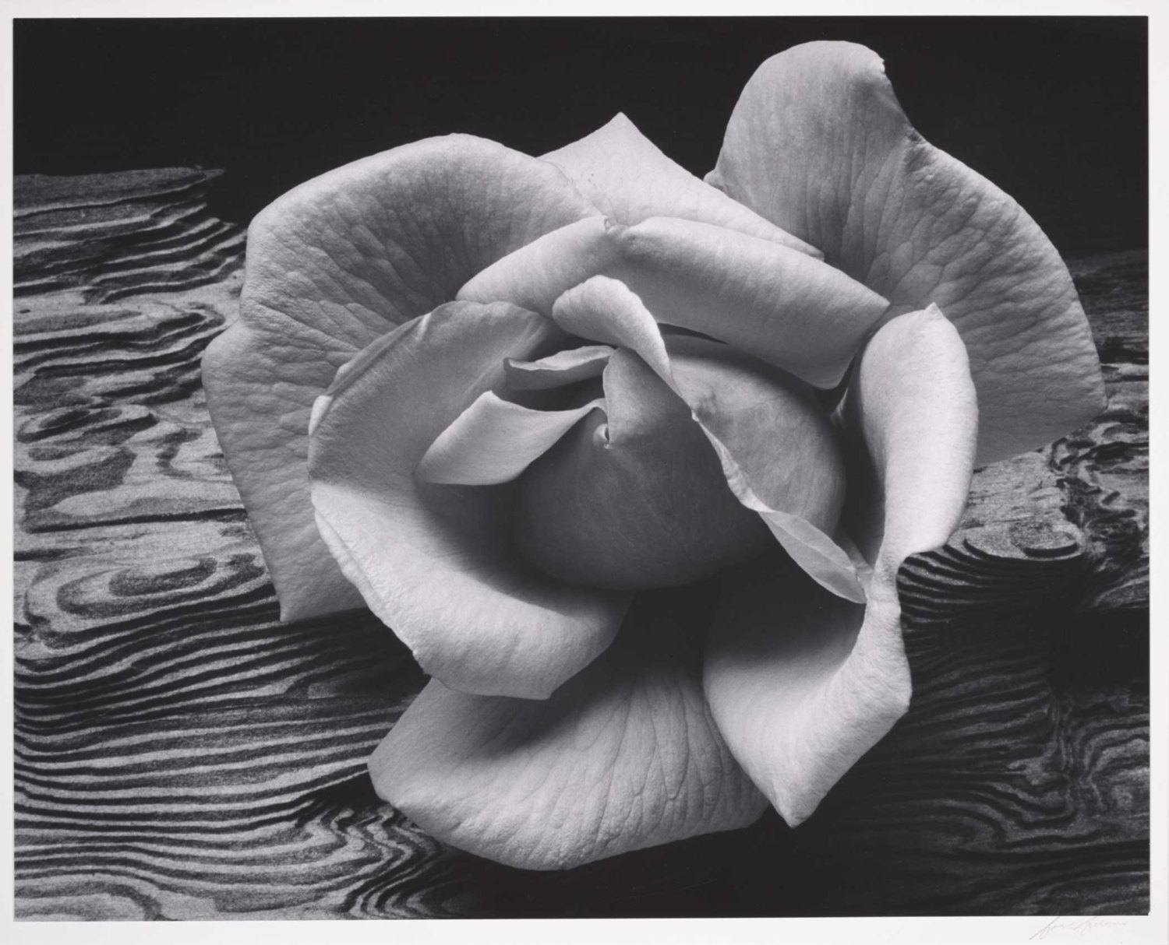
Ansel Adams, Rose & Driftwood, 1932

Answer the following questions in two or more complete sentences each.

- What compositional rule do you think this is, and why?

- What camera setting (Aperture Priority or Shutter Priority) do you think this is, and why?

- Is this a Deep depth of field or a shallow depth of field and why?

