Recreate the Color Wheel Lesson Plan
Fun with Food and Color
This lesson is used after PPTs on display elements, including color, and before the window display assignment.
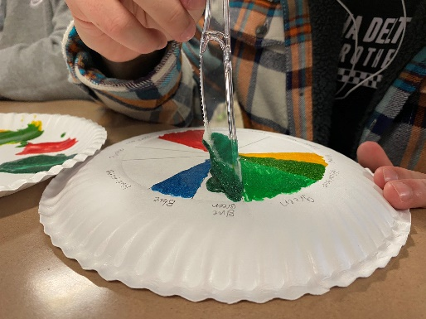
Time Needed 45 + minutes
Supplies:
Pencil
Ruler or Protractor
Paper plates (2 per group)
Popsicle sticks/plastic knife
1 plastic spoon per group
Paper towels
Food Coloring (1 set per table)
White Icing (cheaper to make my own)
Vanilla Wafers (optional – to eat excess icing)

Display Image of Color Wheel on Overhead Projector
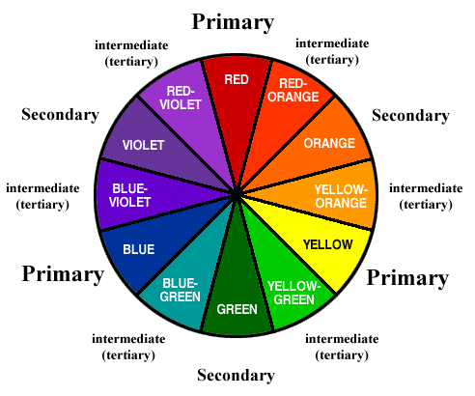
Instructions:
- Give each pair of students 1 paper plate. Demonstrate how to divide into 12 segments (for some this is the hardest part)
- Label the colors on the OUTSIDE of each segment.
- Then each pair can come get a mixing plate with a dollop of icing. Make them wait to mix so you can give directions to the whole class.
- Instruct class to start with primary colors first since that is what the bottles are and what creates all other colors. Demonstrate how to pull out a small amount of icing, drop 2 drops of color and then mix. Remind them that the food coloring is highly concentrated, and more is not always better. Then demonstrate how to spread onto the segment on the plate.
- Monitor class and assist with mixing as needed. Remind them to start with primary colors. Sometimes adding my white icing makes the tertiary colors better.
- Have one partner mix while the other spreads the color.
- Lesson takes 45 + minutes depending if they stay on task and how perfect they are trying to be (the OCD kids will have a hard time with the time constraints).
- Extension - have them write an emotion that evoked by each main color.
- While they clean up, they can get a few vanilla wafers to eat the extra icing they have left.

