Collapsing Can - Atmospheric Pressure
Description: Water is added to an empty soda-pop can and heated to boiling. The can is then quickly inverted into cold water which causes it to collapse.
Concept: When water vapor inside the can is cooled it condenses, decreasing the pressure on the inside of the can. With the pressure on the outside of the can greater than that on the inside, the can will collapse.
Materials:
- Aluminum can (100 % Al, no steel)
- 15 mL of water
- Hot Plate
- Pan full of cold water
- Tongs
Procedure:
Put a small amount of water in can and heat on hot plate until you hear the water boiling. When water is boiling and water vapor escapes the can, quickly invert the can using the tongs into the pan of cold water.
Notes: Shakhashiri says that a steel or partially steel can is more likely to suck water up instead of collapsing.

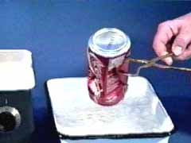

Conclusion:
- Describe what happened to the can.

- Explain why this happened.

