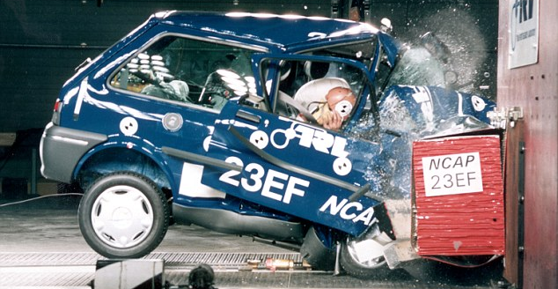
“Speed has never killed anyone.

Suddenly becoming stationary, that's what gets you.”
Jeremy Clarkson

