On-line activities for circular motion labs
Below is the list of experiments (real, video based and data-based) that students can perform as labs for circular motion. For each experiment we provide goals, equipment and rubrics for self-assessment. Rubrics can be found at https://sites.google.com/site/scientificabilities/rubrics

1. Observational experiment: Circular motion and forces
Goals: a) to investigate the direction of the sum of the forces exerted on an object moving in a circle at constant speed.
b) to describe a pattern.
Equipment: none
Rubrics for self-assessment: Ability to represent information in multiple ways A6.
a. Watch the videos of the following three experiments: [https://youtu.be/xO6K0itrZz8]
For each experiment, fill in the blanks in the table that follows. Assume that the frictional forces exerted on all three objects are negligible and that the objects move at constant speed.
Experiment; the circling object is in bold. | List objects that interact with the circling object. | Draw a force diagram for the circling object. | List forces or force components that add to zero. | Indicate the direction of the sum of the forces exerted on the object.
a. Tapping a bowling ball. So it moves in a circle on the floor

b. Swinging a backpack in a horizontal circle.

c. Pulling a rope attached to a moving rollerblader so she moves in a circle.

b. Review your analysis recorded in the table above. Based on your observations and on the analysis, find a pattern for the direction of the sum of the forces exerted on the objects moving at constant speed in a circle in all three experiments. Summarize your pattern in words.

2. Testing experiment: Circular motion and forces
Goal: learn how to make a prediction based on the idea under test.
Equipment: none.
Rubrics for self-assessment: Ability to represent information in multiple ways A6 and the Ability to design an experiment to test an idea C1, C4, and C8.
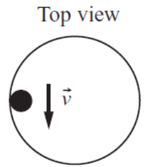
For the following testing experiment, use the pattern that you formulated in Experiment 1 and Newton’s laws to predict the outcome of the experiment. Do not watch the video until you finish part b of this activity.
a. Inside a metal ring, a person rolls a small ball or a marble on a smooth horizontal surface. The marble rolls along the ring. Is the motion of the ball consistent with the pattern formulated in Experiment 1? Explain.
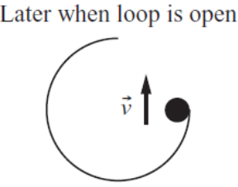
b. Use the pattern you found in Experiment 1 (not your intuition) to predict what will happen to the ball if, after the ball rolls for a couple of turns, the person removes a quarter of the ring as shown in the figure. Justify your prediction in words and with a force diagram before you watch the video of the experiment.
c. After you make your prediction, watch the video at [https://mediaplayer.pearsoncmg.com/assets/_frames.true/sci-phys-egv2e-alg-5-1-4], and compare the outcome to your prediction. What judgment can you make about the idea that you’re testing? Does the outcome support, prove, or disprove the idea you’re testing?

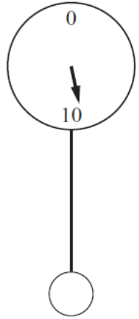
3. Testing experiment: Circular motion and forces
Goal: learn how to make a prediction based on the idea under test.
Equipment: none.
Rubrics for self-assessment: Ability to represent information in multiple ways A5 and A6 and the Ability to design an experiment to test an idea C1, C4, and C8.
a. A 0.1-kg ball hangs from a 1.0-m long string. The other end of the string is attached to a Newton force measuring scale. The string pulls up on the ball, exerting about a 1.0-N force. The string and ball, in turn, pull down on the scale, exerting a 1.0-N force—the scale reads about 1.0 N. Imagine that you pull the ball to the side and release it so that the ball swings like a pendulum at the end of the string. First, determine the direction of the acceleration of the bob at the very bottom of the swing. Although this is not motion at constant speed, you can consider the bob to have the same speed at two points equally distant from the bottom on the right and on the left. Use your knowledge of the relationship between acceleration and the sum of the forces exerted on the object to predict the scale reading as the ball passes directly under the scale (i.e., is it more than, less than, or equal to 1.0 N?). Write and justify your prediction with motion and force diagrams.
b. Watch the video of the experiment [http://islephysics.net/pt3/experiment.php?topicid=5&exptid=59]; record the outcome, and compare it to your prediction. Did the outcome support the pattern? Explain your judgment.

5. Observational experiment: Quantitative analysis of circular motion
Goal: find a quantitative relation between the sum of the forces exerted on an object moving in a circle at constant speed and the speed and the radius of the circle.
Equipment: none.
Rubrics for self-assessment: Ability to represent information in multiple ways A6 and the Ability to conduct an observational experiment B3, B7, B8, and B9.

Use the following link: https://app.pivotinteractives.com/activities/5a6deec203db79001a222161/preview
Follow instructions starting with Part 1 Videos and video measurement tools, to Part 2 Observational Experiments to Part 3 Putting it all together. Answer the questions and write the lab report that can be assessed by the rubrics above.

6. Testing experiment: Quantitative analysis of circular motion
Goals: learn how to make a prediction based on the idea under test.
Equipment: none.
Rubrics for self-assessment: Ability to represent information in multiple ways A6 and the Ability to design an experiment to test an idea C1, and C4-C8.

Use the following link to perform the experiment following the prompts: https://app.pivotinteractives.com/activities/5a81ac5b11d1450020d278e9/preview

Answer the questions and write the lab report that can be assessed by the rubrics above.

7. Testing experiment: Does Newton’s second law apply to circular motion?
Goals: learn how to make a prediction based on the idea under test.
Equipment: protractor.
Rubrics for self-assessment: Ability to represent information in multiple ways A6 and the Ability to design an experiment to test an idea C1, and C4-C8.

Use the video [https://youtu.be/nSgr9lGk764] to test whether Newton’s second law works for circular motion, namely 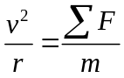.
a. Watch two spheres A and B of different masses move in a circle ((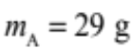and 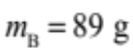). What do you notice about their motion? Write all your observations below (do not measure anything). Draw force diagrams to explain the tilt of the strings qualitatively.
b. Use the data in the video for sphere A to determine whether the angle is consistent with the equation under test. What other quantities do you need to determine to make this judgment? Describe how you will model the objects, interactions, and processes that you will use in your mathematical model. Construct force diagrams as appropriate.
c. Consider the uncertainties in your data. How do they affect your judgment?
d. How can you explain that the tilt of the string for sphere B is the same as for sphere A although sphere B has about three times larger mass?

8. Application experiment: Circular motion with assumptions
Use the following link to perform the experiment and answer the questions:
https://app.pivotinteractives.com/activities/5cf1c561734e7a001e15ad96/preview

9. Application experiment: Studying circular motion using the Phyphox
This activity uses the Phyphox app on your phone and you will also need a measuring tape or a meterstick (any device that allows you to measure length). Hold the phone in front of you with both hands, so that the screen is horizontal and the y-axis points away from you. Start recording the acceleration (choose acceleration without g). Then start rotating with approximately constant speed around your body axis, keeping both hands extended (see figure below).
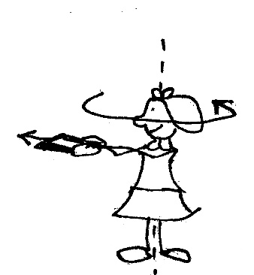

a. Obtain the 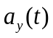 graph. Use the graph to estimate the speed with which the phone was moving (you can measure the length of your arms).
b. What should you do in the previous experiment so that the average magnitude of the reading increases/decreases (the phone should remain in the horizontal position)? Write down your ideas and test them. Do the outcomes agree with your predictions?

