Circuit Folder Game
Introduction:
In order to have a complete, working circuit flow of electricity must be continuous (no breaks in the wire or in this case the aluminum foil). Also, electricity will flow easily through some substances, called conductors, and not easily through other substances, called insulators.

Materials:
Cardstock
Hole punch
Aluminum Foil
Scissors
Tape

Procedure:
- Using the hole punch make 5 holes along each side of the paper. Space them like the picture.

- Tape 1 strip of aluminum foil from one hole to another hole on the opposite side. Cut off any extra foil.
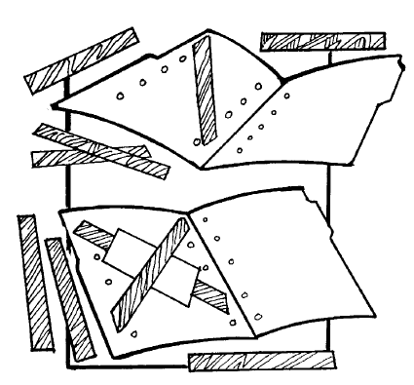
- Place a piece of tape over the top of the foil. This will act as insulator. This is similar to the plastic coating surrounding most wires.

- Continue this process until all 5 holes are connected to the 5 other holes.

- Now write questions and answers for each hole. Be sure that you write correct answers for each question next to the connecting hole. For example, if you connected hole 1 and hole D using aluminum foil you’d want to put the question next to hole 1 and the answer next to hole D.

- Finally, use the light bulb system to check the circuit folder game.
