5th Grade Gymnastics Unit
Day One: Introduction to Gymnastics - Balance on Hands and Feet  Safety: Dress appropriately. Safe Self Space. Center of mat while balancing.  Equipment: 11 AM  Gym Diagram: A  Stretch: Dynamic  - Small/Big arms circles  - Triceps, Wrist and Shoulder Stretches  - Neck circles  - Russian walk (foot to opposite hand)  Teach/Progressions: Symmetrical/Asymmetrical Balance  -4 pt.: Push up position (Plank)  -3 pt.: Lift one leg/arm Left/Right  -2 pt: Lift one leg/arm Left/Right-opposite and same sides.  -4 pt.: Crab position  -3 pt.: Lift one leg/arm Left/Right  -2 pt.: Lift one leg/arm Left/Right-opposite and same sides.  -1 pt.: V-seat | Day Two: Upright Balance  Safety: General  Equipment: 11 AM  Gym Diagram: A  Stretch: Dynamic  Review:  -4 pt.: Push up position (Plank)  -3 pt.: Lift one leg/arm Left/Right  -2 pt: Lift one leg/arm Left/Right-opposite and same sides  -4 pt.: Crab position  -3 pt.: Lift one leg/arm Left/Right  -2 pt.: Lift one leg/arm Left/Right-opposite and same sides  -1 pt.: V-seat  Teach/Progressions: Upright Balance  - Knee Lifter  - Bent/Extended Hip Scale  - The Mechanical Toy | Day Three: Inverted Agility and Upright Balance  Safety: General/AM surrounding  LWB. Only dismount onto mats.  Equipment: 15 AM, 2 LWB  Gym Diagram: B  Stretch: Dynamic  Review:  - Knee Lifter  - Bent/Extended Hip Scale  - The Mechanical Toy  Teach/Progressions: Vaulting over LWB  - High Barrel Roll  - Kangaroo Hops  - Cartwheels | Day Four: Inverted Agility and Upright Balance  Safety: General/AM surrounding  LWB. Only dismount onto mats.  Equipment: 15 AM, 2 LWB, 4 bean bags  Gym Diagram: B  Stretch: Dynamic  Review:  - Knee Lifter  - Bent/Extended Hip Scale  - The Mechanical Toy  - High Barrel Roll  - Kangaroo Hops  - Cartwheels  Teach/Progressions:  - Grapevine  - Cross Over  - Sidestep
Day Five: Backward Rolling  Safety: Keep chin tucked towards chest. Roll onto mats only  Equipment: 15AM, 2 LWB, 4 bean bags  Gym Diagram: B  Stretch: Dynamic/Ballistic  - Hamstrings and Quadriceps  Teach:  - Back rocker  - Back balance  - Back shoulder roll  - Backward roll into straddle and pike  Activity:  Students will alternate between stations practicing upright balance, inverted agility, and back shoulder rolls. | Day Six: Upright Agility  Safety: Keep head level with the floor while jumping.  Equipment: 11 AM  Gym Diagram: A  Stretch: Dynamic/Ballistic  Teach/Progressions:  - Knee Slapper  - Ankle Slapper  - Seat Kicker  - Straddle Jump  - Star Jump  - Pike/Straddle Jump | Day Seven: Upright Agility  Safety: SB will we placed on lip of CM. One pound per jump. Keep head level with the floor.  Equipment: 11 AM, SB, CM  Gym Diagram: C  Stretch: Dynamic  Review:  - Knee Slapper  - Ankle Slapper  - Seat Kicker  - Straddle Jump  - Star Jump  - Pike/Straddle Jump  Teach:  - Rotations (1/4,1/2,3/4, Full)  - Arm Positions for rotating  Activity:  - Students will alternate stations using upright balance, upright agility, and backward rolling. | Day Eight: Three Ring Circuit – Inverted Balance  Equipment: 15 AM, 2 LWB, 4 Beanbags, SB, and CM  Gym Diagram: D  Safety: General/Specific for equipment  Stretch: Dynamic/Ballistic  Review:  - Rotations  Teach:  - Head Touch  - Tripod  Activity:  - See lesson plan.
Day Nine: Inverted Balance  Equipment: 15 AM  Gym Diagram: A  Safety: General. Specific for inverted balance. Tuck chin to chest  Stretch: Ballistic  Review:  - Tripod  - Headtouch  Teach:  - One Knee Up  - Double Knee Up  - Headstand | Day Ten: Forward Rolling  Gym Diagram:  Equipment: 15 AM,  Safety: General. Specific for inverted balance. Tuck chin to chest  Stretch  Review:  - Tripod  - One knee up  - Double knee up  - Headstand  Teach  - Look Behind  - Tip Over  - Forward Roll  Activity:  Students will rotate between stations using a combination of all skills acquired throughout this unit (inverted balance, upright agility, forward rolling, etc.)

Physical Education Lesson Plan by: Brittney Lundberg, Chris Miller, Kyle Coe
Date: 12/7/09 Class: PE 340 Grade: 5th Time:10:30 am
Location: Gym D Final lesson of Gymnastics Unit Number of Students: 8
Objectives of the Lesson: By the end of this unit’s lesson the students will be able to perform the tripod position for a 5 second period with 80% proficiency. The student who is motorically delayed will be able perform the tripod beginning position (head touch) with 100% proficiency.
Procedures/Activities | Organization | Equipment | Time
Introduction:  Welcome students, safety review  Guided Practice:  Warm-up  Demonstration/Review:  Check for safety issues  Guided Practice:  Dynamic/Ballistic stretching (Triceps, Shoulders, Wrists, Hamstrings, and Quadriceps)  Guided Practice:  Go to each station and demonstrate/ have a child demonstrate what activities will be done at each station  Demonstration/Review:  Explain how each of the circuits (areas 1-3) will work and check for complete understanding  Guided Practice:  Have students go from station to station with a 1 minute time frame  Area A  Station 1: upright balance choice 1 - then walk or balance dip or grape vine with the option of bean bag balancing  Station 2: kangaroo jump or cartwheel across beam  Station 3: choice of seat kickers, high knee jumps or star jump with a choice to jump over bean bags to increase the challenge  Station 4: Backwards roll or shoulder roll or forward roll  Station 5: upright balance or upright agility or forward roll in any 5 sequence  Station 6: Back rocker or puppy dog roll or seat roller or backward roll to pike position  Area B  jogging area or skipping  Area C  10 jumping jacks and 10 ski jumps or alternating until group rotates  Demonstration/Review:  Get drink of water/ move mats (each student has a mat)  Introduce tripod skill  Guided Practice:  Practice doing tripod in triangle formation with head and hands  Demonstration/Review:  Show students how to bring one knee to elbow  Guided Practice: (practice as a class)  One knee to elbow  Independent Practice:  Students will practice doing the tripod with bringing one knee up  Demonstration/Explanation:  Bringing both knees to elbows  Independent Practice:  Have students practice bringing both knees up to elbows  Conclusion:  Wrap up gymnastics unit  Ask students what their favorite part of the gymnastics unit was and explain what will be expected for the next class | Seated, scattered, facing wall 3  Run around gym until teacher says “freeze” staying in upright balance  Line up on wall 2 with shoes off with socks on or off as an option  Scattered, facing wall 1  Each teacher will rotate in explaining/ disciplining and clarifying at each station  Have students demonstrate  Students will rotate between areas and stations when signaled.  On mats facing wall 3  On mats facing wall 3  On mats facing wall 3  On mats facing wall 3  On mats facing wall 3  On mats facing wall 3  On mats facing wall 3  Seated, Scattered wall 3 | None  Music  None  None  None  8 pennies  Music and watch (for time)  Low-wide beam and 2 AM  LWB and 2 AM  SB and CM  1 AM  2 AM  1 AM  (lines) visual cue for ski jumps  9 AM  9 AM  9 AM  9 AM  9 AM  9 AM  9 AM  None | 0-2  2-4  4-5  5-9  9-15  15-17  17- 37  37-39  39-41  41-42  42-43  43-45  45-46  46-48  48-50

Mastery of Objectives:
Students will be summatively assessed by visual observation during independent practice of the tripod position.

General Safety Guideline
-Be Respectful to each other while someone is the equipment
-No Gum/Food
-Water bottles next to the wall if you brought one
-No jewelry
-Tuck in shirts
-Safe Self Space. Keep hands and feet to yourself
-No shoes. Socks only
-Appropriate clothing for gymnastics-no jeans, athletic shorts and shirts
-After warm-up, shoes and socks off.

Specific Safety Guideline
Accordion Mats
-Ask for a spotter when performing an inverted balance
-Accordion mats are attached when there is than one mat in a row
-Only one person on the mat unless specified by the teacher
-When tumbling or falling students should land on mat
Low Wide Beam
-Only one student on beam unless specified by the teacher
-Do not jump while on the beam unless you are performing a dismount onto a mat
-Bean bags remain on floor unless they are balanced on the student’s heads.
-Do not throw bean bags
-Two accordion mats surrounding each of the low wide beam
-Low wide beams will be placed away from walls
Springboard
-Springboard needs to be on top of the lip of the accordion mat
-Remind students to move springboard over lip of the mat to be safe
-Only one jump (pound) at the end of the springboard with both feet
-Only go forward off the springboard with eyes looking forward while head is up. Do not jump off backwards
-Only throw bean bags on the mat

Crash mat
-Land in the target region of the mat
-Land on both feet
Strategies and Considerations for Special Needs Students:
Student who is motorically delayed:
- Increase teacher to student ratio to provide additional instructional support.
- Select developmentally appropriate skills that the student will be able to perform successfully.
- Provide IEP accommodations/modifications when necessary.
- Work with the members of the IEP team to prevent injuries, or to provide additional practice in specific movement skills.
Student who is wangster:
- Encourage student to participate in the activities by
- Assign some leadership role to help student to participate.
- Provide positive reinforcement when the student successfully performs a specified skill, and constructive criticism if needed.

Student that doesn’t participate or is off-task:
- Provide several verbal reminders for student to raise her hand before getting a drink or going to the bathroom.
- Be enthusiastic and provide additional modeling for the student if she doesn’t want to participate.
- Remind the student of the expectations for participating in PE.
- Explain why it is beneficial for the student’s health to participate in gymnastics.
Special Needs Resource List:
Bugeja, A. (2002). Reasons for non-participation in physical education – A study in girls’ secondary schools. Ministry of Education, Culture, Youth, & Sport. Retrieved from http://www.education.gov.mt/edu/edu_division/research/research_2002_nonpart_pe.htm.
Kadir, H., & Huay, T. M. (2002). Innovative ways of motivating students in physical education. ITE Teacher’s Conference 2002. Retrieved from www.edt.ite.edu.sg/ite_conf/motivation/tc02mt01.pdf
Parson, M. (2001). Enthusiasm and feedback: A winning combination!. PE Central. Retrieved from http://www.pecentral.org/climate/monicaparsonarticle.html.
Smith, T. E., Polloway, E. A., Patton, J. R., & Dowdy, C. A. (2008). Teaching students with special needs in inclusive settings, 333-334. Boston, MA: Pearson
Wuest, D. (1998). Establishing and maintaining appropriate behavior in PE classes. PE Central. Retrieved from http://www.pecentral.org/climate/october98article.html.

Diagram A
Wall 1
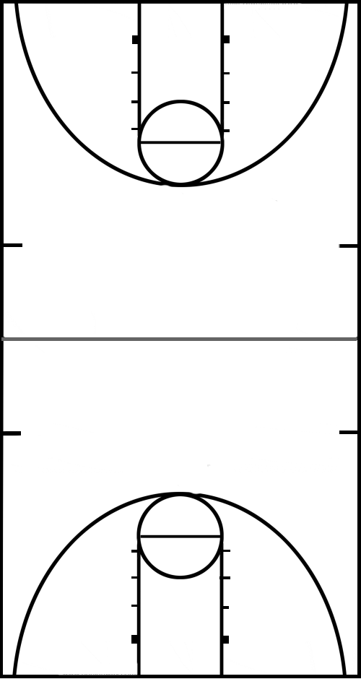

Diagram B

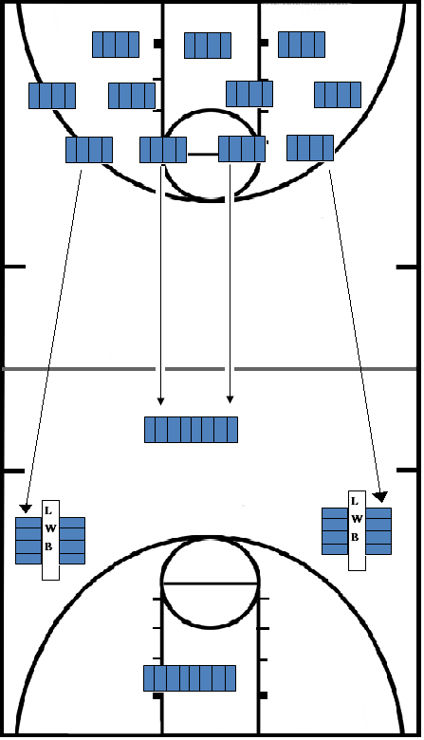

Diagram C
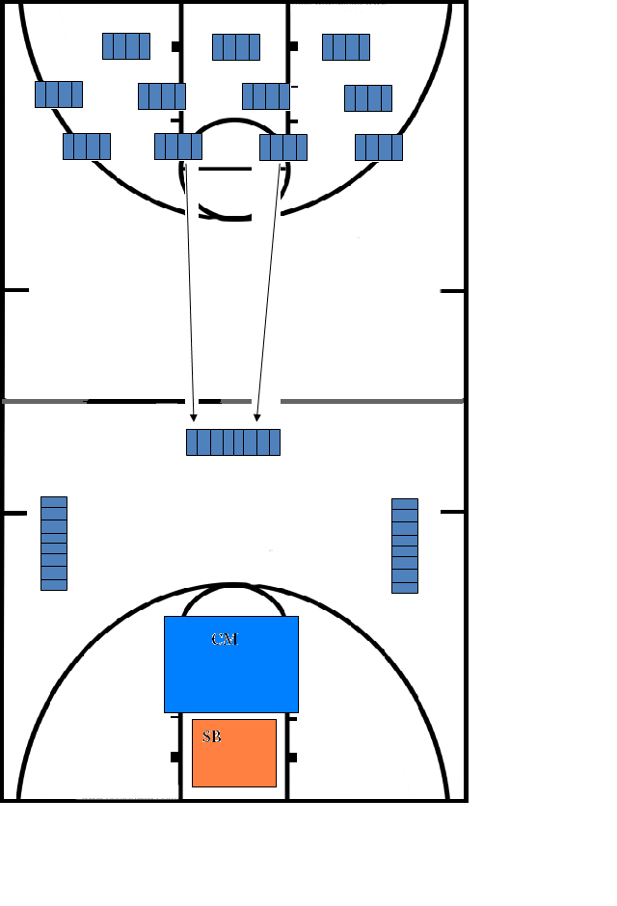

Diagram D
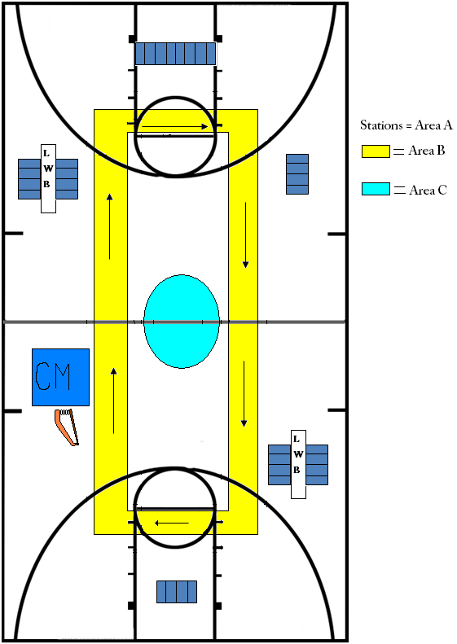
List of Unit Objectives and Outcomes
Day 1: The students will be assessed on their flexibility, balance, and body awareness to have a better understanding how to accommodate and challenge the needs of the children.
Day 2: By the end of day two, the students will be able to perform the mechanical toy, an upright balance, knee lifter, and bent/extended hip scale with 75% accuracy.
Day 3: By the end of day 3 the students will be able to perform high barrel roll, kangaroo hops, and cartwheels with 75% proficiency.
Day 4: By the end of day 4 the students will be able to perform the grapevine, the cross over, and the sidestep on the low wide beam with 80% proficiency.
Day 5: By the end of day 5 the students will be able to perform the back rocker, back balance, back shoulder roll, backward roll into straddle and pike on the accordion mats with 90% proficiency.
Day 6: By the end of day 6 the students will be able to perform the knee slapper, ankle kicker, straddle jump, star jump, and pike/ straddle jump with 75% proficiency.
Day 7: By the end of day 7 each student will be able to progressively perform ¼, ½, ¾, and full turns while using their arms for rotation with 90% proficiency.
Day 8: By the end of day 8 each student will be able to perform a head touch and tripod with 90% proficiency.
Day 9: By the end of day 9 the students will be able to perform a one knee up, double knee up, and a headstand with 75% proficiency.
Day 10: By day 10 the students will be able to perform a look behind, tip over roll, and a forward roll with 90% proficiency.

EALR’s
1.1: Develops motor skills and movement concepts as developmentally appropriate.
1.2: Acquires the knowledge and skills participate in a variety of developmentally appropriate physically activities.
1.4: Understands the concepts of skill-related fitness, and interprets information from feedback, evaluation, and self assessment in order to improve performance

NASPE
Standard 1: Demonstrates competency in motor skills and movement patterns needed to perform a variety of physical activities.
Standard 2: Demonstrates understanding of movement concepts, principles, strategies, and tactics as they apply to the learning and performance of physical activities.
Standard 4: Achieves and maintains a health-enhancing level of physical fitness.
Standard 5: Exhibits responsible personal and social behavior that respects self and others in physical activity settings.
Standard 6: Values physical activity for health, enjoyment, challenge, self-expression, and/or social interaction.

Scenario Description
Level: Elementary
Grade: 5th
Facility: 15 accordion mats, standard PE equipment, 1 springboard, 2 low wide beams, 1 crash mat
# of students: 8
Length of Class: 50 minutes
Special Considerations: There is one wangster. There is one child who is motorically delayed. There is one girl who hates to participate (gets drinks, doesn’t feel well, dressed inappropriately, etc.).
Turn in (hard copy AND ecopy):
- Unit grid (accounting for each day in the unit)
- Safety Concerns (general and specific)
- Considerations and strategies for students with special need
- Diagram of gym set-up
- One lesson plan
- List of unit objectives/outcomes
- List of EALRs for the unit
- List of NASPE standards for the unit
- Scenario description

*Provide copies of the grid for each member of the class (total of 9 copies) on the day of your presentation. You need to e-mail entire copy of the packet to Dr. Martin on the day of your presentation.

*Read course outline regarding this assignment!
You will teach an example lesson on:
Tuesday, December 8th, 10:30-12:30

