Globalization & the Writer

The Sport of Globalization: It’s a Home Run!
Posted on October 14, 2013 by kazzik450
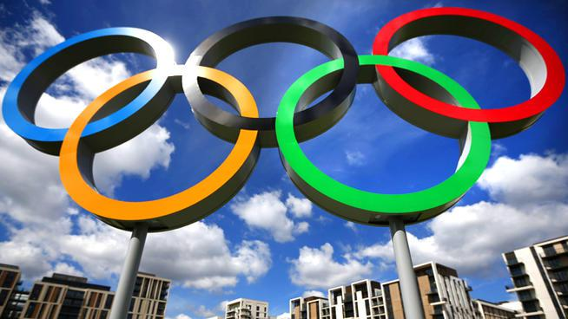
When people think about sports, they usually think about the professional teams of their cities. However, people never really notice the importance that it brings to globalization. The sporting industry is financially one of the top 10 industries globally. There are many sports in the world ranging from each countries preference. For example, in the United States, the main sports are usually baseball and football, while Canada’s main sport is hockey. Sports and competition are a universal concept going back to ancient times. In the United States alone, the sporting industry generates hundreds of billion dollars a year. In an article posted in 2012, it was stated that The National Basketball Association (NBA) generated approximately five billion dollars. Another article stated that the National Football League (NFL) generates approximately nine billion dollars yearly. Given those examples, people seem to forget about the business side of the sporting industry in comparison to the entertainment that people mostly focus on.
Basketball and soccer are primary examples of the globalization of sports because they are such a common “language” across the globe. They are such popular sports that if you go and visit any other country, people will most likely know and be very familiar with the sport. The NBA is a popular league across the globe due to the international players from many countries joining every year. We can see how people from Asia or Europe wear jerseys of American players, thus showing the interaction that the sport brings to everyone around the globe. In soccer, the World Cup is a huge event that every country enjoys. In an article about the 2010 World Cup, it stated that the approximate viewership of the event was 3.2 billion people around the world, which is 46.4 percent of the global population.
One of the greatest sporting events in the world’s history is the Olympics. The Olympics offer all the countries in the world an opportunity to join together as one as we celebrate the events. It allows all the countries to let aside their differences and join in a healthy competition as we all share a common goal of winning. A positive of hosting the Olympics is the attraction that brings many tourists from around the world to visit and watch the event. The attraction allows people from all over the world to visit and experience cultures of other countries. Another positive for hosting the Olympics is the economic factor that it brings. For example, it creates more jobs and brings in more money as people from all over the world come to witness the event. The Olympics are a huge economic booster for the host country. Speaking of the economic factor, the sports industry in general provides a great deal of job opportunities and consumerism that contribute to the global economy. Examples of jobs that are formed include team physicians, business management jobs, referees, engineers, and sport analysts. Even small businesses such as restaurants benefit from the sporting industry. Also big businesses, such as Nike and Adidas, greatly benefit from the sporting industry.
The sport industry is not only about entertainment, it also has an economic influence around the world. We see globalization being impacted positively as more people feel connected through the world of sports. Personally, when I visited the Middle East, I noticed people wearing Kobe Bryant and LeBron James jerseys, as well as Boston Red Sox and New York Yankees baseball caps. That really showed me how many people around the world can feel so connected with sports.
I want to know about how others feel about this topic. Is the growth of the sporting industry a good thing or a bad thing?
How much do sporting events, such as the Olympics, really affect globalization?
Do people really benefit from the sporting industry, other than the owners and players?

