Physics Chapter 9 and 10 Test
- Internal Energy is the energy of a substance due to the __________ ______________ of its component particles and equal to the ___________ __________________ of those particles. (4 Points)
- Match the terms with their definitions: (3 Points)
A. Rotational _____ Small fast movements, back in forth
B. Translational _____ Spinning Motion movement
C. Vibrational _____ Forward or Backward
- Define thermal equilibrium. (1 Point)

- Define expansion and contraction and give an example. (3 Points)

- Name the 5 phase changes and describe each one. (5 Points)

- Match the terms with their definitions. (3 Points)
A. Conduction ______ The process by which energy is transferred by heat
through a fluid, such as air.

B. Radiation ______ The process by which energy is transferred by the
sun.

C. Convection ______ The process by which energy is transferred by heat
through direct contact with another material between two
points of different temperatures.
- A thermodynamic process during which work is done but no energy is transferred as heat is called an __________________ process. (1 Point)
a. Isothermal b. Isovolumetric c. Adiabatic d. Entropy e. Cyclic
- _________________ is the measure of a system’s disorder. (1 Point)
a. Isothermal b. Isovolumetric c. Adiabatic d. Entropy e. Cyclic
- When the system’s temperature remains constant and the internal energy does not change when energy is transferred to or from the system as heat or work it is called an _______________ process. (1 Point)
a. Isothermal b. Isovolumetric c. Adiabatic d. Entropy e. Cyclic
- When a gas undergoes a change in temperature but no change in volume, no work is done. This is an _________________ process. (1 Point)
a. Isothermal b. Isovolumetric c. Adiabatic d. Entropy e. Cyclic
- Define the 1st and 2nd laws of thermodynamics. (4 Points)

- A thermodynamic process in which a system returns to the same conditions under which it started is called a ________________ process. (1 Point)
a. Isothermal b. Isovolumetric c. Adiabatic d. Entropy e. Cyclic
- What is ultimate “heat death” of the universe? (2 Points)

- List the 5 steps of how an internal combustion engine works. (5 points)

- What is the specific heat of a cup of coffee if it had heat energy of 64 Joules, mass of 16 kg, initial temperature of 74 degrees C and final temperature of 95 degrees C? (10 points)
Specific heat = heat energy / (m* (Tf-Ti))

- A 3 kg cup has an initial temperature of 73.4 degrees Celsius when it is submerged in 4 kg of water with an initial temperature of 62 degrees Celsius. What is the cup’s specific heat capacity if the final temperature is 92 degrees Celsius? Specific heat of water = 4186 J/kg x C. (10 points)
Specific heat water * mass water * (Tf-Ti) of water = Specific heat cup * mass cup * (Tf-Ti) of cup

- The temperature in England was 85 degrees Celsius. What is this temperature in Fahrenheit? (10 points)
Tf = (9/5*Tc) + 32

- The temperatures recently was 45 degrees Fahrenheit. Express this temperature in both Celsius and Kelvin. (10 points)
Tc = 5/9 (Tf-32) Tk = Tc +273

- A ball thrown into the air has a mass of 2.5 kg, is thrown to a height of 90 m, and has a velocity of 2.4 m/s. How much internal energy does the ball possess at the top of it’s path? (10 points)
m*g*h + .5*m*v² + internal energy = 0

- A basketball has a pressure of 9.5 x 10⁵ Pa. If the ball has a starting volume of 9 x 10⁻³ m³ and increases the volume to 1.9 x 10⁻² m³, how much work is done by the ball on the surrounding air? (10 points)
Work = pressure x (Vf-Vi)

- (1 Point)
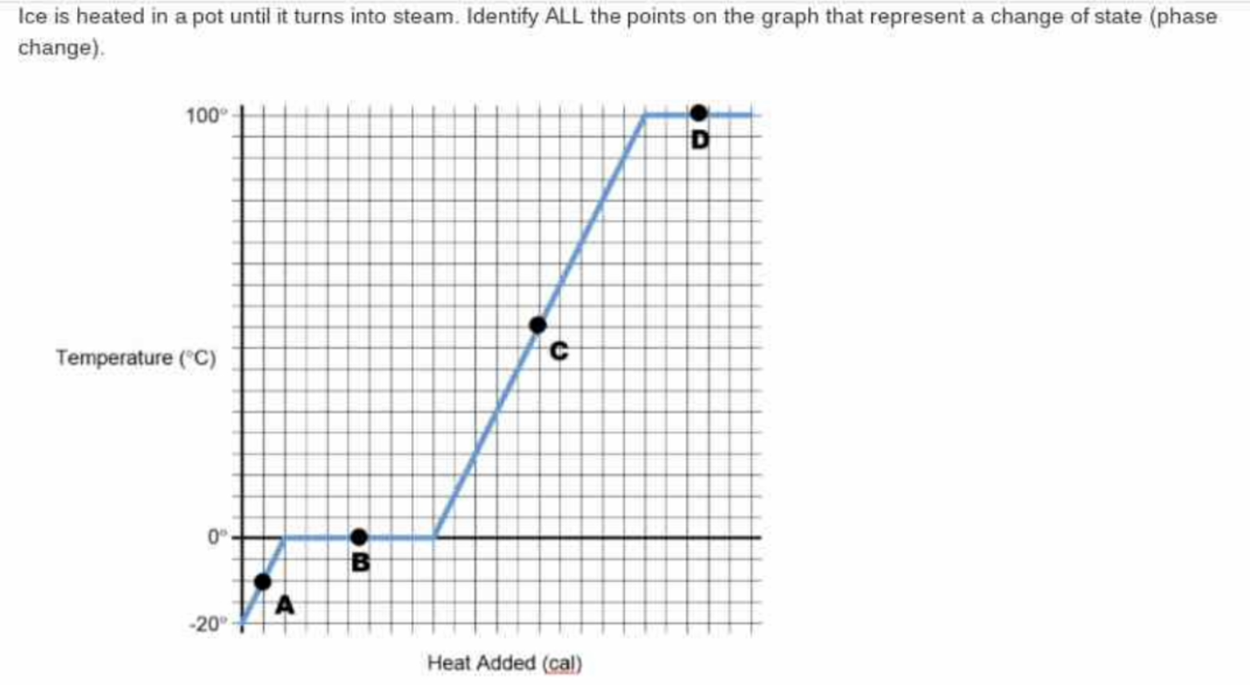
- What would the graph look like for the following: (2 Points)

