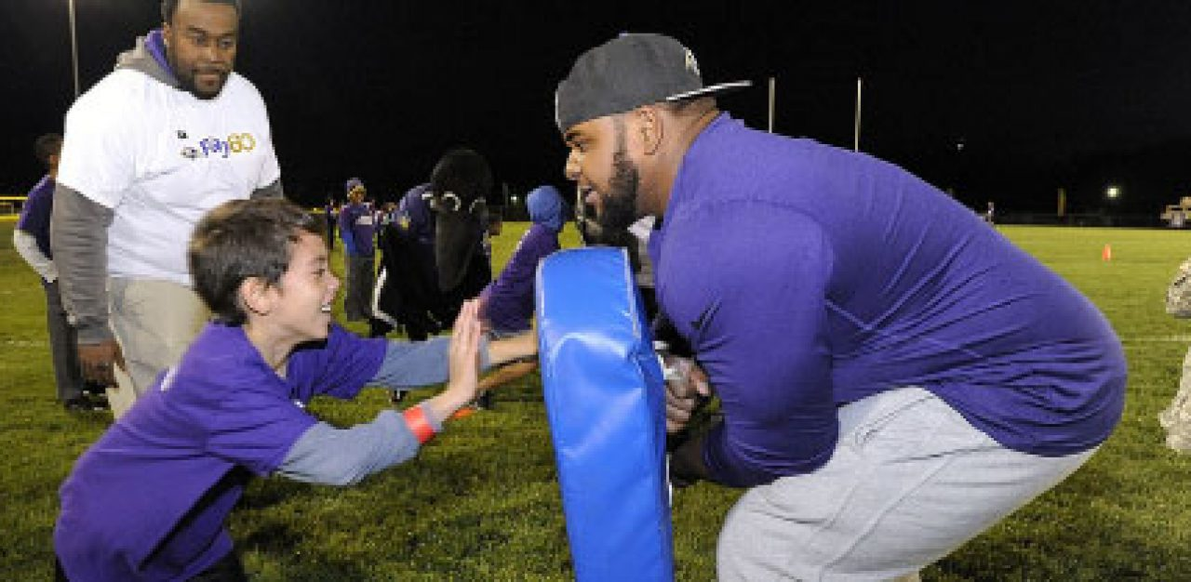

Yuhei Inoue, Ph.D.

Corporate Social Responsibility Strategy in Professional Sports
- Posted on Fri May 8, 2015
What is the role of a corporate social responsibility (CSR) strategy in professional sports? As a child growing up in Japan, sports had a profound impact on my life. By playing baseball, basketball and American football, I gained a newfound focus both as an athlete and a student. I learned valuable lessons about dedication and discipline that I’ve carried throughout my life. Because sports have always been so meaningful to me, I’ve spent my academic career studying the intersection of sports, business and society. I know that athletics improved my life, but can sports organizations truly make a difference in their communities? My research suggests that they can.

Championing Corporate Social Responsibility in Sports
The concept of corporate social responsibility has been around for decades. It’s also referred to as “corporate citizenship.” The basic premise is that corporations should act just as good as citizens do, by being mindful of how their practices affect the community around them and by engaging in and funding initiatives that aim to benefit society. Organizations should also hold themselves to high standards – even higher than what is required by law or government regulations. While this use of resources might seem at odds with the goal of higher profits, studies suggest that practicing CSR strategy can actually boost the bottom line.
Professional sports teams are unique in the business world. Despite being relatively small in comparison to many Fortune 500 corporations, they can generate huge revenues and are among the most visible and recognizable organizations in the world. Sports organizations connect with their customers and fans on a much deeper level than most corporations do; individuals often view their fandom as a core part of their identity. It’s this identification that puts sports teams and leagues in a unique position to advance positive social change in areas like education, health and sustainability.

Making A Difference
Each year, sports organizations launch initiatives to help their communities, from the NFL’s Play 60 campaign to promote exercise among children (and our own Minnesota Vikings’ drive to punt the junk) to the NBA’s Hoops for Troops military family assistance campaign. We’ve begun to study the effects that these effort have on fans and participants. So far, the results are encouraging.
The NFL’s Philadelphia Eagles’ Go Green program has had success in promoting environmental awareness and “green” behaviors like recycling among its fan base. It was launched alongside some major clean-energy renovations to its stadium, Lincoln Financial Field. In surveying Eagles fans, I found that the Go Green program was effective in increasing both environmental consciousness and eco-friendly activities like recycling.
The NBA’s Memphis Grizzlies have focused on childhood health and fitness with the team’s “Get Fit with the Grizzlies” campaign. As part of their health promotion efforts, the Grizzlies also partnered with Memphis Academy of Nutrition and Dietetics, The University of Memphis and the YMCA to create the Family Fitness Challenge. The Grizzlies funded the program, which provided health education, dietary consultations and personal fitness instructors to participants. Across the board, participants reported improvement in health factors like weight and diet. Many of the participants reported that the involvement of the Grizzlies and its players was a major motivational factor.
The benefits of these programs go both ways. Studies by other scholars have shown the positive effect of CSR on corporate reputation and patronage among fans of NFL teams. Data also revealed that spectators tended to evaluate the PGA Tour as more credible when they were aware of its CSR activities.

Three Signs Your Favorite Team Has A Successful CSR Strategy
While the benefits to the community and the teams themselves are clear, sports organizations must take the right approach if their corporate social responsibility efforts are to be effective. Here are the three ways to tell if your local team has a successful CSR strategy:
- It’s focused. While the impulse to give to as many worthy causes as possible is idealistic, in practice a sports organization is more able to affect real change by honing on one (or a small handful) of initiatives. This allows the team’s resources and the star power of its talent to be targeted more effectively.
- It’s involved. Money is important to any social cause, but the best CSR programs are built around real and meaningful participation by teams and their athletes. By getting out and working with the community, teams can build real connections with fans – and put the media spotlight on their cause.
- It’s consistent. CSR efforts are more effective if aligned with an organization’s mission and image. Health and fitness programs are a natural fit for professional sports and the Eagles’ “Go Green” campaign was in concert with the team’s signature color and its zero-waste, clean-energy renovation of Lincoln Financial Stadium.

