Chapter 15, 16, and 17
Physics Electricity Test
- Like charges ____________.

- Opposite charges ____________.

- Define a conductor and list 3 examples.

- Define an insulator and list 3 examples.

- Draw an electric field for two like charges and an electric field for two opposite charges.

- What is used to store electricity?

- If electricity is a drop of water and the flow of electricity is a river – which one is voltage and which one is current?

- Which is more dangerous; 10,000 volts or 120 amps? Why?

- What is AC? What is DC?

- Resistance depends on what 4 things?

- Draw a circuit schematic that includes a battery, wire, switch, and 3 bulbs in series. Label everything.

- Draw a circuit schematic that includes a battery, wire, switch, and 3 bulbs in parallel. Label everything.

- Define short circuit.

- 3 resistors, 16.75, 5.3, and 11.6. The resistors are joined in series. Calculate the resistance
R₁+R₂+R₃ = R_{total}

- A 120 V storage battery is connected to a resistor of 42. Calculate the current.
R = Voltage / Current

- Several light bulbs are connected in series across a 215 V source. What is the resistance if the current in the circuit is 11.7 A? Resistance = Voltage / Current

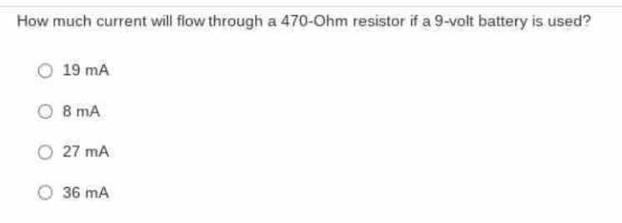
- Resistance = Voltage / Current

- Resistance = Voltage / Current
