 Name: ________________________________
OBA Art
AP Photography
Mrs. Russell

Earning Extra Income: Portraits
Chapter Fourteen: People

Read pages 181-195 in The Photographic Eye. Some answers will require internet research.
Type your answers and staple to this sheet.

The main purpose of portrait photography is to capture the essence of a person.
There are 4 different genres of portrait:
- Formal Portraits: Posed, serious, usually smiling, upper body or full body shots, subject is in a non-
natural location/position/circumstance. (ie. Senior photos)

- Casual Portraits: More relaxed, subject may or may not be smiling, may be a tighter close-up shot,
catches the mood of a subject, more natural choice of location/position.

- Personality Portraits: Fun shots, very cute, depicts the personality of the subject through facial
expressions or actions, can include “dressing up”.

- Environmental Portraits: The environment is shown, helps to give the whole story of who that person
is- you should consider both their primary role in life, as well as any other
persona they adopt on a regular basis.
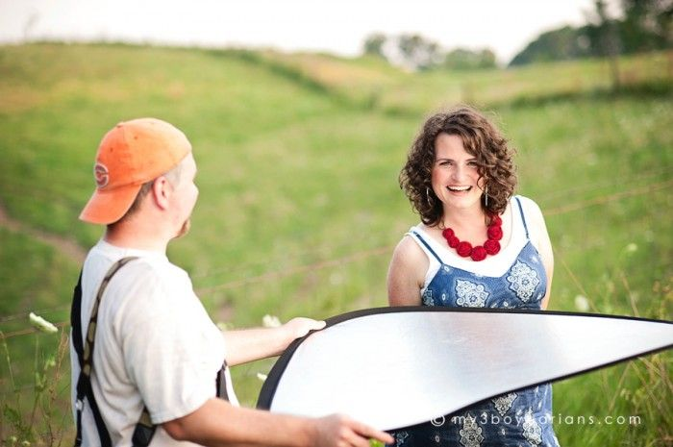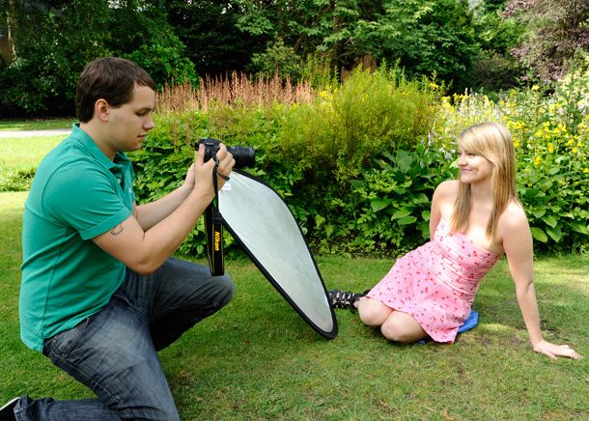
REFLECTORS:
- A reflector is simply a tool that reflects light. A reflector doesn’t create light like a flash does, it simply redirects the existing light. The primary purpose of reflectors is to fix shadows.
- TYPES OF REFLECTORS: White (light is nice and soft); Silver (light is brighter); Gold (warmer tones).
- REFLECTORS IN PORTRAIT PHOTOGRAPHY:
- Hold the reflector directly opposite the light source, you’ll get the most, or brightest, light.
- If the light is directly behind the subject, using a reflector in front of the subject will help prevent a silhouette.
- If the light is coming in from one side, using a reflector on the opposite side will help fill in the shadows.
- Laying the reflector on the ground in front of the subject when taking a portrait can help prevent under-eye shadows.
- If it impossible for you or the subject to hold a reflector, enlist help!
LIGHTING and SPECIAL EFFECTS:

Where do I get reflectors?
- Photography Supply Stores
- Use an automobile sun-visor
- Make one out of cardboard and aluminum foil

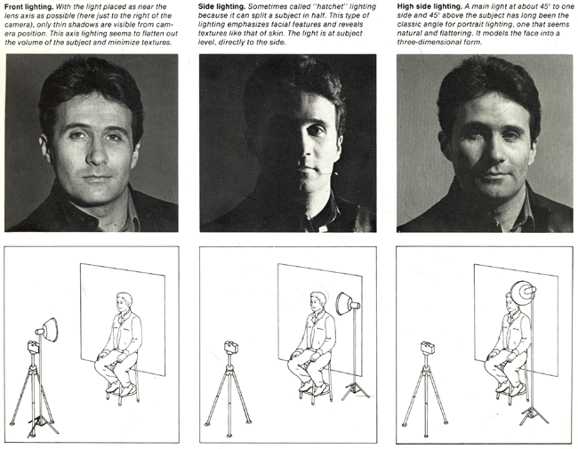

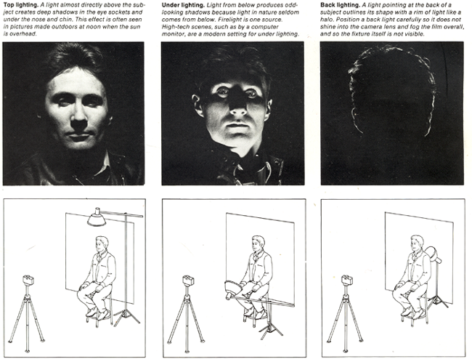

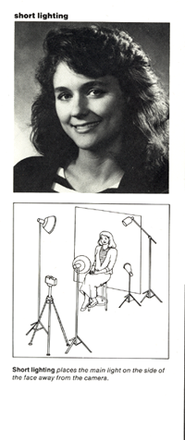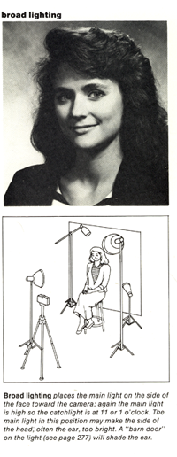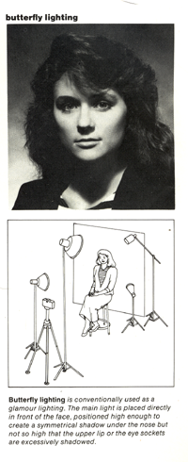

Notes for photographing portraits:

- You will need the cooperation of the subject. The photographs will be a joint venture between you and your subject.
- Know what you are planning to do before you do. Lighting, background, props etc. should be considered.
- Consider both head and shoulders and full view portraits.
- Consider whether the mood of the image is important. Mood can be altered by changing the lighting tones.

Clothing for Portrait Session:
Clothing can be key in a successful or unsuccessful portrait session. Tell your clients the following
recommendations for a timeless portrait :
- Wear solid color clothing (no logos, graphics, etc.)
- Choose 1-3 colors for a group portrait; coordinate but don’t match
- Adults, choose a top with sleeves
- Choose long pants for men; Choose a skirt that is longer than the knees for the ladies
- Choose dark socks and footwear
- Keep jewelry simple
- Do your hair how you normally style it (don’t plan on a new haircut, style, or color right
before a portrait session)
- Make sure the children are comfortable in their clothing and not pulling or scratching.
- Make sure your location complements the wardrobe.
- Children: If accessories are present, make sure they match the kid’s personality

- What are 3 things that a portrait should reveal?

- What is your first task as a portrait photographer?

- You should always be aware of the other’s person’s ____________.

- Your textbook states about having your subject recite the alphabet. Why?

- Who was one of the first demonstrate photography’s full potential for expressive portraiture?

- How did Edward Steichen change portraiture?

- What was created in 1905?

- What is the purpose of a reflector?

- You just took a photograph of a person but they have dark shadows under their eyes. What is the best solution to get rid of those?

- You just took a photograph of a person but he/she is too dark and it looks like a silhouette. What is the best solution in this scenario?

- Your client shows up to your photo shoot wearing an Under Armor t-shirt, lime green and purple polka dot shorts, neon pink sandals, and a straw beach hat. Your location is at an area hay field and barn. How would you handle this situation? What would your recommendation be?


Assignment
Take the following photographs: (Note: You cannot use any previous photographs taken for this class). All photograph files will be e-mailed to Mrs. Russell for grading.

LOCATION IS EVERYTHING. A bad location can be very distracting. You might have to “move” things around. Think about lighting. Think about poses (nothing “cheesy”). A successful portrait should be timeless and a happy memory for years to come.
- Take one Formal portrait of a person over the age of 40. Subject needs to be in “church” clothes. Make sure the surroundings fit the occasion. (A gym or a swimming pool might not be the best location for a photo shoot).
- Take one Personality portrait and one Casual portrait of a teenager (can be the same person). This would be two different styles of a senior photograph.
- Take one photograph of a child under the age of 8. Children can be hard to photograph. They might be goofy, not paying attention to the photographer. Be prepared to quack like a duck and act like a fool to get a smile.
- Read page 194 in your textbook. Take one Detail portrait. Only a portion of the face, if that, should be seen.
- Take one group photo (ie. Family). Must include more than 3 people. Again, this should be timeless.
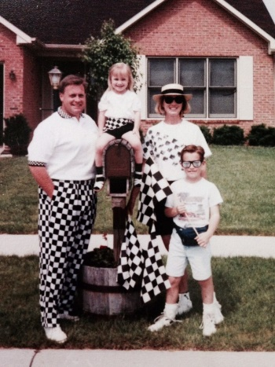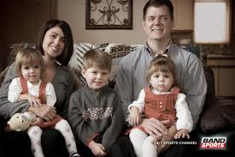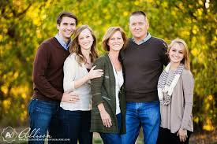
BAD DECENT GOOD
∙ The clothing is ∙ Clothing choice is better and coordinated, ∙ Clothing is coordinated and simple
very distracting. but with the positioning of the people, it is
hard to see the clothes.
∙ Awkward pose. ∙ Better pose but the background is distracting! ∙ Background is simple and not
distracting.
∙ Think of poses and ∙ Think about “breathing room” around the ∙ No unusual cropping and perfect
background. It family. Dad has his head cropped, mom amount of “breathing room.”
appears that the little has her elbow cropped, little boy’s fingers
girl has foliage growing are too close to the bottom, and there is too
from the top of her negative space on the right.
head.

- Choose a name for your photography business and create a “logo” for your photography business. (This is not a graphic design course, so this does not have to be fancy). Think of a special font, etc. Search different photographers and get ideas.
- Use this “logo” and create your own invoice, copyright release/contract and print release form. I’ve provided examples for you to look at. These forms should be e-mailed to me with the photographs. You can also look online to see other examples from other photographers.

