Cell (Cytology) Lab

Comparing Eukaryotic Animal and Plant Cells

Introduction

Do animal and plant cells differ? Although animal and plant cells have many structures in common such as a nucleus, cell membrane, and cytoplasm, they also have differences. For example, animal cells lack a cell wall made of cellulose (a sugar), plastids for storing sugar, pigments, and making glucose and a large vacuole for storing water/waste and giving support.
Epithelial cells from animals, such as those from inside of your cheek, and from plants, such as those from an onion peel, cover and protect the surfaces of tissues because of their flatten shapes. The porous nuclei, which contain DNA and a nucleolus, help to regulate the cell’s activities especially when it comes to making proteins. The membrane found in cells is made of proteins and phospholipids. If a cell wall is present, then that layer would be found outside the cell membrane, such as in plants and some bacteria. The cytoplasm surrounds all the organelles within the cell membrane and contains sugars, fats, proteins, and the cytoskeleton. Sometimes, the clear, large vacuoles of plant cells have a tendency to push the nucleus up against the cell membrane and displace the cytoplasm greatly. The hypothesis is that similarities and differences will be noted between animal and plant epithelial cells.

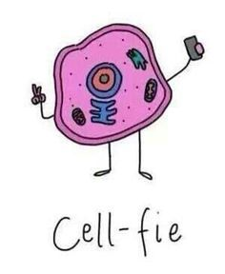

Procedure
“Cytoplasm”
Epithelial Animal Cells: Human Skin

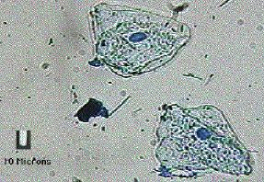Materials:
“Cell Membrane”

Microscope
“Nucleus”
Slide
Cover Slip
Toothpick (flat)
Lugol's Solution
References

Steps:

1. Place one (1) drop of Lugol's solution on the slide from the stock table then return to your table.

2. Obtain epithelium cells by gently scraping the inside of your (or partner's) cheek with a clean
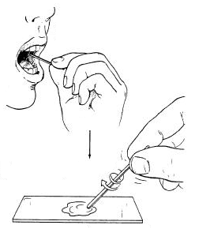
toothpick for about 60 seconds; use the flat end of the toothpick.

3. Stir the material from the toothpick in the drop of Lugol's on the
slide; you will not be able to see any cells until you use the
microscope. Then immediately throw the toothpick away.

4. Carefully place a cover slip on the slide. Examine the slide
under low power. Notice a cluster of “orange” cells; however,
focus on just one cell (separate from the cluster); adjust your
lighting and examine the cell under a higher power.

Result Questions: (See Result / Data Sheet to Place Your Answers On)

Hint: See background paragraph for many of the answers to the following questions:

1. In the box provided, Draw and Label (nucleus, cytoplasm, and cell membrane) of just one (1) cell as the cell
appears under your best highest possible power.
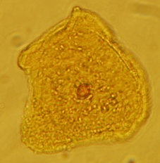
2. What shape best describes the cheek cells to be (triangular,
square, or irregular)?

3. Were you able to see any plastids and large vacuoles in
the cells? (Yes or No)

4. From what you noticed about the shape of the cells, what
type of function would these cells have?

5. Would you agree that an epithelial cell (ie skin cell) contains
the same number of mitochondria as a muscle cell and/or the
same amount of Golgi bodies as a salivary gland cell? (Yes or No)

Please be Checked by Instructor “Before” Moving on to the Next Procedure
Epithelial Plant Cells: Onion Peel

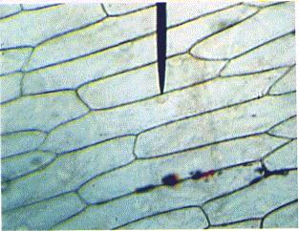
Materials:
“Cytoplasm”
“Nucleus”
Microscope
Slide

“Cell Wall”

Cover Slip
White Onion (sliced)
Lugol's Solution
Forceps
References

Steps:

1. Obtain an onion slice and forceps from the stock bowl and return to your table.

2. From the inner-concaved layer of the onion slice, use your finger-nails
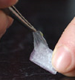
or forceps to peel the clear epidermal layer from the slice. Place on slide.

3. Add one (1) drop of Lugol's solution to the onion tissue. Note: Lugol’s
will stain skin and clothes. Place a cover slip on the sample at an angle.

4. Examine the slide under low power, then on a higher power if possible.
Adjust the diaphragm on your scope to for the best lighting.

5. Try to focus on one cell and note the cell wall, nucleus, and cytoplasm
(which may have small specks/bubbles/dots (organelles)) throughout the
cell.

Result Questions: (See Result / Data Sheet to Place Your Answers On)

Hint: See background paragraph for many of the answers to the following questions:

1. In the box provided, Draw and Label (nucleus, cytoplasm, and cell wall) of just one (1) cell as the cell appears
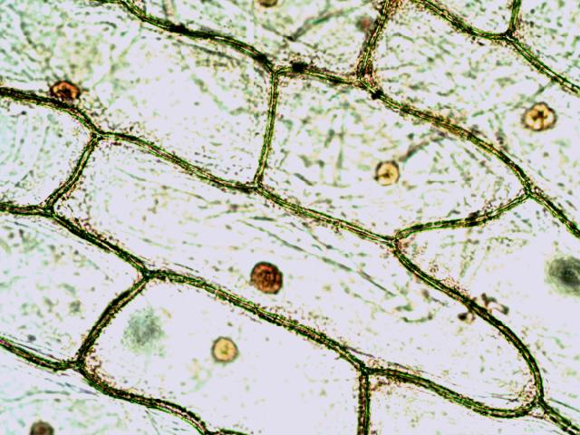
under your best highest possible power.

2. What shape best describes the onion cells to be (triangular,
circular, or rectangular)?

3. Do you see a cell wall that indicates that these are plant cells
and not animal cells? (Yes or No)

4. After adding the stain, a brownish-orange "circle" called a what,
which stores DNA for the cell, should be seen in each cell?

5. Some nuclei may be pushed up along the cell membrane by a transparent or clear organelle that stores mainly
water/waste called the what?

Please be Checked by Instructor “Before” Moving on to the Next Procedure

Extras

Epithelial Plant Cells and Chromoplast: Red Pepper

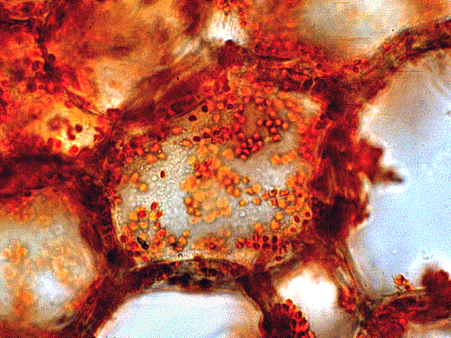
“Chromoplast”
(red)

Materials:
“Cytoplasm”
Microscope
Slide (no coverslip)
Red Pepper (sliced)
Razor Scalpel
“Cell Wall”
References

Steps:

1. Use a paper towel on the table and a razor scalpel carefully put the plant on the towel and cut a very thin slice
of skin off the fruit about the size of a dime; there should be no other tissue except the skin of the plant.

2. Place the skinned slice on a clean slide (no cover slip “and” no stain is needed).

3. Examine the skin along the edge where there will be less layers of tissue.

4. The boundary that you see around each cell is the cell wall (cell membrane; below the wall, is too thin to see
with the microscope). The numerous small, oval bodies are chromoplasts (not chloroplasts) that hold, in this
case, red pigments called “carotenoids”.

No Need to be Checked by Instructor Unless You have Questions

See Next Page
Epithelial Plant Cells and Leucoplast: Potato
“Cell Wall”
“Leucoplast” (contains starch)
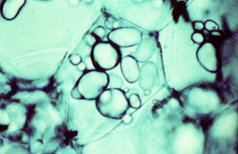
Materials:

Microscope
Slide (no coverslip)
Potato Cube
Razor blade or Scalpel

Steps:

1. Use a paper towel on the table and a razor scalpel carefully put the plant on the towel and cut a very thin slice
of potato off the plant about the size of a dime.

2. Place the skinned slice on a clean slide (no cover slip “and” no stain is needed).

3. Examine the skin along the edge where there will be less layers of tissue.

4. Starting with the lowest power, focus on the small round granules that look like small bubbles. The granules
are “leucoplasts” organelles that contain starch (sugar). Look carefully around the leucoplast and you will
see the clear yet thick cell walls of the potato cells.

No Need to be Checked by Instructor Unless You have Questions

See Next Page
Epithelial Plant Cells and Vacuole: Red Apple

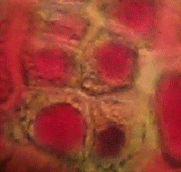
“Vacuole”
(contains anthocyanin (red pigment))

Materials:

Microscope
Slide (no coverslip)
Red Apple Skin
“Cell Wall”
Razor Blade or Scalpel

Steps:

1. Use a paper towel on the table and a razor scalpel carefully put the plant on the towel and cut a very thin slice
of skin off the fruit about the size of a dime; there should be no other tissue except the skin of the plant.

2. Place the skinned slice on a clean slide (no cover slip “and” no stain is needed).

3. Examine the skin along the edge where there will be less layers of tissue.

4. If done properly, a magnified fruit peel cell will show a “cell wall” and cytoplasmic region surrounding a
stained red “large vacuole”. The vacuole contains anthocyanin pigments, which have a red color to it; which
can take up more than 50% of the area of a cell. Not all vacuoles have pigments; but in this case they do
which makes it easier to see a vacuole.

No Need to be Checked by Instructor Unless You have Questions

First and Last Name:
Lab Practical: / 50 TBA

Cell (Cytology) Lab: Result / Data Sheet

Questions:

Animal: Human Epithelial Cells
Label: nucleus, cytoplasm, and cell membrane only

[One Cell Only]

1. Use Box for Drawing:

Draw Cell Here:

2.

3.

4.

5.

Plant: Onion Peel Epithelial Cells
Label: nucleus, cytoplasm, and cell wall only

[One Cell Only]

1. Use Box for Drawing:

Draw Cell Here:

2.

3.

4.

5.

First and Last Name: KEY
Lab Practical: 50 Points

Cell (Cytology) Lab: Result / Data Sheet

Animal Cells: Human Skin

1.
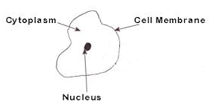
2.
IRREGULAR
3.
NO
4.
PROTECTION or TO COVER
5.
NO

Plant Cells: Onion Peel

1.
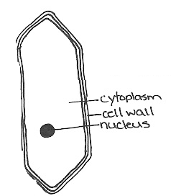

2.
RECTANGULAR
3.
YES
4.
NUCLEUS
5.
VACUOLE

Extras

Verify

