Cell Analogy Poster Project
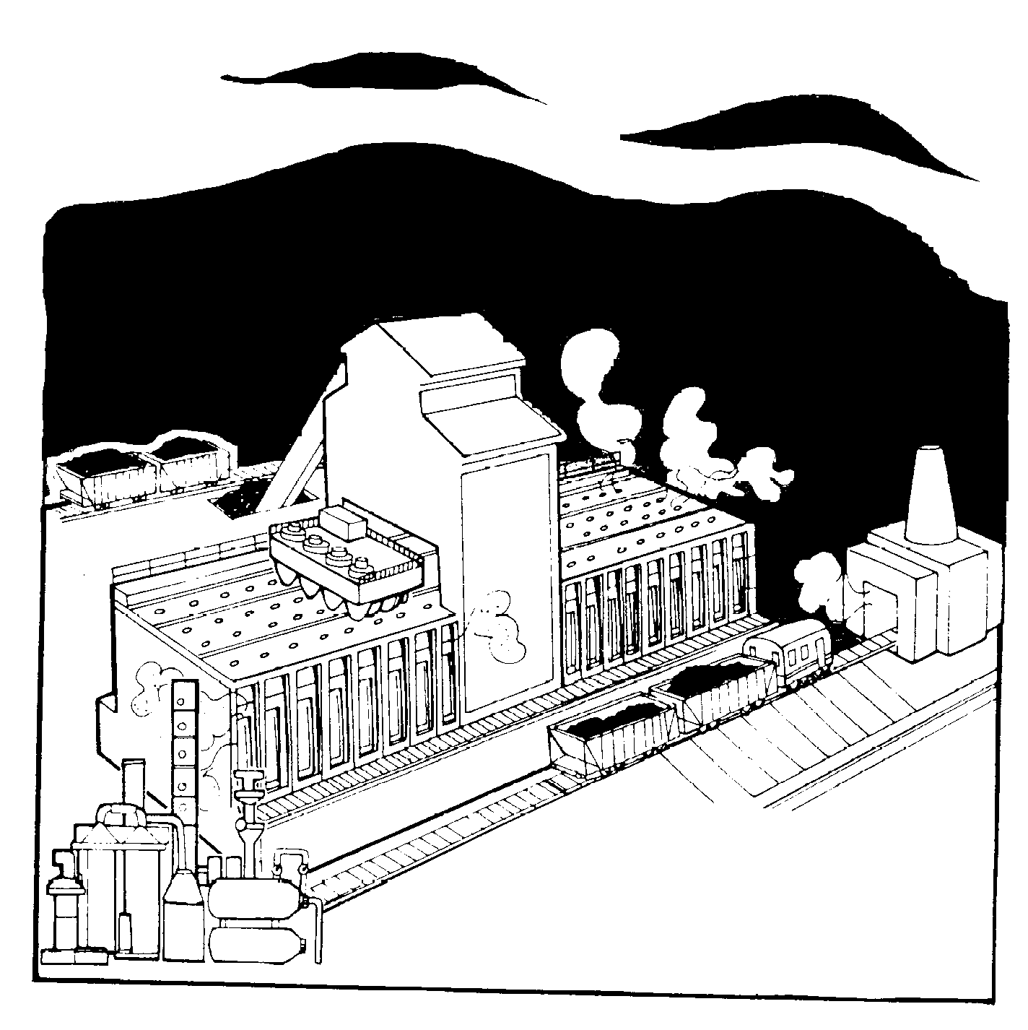
How is a cell like a factory?

Goals:
- To determine how a cell functions.
- To compare a cell and its organelles with a familiar
unit or system and its important smaller parts.

Background Information: An analogy is a comparison between two things, which are similar in some ways, but different in other ways. An analogy is a way of learning about something complex by comparing it point by point with something else that is more familiar to us. Analogies are often used to explain complex abstract concepts.
Cells are the basic units of life. They are very organized and are made up of many smaller structures called organelles. Each organelle has its own shape and function. Each cell, whether it is an organism unto itself like a single-celled organism or a part of a massive creature like a whale, accomplishes all of the tasks that keep an organism alive.
The most common analogy teachers use to describe the working of a cell is “The cell is like a factory.” As in a factory, the various parts of a cell make products that need to be produced, packaged, transported, and delivered to places inside or outside the cell. The factory needs energy to make its products, and it needs blueprints to guide production.
Your goal in this project will be to create a cell analogy poster to show how a cell and its organelles can be compared to a system or unit you are familiar with.

Procedure:
- Draw a picture of either a plant or animal cell in the center of an 18 X 24 inch white sheet of drawing paper. Use pages 26 and 27 in your textbook as a resource for your drawing. Your cell should be about the size of your fist. Follow the procedure for creating a biological drawing to label the main parts of your cell. These parts should include :
- nucleus
- chromosomes
- vacuoles
- mitochondria
- endoplasmic reticuli (ER)
- cell membrane
- cytoplasm
- ribosomes
- Golgi bodies
- lysosomes
- chloroplasts (for plant cells only)
- cell wall (for plant cells only)

- Think of a good analogy for your cell. Some examples are: A cell is like a firehouse or a police station. A cell is like a house. A cell is like a mall, an airport, or a cruise ship. A cell is like a city. A cell is like a car. A cell is like a school. There are lots more!
- Write the title on the top of the drawing paper: A Cell is like a ________. Fill in the blank with the name of the analogy unit or system that you will compare your cell and its parts (car, town, house, etc.).

- Write your name and your core number in the lower right hand corner of your paper.

- Next to each cell part explain what part of your analogy the cell part is like using complete sentences. For example, in the factory analogy, “A mitochondrion is like the power plant or generator of a factory. It creates the energy to run the factory from fuel.

- Draw pictures of each of the analogy parts next to their descriptions. For example, a motor could be pasted or drawn next to your description of a mitochondrion. You may also cut out pictures from the internet, magazines, and/or newspapers for a collage effect.

This poster project is due on __________________.

Example:

A Cell is Like a Factory

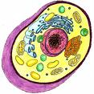
The ER is like the aisles of the factory florr. They are the pathways for moving things around.
The mitochondrion is like the engine room of the factory.
The Golgi body is like the shipping department wher items are packaged to be sent out.
The nucleus is like the manager’s office. It controls what goes on.

Name: ______________

