CD Spinning Top – Angular Motion
Materials:
Pencil, CDs, Duct Tape, Hot Glue, Timer

Procedure:
- Place a pencil through the hole in a CD.
- Tape and/or hot glue the pencil into place.
- Give the pencil and CD a spin like you would a top.
- If your top does not spin well, re-tape the pencil to correct the problem.
- The lower the CD, the more balance the top will have.
- Tape the CD low enough for the top to spin successfully.
- Spin the top and record the amount of time it remains spinning. Repeat the spin several times using different partners. Record each time.

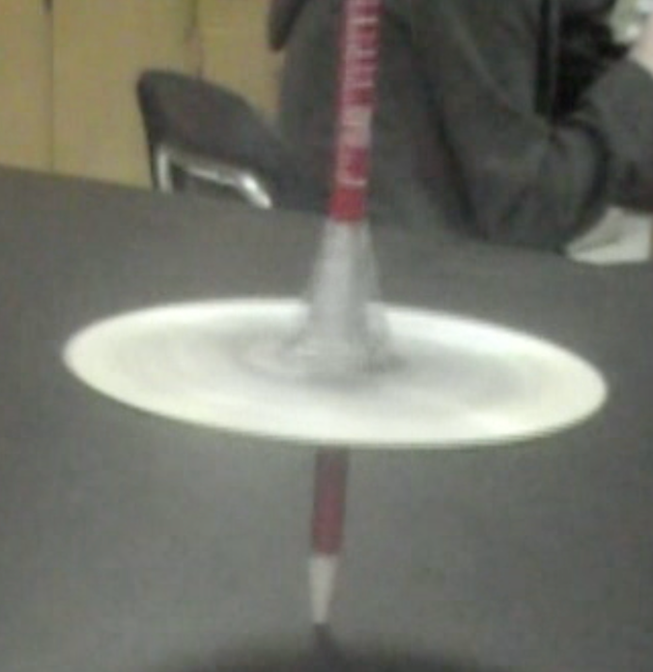

Time __________________________

Time __________________________

Time __________________________

- Build a spinning top that will spin the longest time.
- Practice spinning it until you get really good at it.
- Have each partner spin and time it.
- Whichever partner spins the best, that person will compete.
- The last part of class we will compete!

