CBL Friction Lab - Weight
Materials
1 wood block
5 Weights
String
CBL
Force Probe

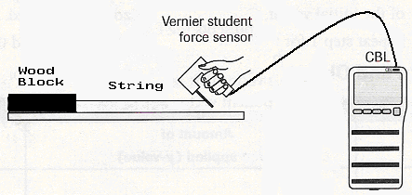

Procedure:
- Place a thumb tack on the end of a piece of wood.
- Tie a piece of string to the thumb tack.
- Tie the Force Probe to the other end of the string.
- Place the wood flat on a table and use the Force Probe to slowly drag the wood. Record the force from the scale needed to start the dragging of the wood. *** Make sure you pull the scale parallel to the table! No angle!!!
- Place 1 weight on the wood piece and repeat the experiment. Record.
- Place 2 weights, 3 weights, 4 weights, and finally 5 weights on the wood. Record your results each time.

Data:
Measured Force of Friction

No Weights ________

1 Weight ________

2 Weights ________

3 Weights ________

4 Weight ________

5 Weights ________

Conclusion:
- What happened to the frictional force when weights were added? Why do you think this is true?

- When was the greatest force needed to move the wood? Why do you think this is true?

- Use your data recorded and predict what you think the frictional force would be if you added 6 weights and then 10 weights.

Graph your results below:

