CBL Force Lab - Angles
Materials:
Meterstick
Protractor
Tape
Book
String
Scissors
Xplorer GLX
Force Probe

Procedure:
- Cut the string to a length of about 10 cm. Tape one end of the string to the textbook as the picture shows. Tie the other end of the string to the force probe end.
- Determine an angle of 45 degrees above the horizontal (look at picture).
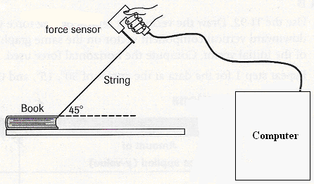
- Make sure the force sensor is connected to the GLX and the GLX is connected to the computer. Double click the icon on the computer screen that says “Data Studio”.
- Place the book at one end of the table. Hold the force sensor on it’s side so that when you pull the book, the metal rod will be pulled. Make sure you are at a 45 degree angle.
- On the computer screen, push start. One partner should watch the screen as it begins recording, while the other partner very slowly and with a constant speed pulls the book across the table.
- The graph on the screen should be a relatively flat line since you pulled with a constant force and speed. If not repeat the experiment with a more constant speed and force.
- Record the average force pulled below and repeat with an angle of 30, 15, and 0.

Data:

45 º 30 º 15 º 0 º

Force _______ _______ _______ _______

Conclusion:

- Use the angle, the average force, and Trig to find what the X and Y component for each force was?
45 Degrees 30 Degrees 15 degrees 0/360 Degrees

X = ______ X = ______ X = ______ X = ______

Y = ______ Y = ______ Y = ______ Y = ______
Now, review the horizontal force for each total force for each angle. What pattern do you see?

- Since you know which angle takes the greatest force to move a book, at what angle would it best to push a large crate across a floor?

- Would the force you apply while pulling at a 30 º angle be identical to the force if you pulled at a -30 º angle? Why or why not?

- Review your data. How difficult do you think it would be to pull the book if the force were applied at 60 º?

