CARTESIAN DIVER
MATERIALS:
2 liter bottle with cap
Eyedroppers
Beaker
Water
Wire
Blow Dryer
Nuts

PROCEDURE:
- Fill one of the eyedroppers about 2/3 full of water and put it in the beaker. The eyedropper should barely float in the water (the top of the eye dropper should be just above the surface of the water, if not adjust the water level in the eyedropper). Next, wrap a piece of wire around the neck of the eyedropper and bend the wire into a hook (see picture).
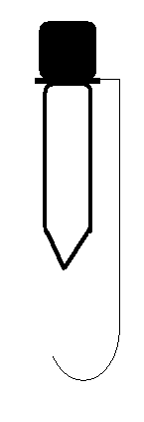
- Fill the other eyedropper full of water and put it in the beaker. The eyedropper should sink to about half way. Attach a piece of wire onto the eyedropper into a shape of an O.
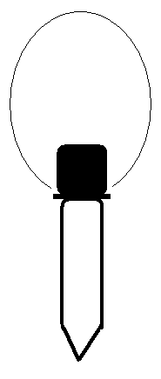
- Fill the 2-liter bottle full of water.

- Put both of the droppers into the 2-liter and screw on the cap. Be sure the hook diver floats and the O diver sinks partially before putting on the cap.

- Squeeze the sides of the bottle. Release the sides and observe what happens.

- Watch what happens to the air bubble in the dropper. Notice the size of bubbles when squeezing and not squeezing.

- Try and use the hook diver to hook the O diver.

PROCEDURE 2:
- Use the blow dryer to heat the water inside the 2-liter.

- Repeat the experiment and notice if there is any difference in the buoyancy of the eyedropper and size of the air bubble.

PROCEDURE 3:
- Number 5 droppers with a permanent marker. Fill the number one with as much water as possible that still allows the dropper to float. Fill #2 with a little less water than the first. Continue this until dropper #5 has almost no water.

- Place all five droppers in the bottle and put on the cap. Complete the data table.
Data Table:
Amount of water in dropper Amount of pressure needed to move dropper
Empty (no water in dropper) _______________________________________
¼ full ________________________________________
½ full ________________________________________
¾ full ________________________________________
Completely full ________________________________________
CONCLUSION
- Why does the diver drop when you squeeze the bottle?

- Why do the bubbles change sizes when you squeeze?

- What happened when we heated the water in the 2 liter before doing the experiment? Why do you think this happened?

- What amount of water in the dropper was the easiest to make rise and fall? Why do you think this is?

- What amount of water in the dropper was the hardest to make rise and fall? Why do you think this is?

- What happened to the volume of gas in the dropper when the bottle was squeezed?

- What happened to the water level in the dropper when the bottle was squeezed?

- What happened to the water level in the dropper when you stopped squeezing the bottle?

- How does this experiment explain Pascal’s Principle?

