Cardio Cards
Shuffle a deck of cards. Draw the cards and use the sheet below to perform the appropriate exercises. King, Queen, Jacks, and Aces have specific exercises no matter the suite. Hearts, Diamonds, Spades, and Clubs perform the number associated with the exercise. Exercise for 20 minutes and drink water when needed
Have fun!

 Hearts: Push Ups
 Diamonds: Mountain Climbers
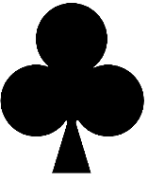 Clubs: Curl ups / Sit ups
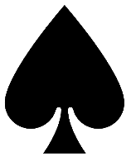 Spades: Squats
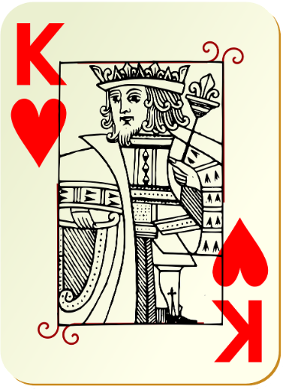 King: 10 Criss Cross Touch
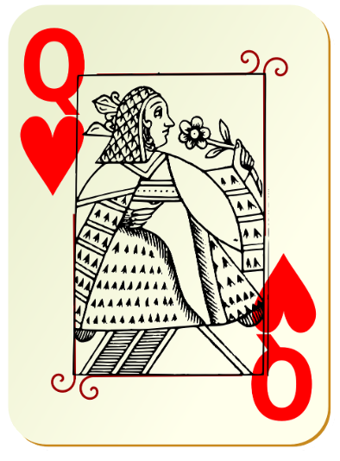 Queen: 20 Windmills
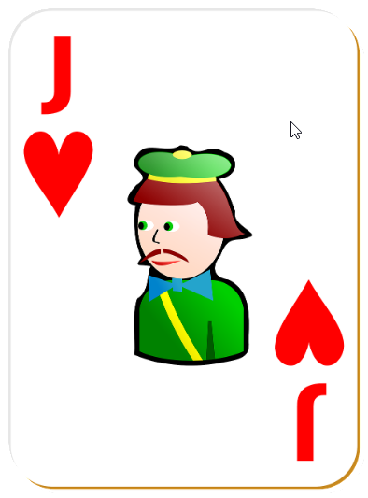 Jacks: 20 Jumping Jacks
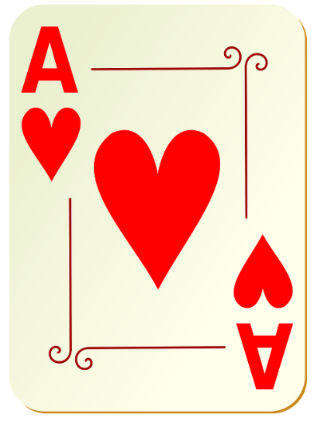 Ace: Jog in Place for 1 minute
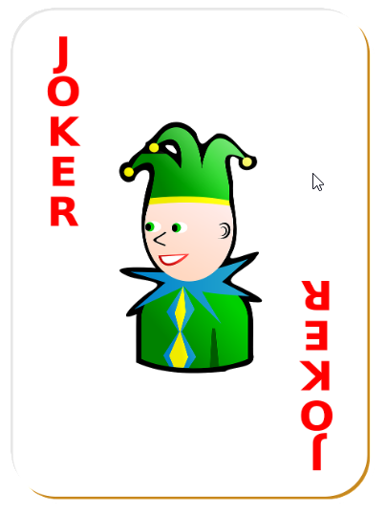 Joker: Your Choice

