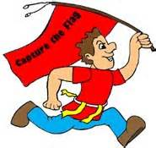
ACTIVITY: Capture the Flag

GROUP TOPIC: Teamwork/Sportsmanship

GROUP FOCUS: To work as a team to capture the flag

MATERIALS:

2 hula hoops
2 bandanas for flags

GROUP DESCRIPTION: Divide the group in to two teams. At the far side of each team’s section of field place the flag inside the hula hoop. Explain that the goal is to get the opposing team’s flag back into your team’s “territory” When you cross into the opposing team’s territory they can tag you to get you out. If you are inside the hula hoop you are safe and cannot be tagged out. You can toss the flag to a teammate to be carried back into your territory. The match is won when you successfully get the opposing team’s flag across the center line into your team’s territory.

POSSIBLE DISCUSSION QUESTIONS:
1. Why is teamwork important?
2. Did your team have a strategy for winning?
3. Who stood out as a leader/ team captain?
4. What is the importance of sportsmanship when playing competitive games?
5. When can teamwork/sportsmanship be used in everyday life?

***Precaution***
***Proper footwear is required for safety reasons***

