Closing Activities

To help calm the students down to prepare them for going back to a classroom environment I always end my classes with five minutes of yoga. The following are some of the resources I have used.
- Yoga Kids ABC’s 2 DVD by Marsha Wenig
- Yoga Kids Silly to Calm 3 DVD by Marsh Wenig
- The Kid’s Yoga Deck by Annie Buckley
- Yoga Kids Educating the Whole Child Through Yoga by Marsha Wenig
- I Can’t Believe It’s Yoga for Kids by lisa Trivell
- Yoga for Kids by liz lark
- My Daddy is a Pretzel by Baron Baptiste
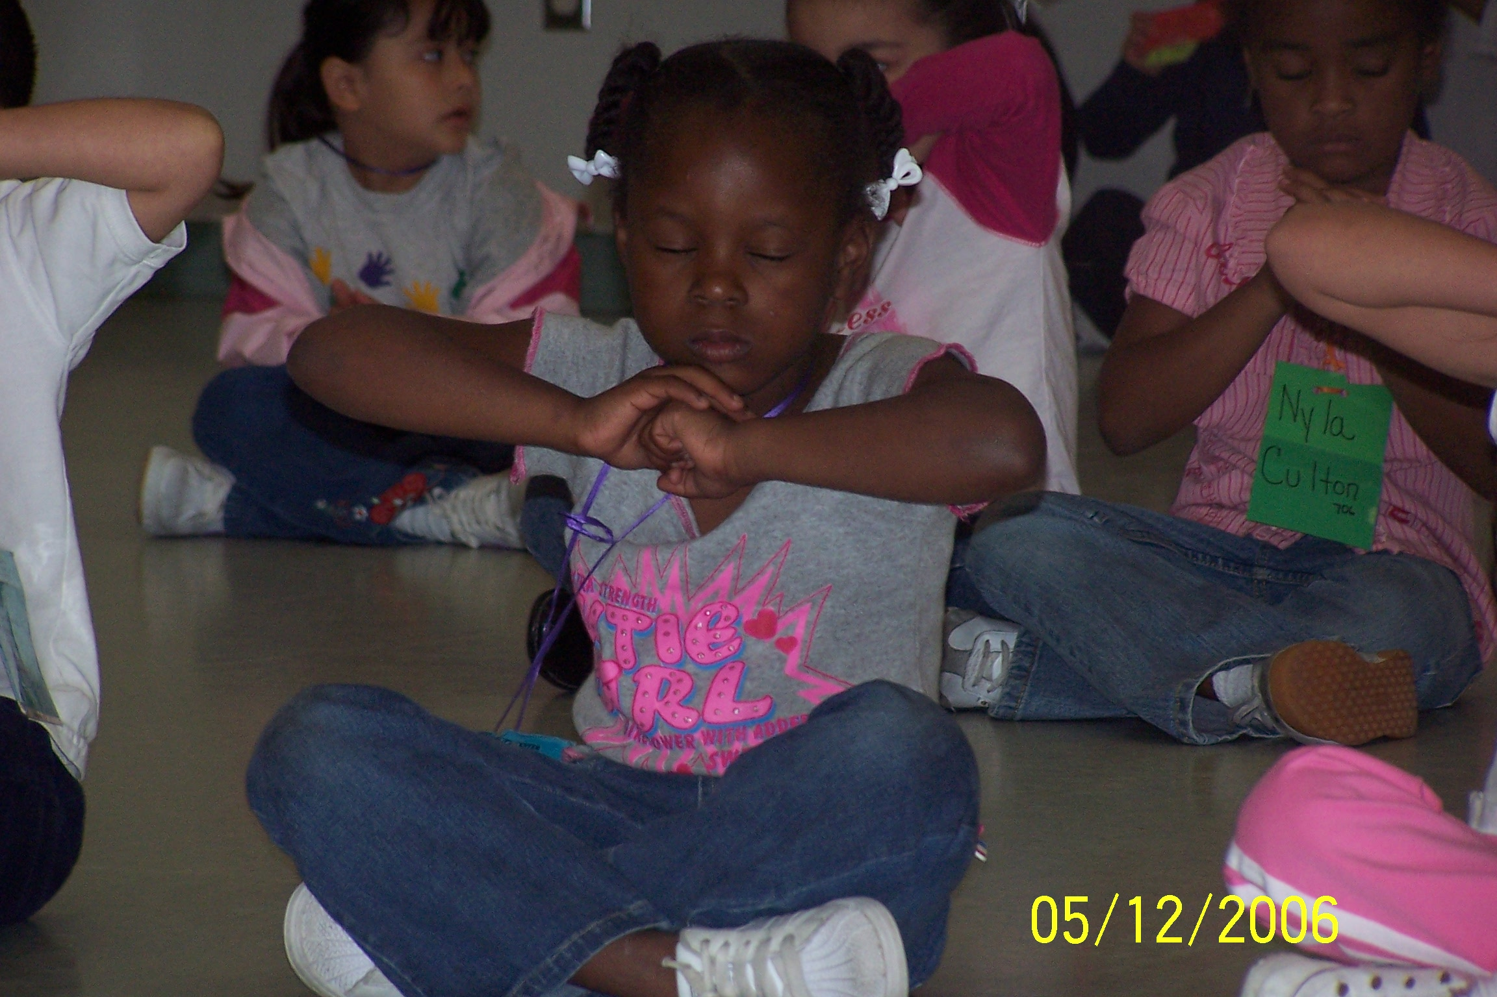

Zoo animal exercises- I also have pictures of different animals that I got from calendars at the dollar store. Below are the movements I do with each animal.
- Tiger, lion, cat, dog, pig, wolf- start in the standing position, move down to the floor on hands and knees and roar out the appropriate sound. Stand back up and say “One” and do it again.
- Alligator- start in the standing position and lie down on the floor stretching arms over head using them to pretend to be the alligator’s mouth and roar. Stand up and count and do it again.
- Giraffe- squat down; rise up on toes stretching hand over head using them to pretend to be the neck and head of the giraffe. Squat down and do it again.
- Seal- start in the standing position, lie down and push shoulders and head up off floor, bark like a seal. Stand up and do it again.
- Penguin- squat down, raise up with hands close to side and waddle like a penguin. Squat down and do it again.
- Turtle- start in the standing position, touch hands to floor spreading hands and legs wide, and don’t let your belly touch the floor. Stand up and do it again.
- Snake- start in the standing position and lie on the floor with arms at side, wiggle and hiss. Stand up and do it again.
- Duck- start in the standing position, squat, quack and flap. Stand up and do it again.
- Monkey, Gorilla- squat down, pop up and act like a monkey. Squat down and do it again.
- Elephant- start in the standing position, clasp hands and stretch over head, trumpet like an elephant. Stand up and do it again.
- Bear- squat down, stretch up with hand forming claws and growl. Squat down and do it again.

Pre-K TEKS- Physical Development 1A, 1B, 1C, 1D, 1E, 1F; Mathematics 1B; Language 1A, 1B, 1C
Kindergarten TEKS- Physical Education 1A, 1B, 1C, 1D, 1F, 2A, 2b, 3B, 3C, 6A, 6B, 7A, 7b, 7C

