Calculating Speed from Skid Marks
Background:
Police are able to use the friction sled and the length of the skid marks to estimate a driver’s speed.

“Speed from skid Mark” equation: Speed (mph) = √(30 x friction x distance)
Distance = feet
Friction = drag factor = pulled force / weight

Procedure:
- Measure the length of each skid mark (in feet) and record the distance.

- Divide the total length of the skid marks by the number of skid marks measured to find the average length.
Example:
Left front skid mark: 30 ft
Right front skid mark: 30 ft
Left rear skid mark: 20 ft
Right rear skid mark: 26 ft
Total = 106 ft / 4 = 26.5 feet

- Use the drag sled to calculate the pulling force and finally the friction of the road. Be sure and pull the drag sled next to the skid mark and in the same direction as the skid mark.

- Repeat the above procedure for all 4 of the skid marks. For skip marks, measure the length of each skid mark and add the total for each skid mark. See example:
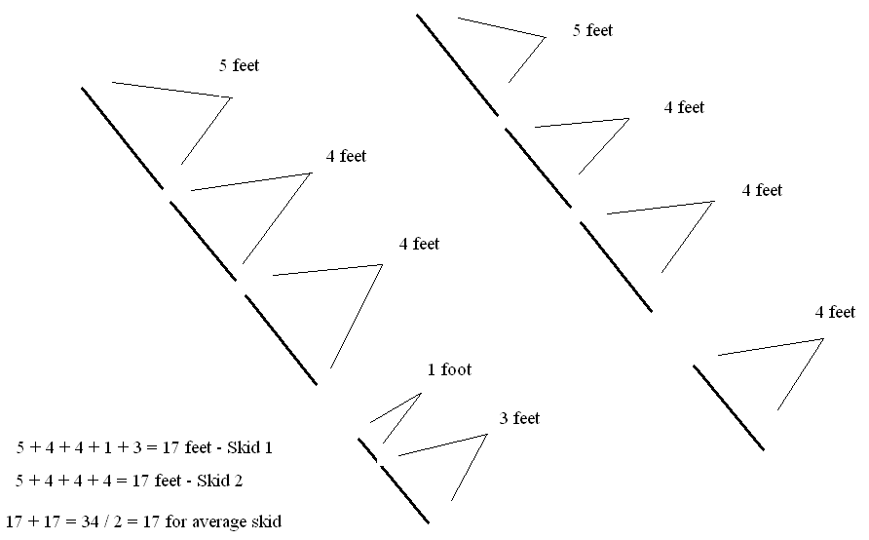

Data Table:
Distance of skid (feet) Pulling Force Friction = Pulling force / weight of drag sled
Skid 1 _____________ ______ ___________________________
Skid 2 _____________ ______ ___________________________
Skid 3 _____________ ______ ___________________________
Skid 4 _____________ ______ ___________________________
Skid 5 _____________ ______ ___________________________

Data Table 2: Speed
Speed (mph) = √(30 x friction x distance)

Speed of car in skid 1 __________________________

Speed of car in skid 2 __________________________

Speed of car in skid 3 __________________________

Speed of car in skid 4 __________________________

Speed of car in skid 5 __________________________

Conclusion:

1. What are 3 things that need to be considered when using the drag sled to measure friction of the road for a skid mark and speed estimation?

2. What causes skid marks?

3. What causes skipped skid marks?

4. Why do skid marks get darker as the car continues to skid?

5. Is the drag factor or friction of the road always the same? Why?

6. Do skid marks for one car all have to be the same length? What causes skid marks to be different lengths?

7. Which do you think has greater friction, slipping only or slipping and skipping? Which is better for breaking? What is this an example of?

