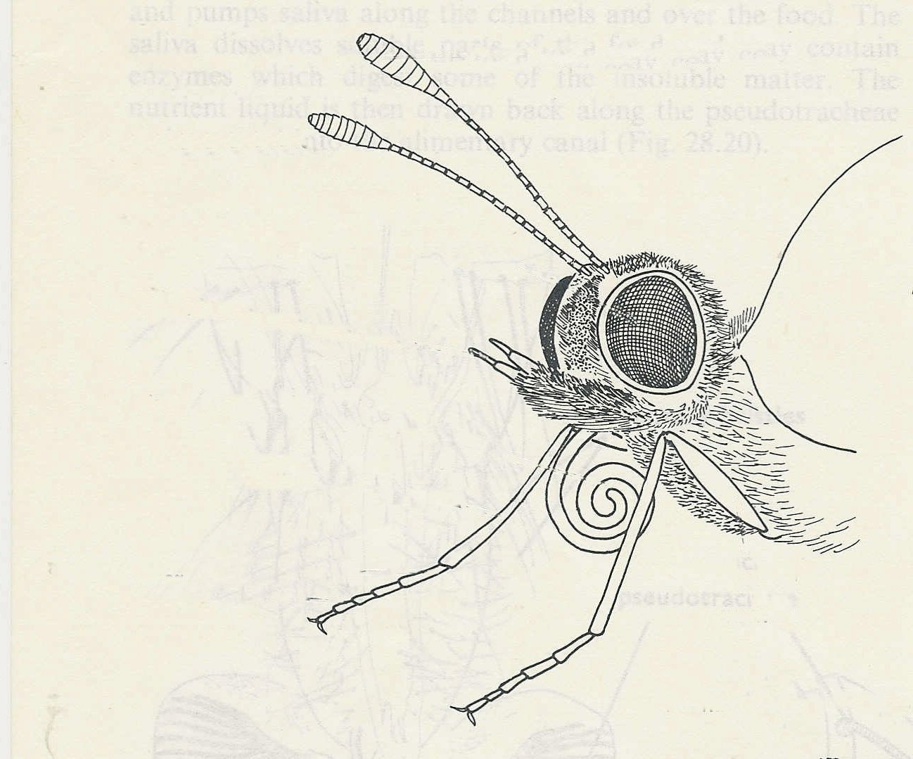
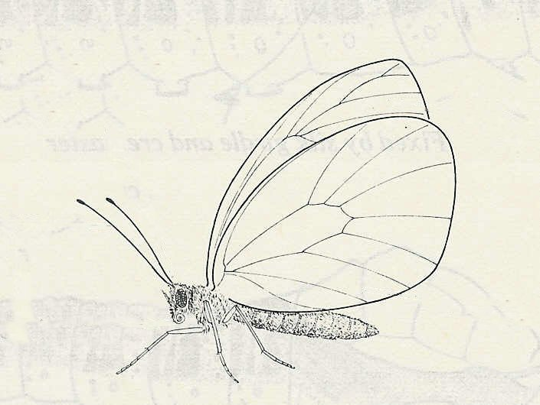
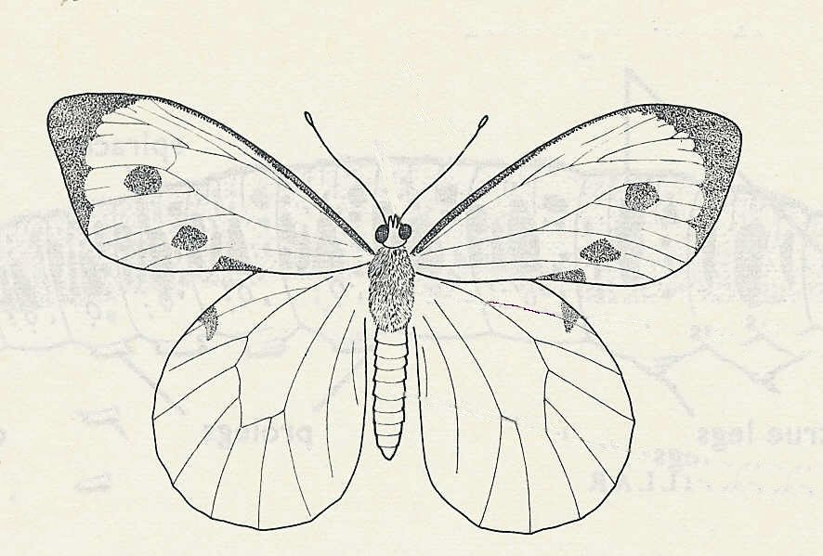
The Large White butterfly feeds on nectar from flowers using its long tubular proboscis.
It is attracted to the flowers by their colour and scent. The antennae are the organs of smell.

fore-wing
hind wing
antenna
thorax
abdomen
compound eye
fore-wing
hind wing
antenna
At rest, the butterfly folds its wings upwards.

In flight. both wings beat in unison.

The compound eyes consist of
thousands of separate lenses with light-sensitive cells beneath them.
proboscis
abdomen
The proboscis is like a flexible drinking straw. It is kept coiled beneath the head, but when the butterfly feeds, it is extended to form a long tube which reaches to the nectaries inside the flower, and sucks up nectar
antenna
compound eye
proboscis
The butterfly lays its eggs on the plant that the caterpillar will feed on
© D.G. Mackean

