AP Physics – Buoyant About Life Lab
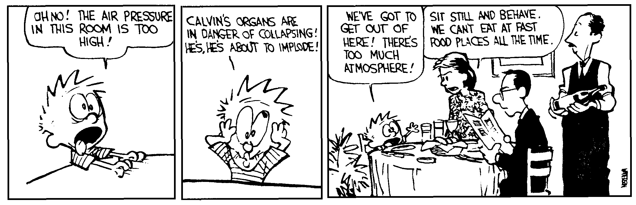
If a man will begin with certainties, he shall end in doubts; but if he will be content to begin in doubts,
he shall end in certainties. -- Francis Bacon

Come up with a lab that will confirm the buoyant force equation.

May the buoyant force be with you.

