AP Physics – El Projo Lab
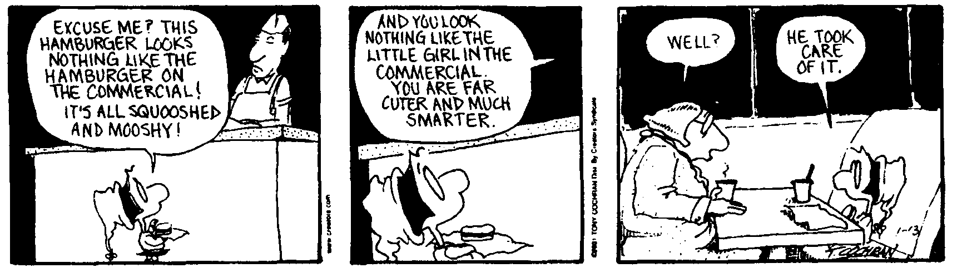
To believe all men honest would be folly. To believe none so is something worse. -- John Quincy Adams

Basic idea: A steel ball will roll down a ramp and into a pan set on the deck.

Required Gear: 1. Steel ball (supplied by the beloved Physics Kahuna on request)
- Aluminum channel
- Meter stick
- Protractor
- Metal pan (supplied by the beloved Physics Kahuna on request)

Discussion: The ball is placed at point A some distance d from the lower end of the ramp (B). When released, the ball will accelerate along the ramp from point A to point B a distance of d. From point B to point C it will travel at, for all practical purposes, a constant speed, at C it will begin to fall.

You need to determine the distance d up the ramp that you want to use as the start point. This can be any value that you desire. The Physics Kahuna suggests that it should not be a short distance (this would require a very steep angle). Anyway, based on that position, you will then calculate the angle θ needed so that the ball will land in a pan placed on the deck. The center of this pan will be set 65 cm from the top edge of the lab tabletop.

Once you have determined your point A, calculated the angle, and set up the ramp, notify the Physics Kahuna that you are ready to make your try. The Physics Kahuna will then issue you a steel ball, observe your attempt, and see if the balls do land in the pan.

You get one shot at the pan, so do your calculations carefully.

Good luck.

