Name(s)_____________________________________ Date________________ Period ______
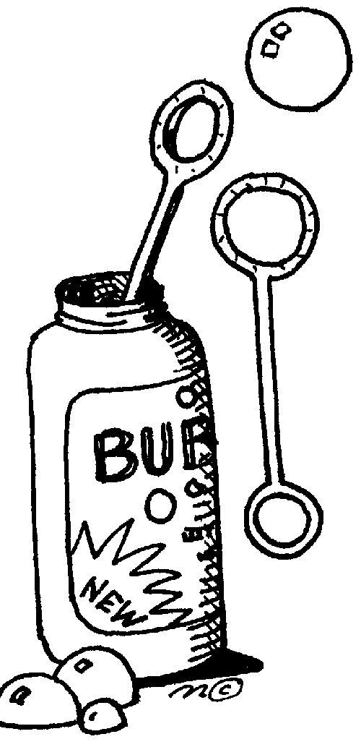
BUBBLE-OLOGY LAB

EXPERIMENTING USING THE SCIENTIFIC METHOD

This laboratory experiment is designed to illustrate the correct procedure used in the scientific method. Follow all the directions and be sure to answer the questions on the data sheet.

1. Comparing bubble solutions

The object of this investigation is to compare 2 brands of dishwashing liquid to find out which makes the biggest bubbles. Write a hypothesis to predict the outcome of the experiment.

Materials:

- Large beakers containing the soap mixture (2 per group)
- Graduated cylinder
- Plastic stirring rods (2 per group)
- Meter stick and/or ruler (1 per group)
- Plastic drinking straws (1 per person)
- Paper towels/squeegie

Procedure:

- Using a graduated cylinder, measure 10 mL of Brand A dishwashing liquid and pour into 150 mL of water in a large beaker. Mix well with the stirring rod.

- Do the same thing for the Brand B dishwashing liquid. Label them “soap brands A and B”, and record this information on the data sheet.

Your Procedure Starts Here:

- Pour some soap solution A on the surface of the lab table and use your hand to wet an area about 18”-20” in diameter.

- Dip a straw into the solution in the beaker.

- With the straw just touching the soapy surface of the table, gently blow through the straw to form a bubble dome, and continue blowing until it pops. Take more than one breath if necessary…however, DO NOT REMOVE THE STRAW FROM THE BUBBLE!!!

- With a ruler (or meter stick), measure the diameter of the ring of soap suds left by the bubble dome. Record the diameter (cm) on the data sheet. DON’T FORGET THE UNITS!!

- Measure four bubbles for Brand A solution and average the results on the data sheet. Record you data in the data table with units.
- Clean surface area and repeat steps 3-7 for Brand B solution.

BUBBLE-OLOGY LAB

1. Complete a hypothesis for this lab experiment:

Soap brand ______ will create a ____________________ bubble average than soap brand _____.

6. & 7. Data Sheet

 | Bubble 1 (cm) | Bubble 2 (cm) | Bubble 3 (cm) | Bubble 4 (cm) | Average Bubble Size (cm)
Soap Brand

______

Soap Brand

______

8. Graphing Data:

Graph your data using a bar graph. Be sure to include a title, legend, and labels for the x and y-axis. This should be done on the graph paper attached.

9. Analyzing the Data:

Using the data you collected, answer the following questions. All answers should be written in complete sentences unless you are told otherwise.

- According to the data, which soap brand made the largest average bubble? Include their averages.

- List two experimental errors that may have occurred in this experiment.

- Did your experimentation and data support this hypothesis? (Was your hypothesis correct?)
Explain your answer.

8. Graphing data. Use a bar graph.

CLEAN YOUR AREA:

1. WIPE DOWN THE TABLES, CHAIR, FLOOR, ETC.
2. WASH & RINSE THEN DRY THE EQUIPMENT WITH PAPER TOWELS.
3. HANG YOUR APRON ON THE BACK OF YOUR CHAIR.
4. CLEAN YOUR SAFETY GLASSES AND PLACE ON YOUR TABLE.
4. TURN IN YOUR LAB PAPERWORK.
5. MAKE SURE YOU GET CLEARED BY YOUR TEACHER.

