Activity: BIG BANG THEORY TIMELINE

Learning goal: You will be able to cite and explain how microwave background radiation, redshift of galaxies, and the elemental composition of the universe all contributed to the development and verification of the Big Bang Theory explanation of our universe. Using your background knowledge and additional online resources, display you will display understanding of the Big Bang Theory.

Directions:
Part 1: Timeline
Use a Legal size piece of paper, Google, and your notes, to create a Timeline displaying the Big Bang Theory.
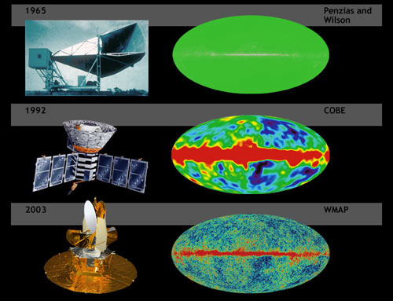
Include:
- Dates
- Scientist names
- Technologies Used/Created
- Discoveries made
- Color
- Photos/Images/Diagrams
- Neatness

--------------------------------------------------------------------

Part 2: Analysis
Based on your timeline and prior knowledge, construct a typed explanation of the Big Bang Theory that includes a description of how astronomical evidence from numerous sources (see list below) is used collectively to support the Big Bang Theory and how we know that the universe is currently expanding.
Your explanation must include the following pieces of evidence…
- Composition of Stars
- H/He ratio
- Redshift (Hubble’s law)
- Cosmic Background Radiation
- Any technology used that may have been used to obtain the evidence
**Keep in mind the academic dishonesty policy! This must be your own work, in your own words. If you quote from anywhere you must site the resource and use quotations!!!

