Chemistry 123 Oregon State University
Worksheet 11 Notes Dr. Richard Nafshun

1. Draw the line structure for CH₃CH₂CH₃. What is the name of this organic compound?

/\ propane

2. Draw the line structure for CH₃CH₂CH₂CH₃. What is the name of this organic compound?

/\/ butane

3. Draw the line structure for 3-methyl octane. What is the chemical formula of this organic compound?

C₉H₂₀

4. Draw the line structure for 2-methyl octane. What is the chemical formula of this organic compound?

C₉H₂₀

5. Draw the line structure for 4-ethyl octane. What is the chemical formula of this organic compound?

C₁₀H₂₂

6.
(UV energy)
CH₄ (g) + Br₂ (g) → CH₃Br + HBr (g)

7. Name

3-methylhexane

8. Sketch three isomers of C₆H₁₄. Name them.

I have identified five possible isomers (I cannot seem to identify another):

hexane

2-methylpentane

3-methylpentane

2,3-dimethylbutane

2,2-dimethylbutane

9. Sketch three isomers of C₈H₁₈. Name them.

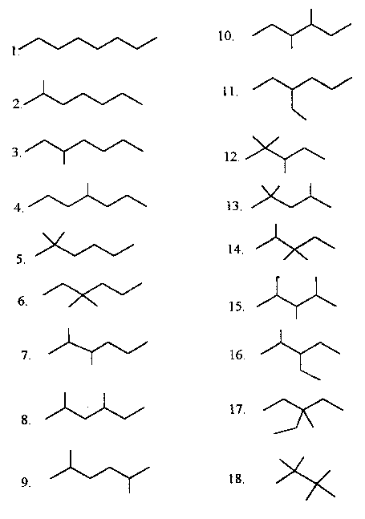

1. octane
2. 2-methylheptane
3. 3-methylheptane
4. 4-methylheptane
5. 2,2-dimethylhexane
6. 3,3-dimethylhexane
7. 2,3-dimethylhexane
8. 2,4-dimethylhexane
9. 2,5-dimethylhexane
10. 3,4-dimethylhexane
11. 3-ethylhexane
12. 2,2,3-trimethylpentane
13. 2,2,4-trimethylpentane
14. 2,3,3-trimethylpentane
15. 2,3,4-trimethylpentane
16. 3-ethyl-2-methylpentane
17. 3-ethyl-3-methylpentane
18. 2,2,3,3-tetramethylbutane

10. Sketch two isomers of C₃H₇Br. Suggest a reaction to produce these.

(UV energy)
C₃H₈ (g) + Br₂ (g) → C₃H₇Br + HBr (g)

11. What is meant by the formula C_{n}H_{2n+2}?

For alkanes there are 2n+2 hydrogens for n carbons.

12. What is meant by the family name "alkane?"

Single bonds only.

13. Discuss the reactivity of alkanes. Write the balanced equation for the combustion of 2,2,4-trimethyl pentane.

Alkanes are not very reactive. We can:
1. Substitute the hydrogen with a halogen under extreme conditions (Br₂ and UV).
2. Crack them (break down large alkanes in crude oil into smaller alkane fuels, asphalt, waxes...)
3. Combust them

2 C₈H₁₈ (l) + 25 O₂ (g) → 16 CO₂ (g) + 18 H₂O (l)

Did you identify the chemical formula of 2,2,4-trimethyl pentane to be C₈H₁₈?

14. Write the balanced equation for the combustion of
3,3-dimethyl heptane.

C₉H₂₀ (l) + 14 O₂ (g) → 9 CO₂ (g) + 10 H₂O (l)

15. The molecule shown below is:
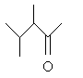
(A) an aldehyde.
(B) a ketone.
(C) a carboxylic acid.
(D) an amine.
(E) all of the above.

16, 17, and 18. [Your own questions]

19. The molecule shown below is:
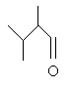
(A) an aldehyde.
(B) a ketone.
(C) a carboxylic acid.
(D) an amine.
(E) all of the above.

20. What is meant by a condensation reaction? Give an example.

Water is lost during a condensation reaction. Examples include: the formation of an ester from an alcohol and a carboxylic acid, the formation of an amide from an amine and a carboxylic acid.

21. What is meant by an addition reaction? Give an example.

Addition is to make an addition to a molecule. An example is the addition of a small molecule (such as Br₂) to an alkene.

+ Br₂ (in UV) →
propene 1,2-dibromopropane

22. What is meant by a substitution reaction? Give an example of one.

Substitution is to substitute an atom on a molecule. An example is electrophilic aromatic substitution.

+ in the presence of AlCl₃ → + HCl

23. The reaction of hydrochloric acid and ethene produces:

HCl + →

24. The building blocks of proteins are amino acids.

25. What is chiral? Sketch a molecule that contains three chiral carbons.

A molecule is chiral if it cannot be superimposed on its mirror image. A carbon in a molecule is chiral if it has four different groups attached to it. CH₂BrF is not chiral. CHBrClF is.

26. Sketch Ala-Ala-Gly-Cys-Tyr.

Where: R₁ is CH₃
R₂ is CH₃
R₃ is H
R₄ is CH₂SH
R₅ is

27. What polymer is formed by the reaction of HOCH₂OH and HOOCCH₂CH₂CH₂CH₂COOH?

This is a condensation polymerization. Water is lost between the alcohol and carboxylic acid:
O O O O
|| || || ||
HOCH₂OH + HOCCH₂CH₂CH₂CH₂COH → HOCH₂OCCH₂CH₂CH₂CH₂COH
water will leave

The carboxylic acid group on the right is still in tact and will react with an alcohol group from another HOCH₂OH molecule. The alcohol group on the left is still in tact and will react with a carboxylic acid group from another HOOCCH₂CH₂CH₂CH₂COOH molecule.

The polymer may be represented as:

O O
|| ||
-[-CH₂OCCH₂CH₂CH₂CH₂CO-]_{n}-

Where n is a large number representing a large number of these repeat units make up the polymer.

28. Define: trans-, unsaturated, saturated, and omega-3 fats. What is meant by partially hydrogenated vegetable oil?

trans- fats have the trans- conformation about a double bond.

unsaturated fats have double bonds (they are not saturated with hydrogens).

saturated fats have no double bonds (any double bonds have been saturated with
hydrogen).

omega-3 fats have a double bond located at the third carbon from the end of the
chain. The term omega-3 is used because omega indicates the first carbon at the end of the chain and the 3 indicates the third carbon atom in.

partially hydrogenated vegetable oil some, but not all, of the double bonds
present in the carbon chains have been hydrogenated (had hydrogen added across the pi-bond).

29. What polymer is formed by the reaction of a radical initiator and CF(C₆H₅)CF₂?

-[-CF(C₆H₅)CF₂-]_{n}-

The radical initiator breaks the pi-bond in the monomer causing it to become a larger radical and attacking another monomer unit.

+ R• →
monomer initiator new, larger, radical
(The dot inside the right carbon is to represent the radical electron)
(This new radical will attack a monomer unit and this process will continue...)

30. What polymer is formed by the reaction of HOOCCH₂CH₂CH₂COOH and H₂NCH₂CH₂CH₂CH₂NH₂?

This is a condensation polymerization. Water is lost between the amine and carboxylic acid:
H H O O
| | || ||
HNCH₂CH₂CH₂CH₂NH + HOCCH₂CH₂COH →
water will leave

H H O O
| | || ||
HNCH₂CH₂CH₂CH₂NCCH₂CH₂COH
new amide

The carboxylic acid group on the right is still in tact and will react with an amine group from another H₂NCH₂CH₂CH₂CH₂NH₂ molecule. The amine group on the left is still in tact and will react with a carboxylic acid group from another HOOCCH₂CH₂COOH molecule.

