Name: _______________________________________________ Period: ____ Date: ___/___/___
Bio - Mendelian Genetics Packet: 2024-2025
Allele, Genotype, Phenotype
- Label each of the following as either an allele, genotype, or phenotype.
AA: ____________ | Purple Flowers: ___________ | w: ____________ | Wing Length: _________
b: ____________ | Hair Color: ____________ | Aa: ____________ | Ee: ____________
Blue eyes: ___________ | Mm: ____________ | H: ____________ | e: ____________
Q: ___________ | Round Seeds: ____________ | Height: ___________ | ee: ____________
- Below each of the words are choices. Circle the choices that are examples of that word.

Dominant Allele: | k | L | N | n | R | s | G | g

Recessive Allele: | d | F | G | r | j | B | L | s

- For each genotype below, indicate whether it is heterozygous (He) or homozygous (Ho)

AA: _____ | Dd: _____ | gg: _____ | Jj: _____ | MM: _____
bb: _____ | Ee: _____ | HH: _____ | kk: _____ | nn: _____
CC: _____ | ff: _____ | Ii: _____ | LL: _____ | Oo: _____

- Below each of the words are choices. Circle the choices that are examples of that word.

Homozygous Dominant: | AA | Bb | cc | Dd | ee | FF | GG | HH | ii

Heterozygous: | JJ | kk | Ll | Mm | Nn | OO | Pp | Qq | rr

homozygous recessive: | Ss | tt | uu | Vv | WW | Xx | yy | ZZ

- For each of these genes, give the genotype that would be homozygous dominant (HD), heterozygous (He), and homozygous recessive (hr). (For example: G→ HD: _GG_ He: _Gg_ hr: _gg_)

F → HD: ____ He: ___ hr: ___ | Q → HD: ____ He: ___ hr: ___ | M → HD: ____ He: ___ hr: ___
E → HD: ____ He: ___ hr: ___ | Y → HD: ____ He: ___ hr: ___ | Z → HD: ____ He: ___ hr: ___

- Below each of the words are choices. Circle the choices that are examples of that word.
Genotypes in which the DOMINANT gene will produce the phenotype:
AA | BB | cc | dd | Ee | FF | gg | Hh | ii | JJ
Genotypes in which the RECESSIVE gene will produce the phenotype:
Aa | bb | Cc | dd | EE | ff | GG | Hh | Ii | jj

- For each of the genotypes below determine what phenotypes would be possible.
Purple flowers are dominant to white flowers. | RR: __________ | Rr: __________ | rr: ___________
Wrinkled Pea Pods are recessive to Inflated Pea Pods. | NN: __________ | Nn: __________ | nn: __________
Green pea pods (H) are dominant to yellow pea pods (h). | HH: __________ | Hh: __________ | hh: __________
- For each phenotype below, list the genotypes.

Red fur (d) is recessive to white fur (D) in cats | _____: white | _____: white | _____: red
Tall (C) pea plants are dominant to short (c) pea plants | ____: tall | ____: tall | ____: short
Round pea pods (J) are dominant to wrinkled pea pods (j). | _____: round | _____: round | _____: wrinkled

In each of these scenarios, use the following traits to determine either the Genotype or Phenotype.

Trait | Dominant Allele | Dominant Phenotype |  | Recessive Allele | Recessive Phenotype
Plant Height | E | Tall |  | e | Short
Seed Shape | C | Round |  | c | Wrinkled
Seed Color | K | Yellow |  | k | Green
Pod Shape | T | Inflated |  | t | Constricted
Flower Location | L | Terminal |  | l | Axial
- Write out the GENOTYPE(S) for these plants:  - Heterozygous Seed Shape: ______  - Homozygous Terminal Position: ______  - Purebred Round Seeds: ______  - Heterozygous Yellow Seeds: ______  - Homozygous Short: ______  - Homozygous Inflated Seed: ______  - Axial Flowers: ______  - Inflated pods: ______ or ______  - Short Plant: ______ |  |  | - Write out the PHENOTYPES for these plants:  - Ee: _______________________________  - Cc: _______________________________  - KK: _______________________________  - LL: _______________________________  - Tt: _______________________________  - Ll: _______________________________  - CC: _______________________________  - LL: _______________________________  - Cc: _______________________________
Punnett Squares
Directions: Read each question and write down an answer in the appropriate space.
- Observe how your complete a Punnett square. Answer the questions below.
  - What do the letters on the outside of the Punnett square stand for?
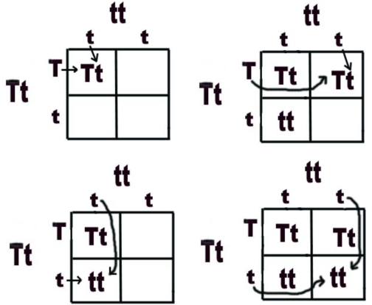

  - What do the letters on the inside of the Punnett square stand for?

  - Why does each box only get one allele from each parent?

  - How much of your DNA comes from each parent?

- Complete the Punnett Squares below.

 | A | A |  |  | H | H |  |  | F | f
A |  |  |  | h |  |  |  | F
a |  |  |  | h |  |  |  | f

 | e | e |  |  | j | j |  |  | R | r
e |  |  |  | J |  |  |  | r
e |  |  |  | J |  |  |  | r

Punnett Squares
- 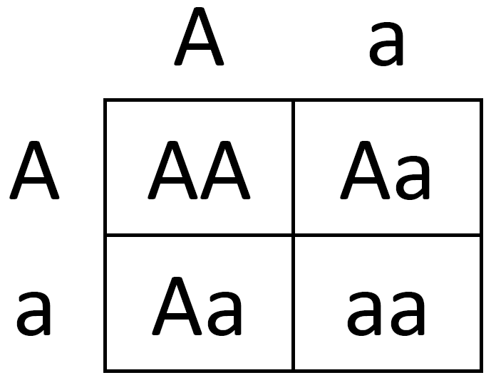Analyze the Punnett square and answer the questions below.
  - What letter represents the dominant allele? ______
  - What letter represents the recessive allele? ______
  - What are the genotypes of the parents? ______ x ______
  - What genotype(s) can the offspring have? _________________
  - What percent of the offspring will have produce the dominant phenotype? ______
  - What percent of the offspring will have produce the recessive phenotype? ______
- 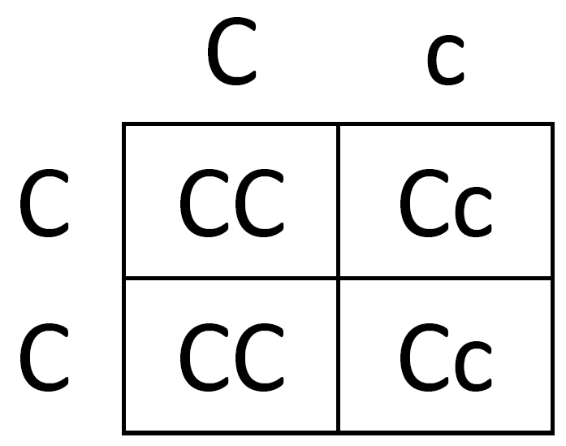Analyze the Punnett square and answer the questions below.
  - What letter represents the dominant allele? ______
  - What letter represents the recessive allele? ______
  - What are the genotypes of the parents? ______ x ______
  - What genotype(s) can the offspring have? _________________
  - What percent of the offspring will have produce the dominant phenotype? ______
  - What percent of the offspring will have produce the recessive phenotype? ______

- In dogs, long hair (H) is dominant to short hair (h). A female dog has a homozygous dominant genotype and long hair female as a phenotype. A male dog has a homozygous recessive genotype and short hair as a phenotype. Complete the Punnett Square to determine the possible offspring.

- Father’s genotype: _______, Father’s phenotype: ______________

- Mother’s genotype _______, Mother’s phenotype: ______________

- Circle the genotype(s) that are possible in the offspring: HH Hh hh

- In pea plants, purple flowers are dominant (B) while white flowers are recessive (b). Two purple flower plants that are both homozygous dominants (BB) are crossed. Complete the Punnett Square to determine the possible offspring.

- Father’s genotype: _______, Father’s phenotype: ______________

- Mother’s genotype ________, Mother’s phenotype: ______________

- Circle the genotype(s) that are possible in the offspring: BB Bb bb
Monohybrid Punnett Squares
Directions: Read each genetics problem and complete the Punnett square. Calculate the ratios of each genotype and phenotype by using the Punnett square. (For example: 2/4 squares = 50%)

- A yellow pea plant (Aa) parent mates with Yellow pea plant (Aa) parent. Yellow plants are dominant to green plants.

Genotype | Ratio  (#/#) | Percent  (%) |  | Phenotype | Ratio  (#/#) | Percent  (%)
AA | / |  |  | Yellow  (AA, Aa) | /
Aa | / |  |  | Green  (aa) | /
aa | /

- A tall plant (TT) is crossed with a short plant (tt). Tall plants are dominant to short plants.
Genotype | Ratio  (#/#) | Percent  (%) |  | Phenotype | Ratio  (#/#) | Percent  (%)
TT |  |  |  | Tall
Tt |  |  |  | Short
tt

- A wrinkled seed pea plant (ee) is crossed with a smooth seed pea plant (Ee). Smooth seeds are dominant to wrinkled seeds.

Genotype | Ratio  (#/#) | Percent  (%) |  | Phenotype | Ratio  (#/#) | Percent  (%)
EE |  |  |  | Smooth
Ee |  |  |  | Wrinkled
ee

Monohybrid Punnett Squares
- A white flower (rr) is crossed with a white flower (rr). White flowers are recessive to purple flowers.
Genotype | Ratio | Percent |  | Phenotype | Ratio | Percent

- Two homozygous dominant brown mice are crossed. Brown fur is dominant to white fur in mice. Choose whatever letter you would like to use for this question.

Genotype | Ratio | Percent |  | Phenotype | Ratio | Percent

- Butterflies have two colors of wings. Red wings are dominant to white wings. A homozygous dominant butterfly is crossed with a homozygous recessive butterfly. Choose whatever letter you would like to use for this question.
Genotype | Ratio | Percent |  | Phenotype | Ratio | Percent

Mendel’s Data
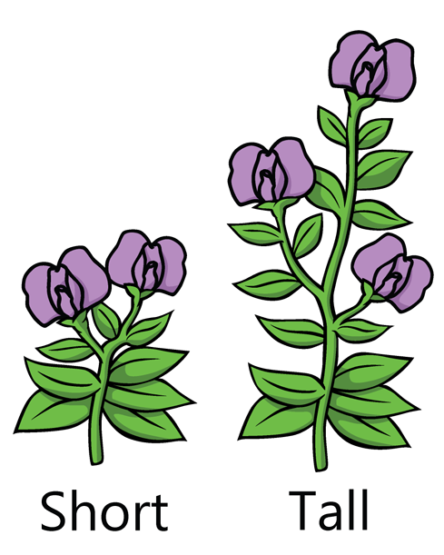
Directions: Mendel studied thousands of pea plants by recording the phenotypes of the plants over 8 years. Mendel also made sure that he crossed certain pea plants with characteristics with other pea plants with different characteristics. Calculate the percent of each phenotype and try to figure out what the genotypes of the parents were. Complete a Punnett square for each problem.

- Mendel crossed a tall pea plant with a tall pea plant. Mendel collected 8,000 offspring pea plants. Out of all of the offspring, 6000 (75%) were tall. Out of all of the offspring, 2,000 (25%) were short which is 25%. (Use A/a as the allele)

- What phenotype is dominant? _________
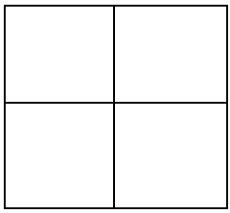
- What phenotype is recessive? _________
- What phenotype does the AA produce? ______________
- What phenotype does the Aa produce? ______________
- What phenotype does the aa produce? ______________
- What percent of the offspring has the dominant phenotype? _________
- What percent of the offspring has the recessive phenotype? _________
- What are the genotypes of the parents? _____ x _____

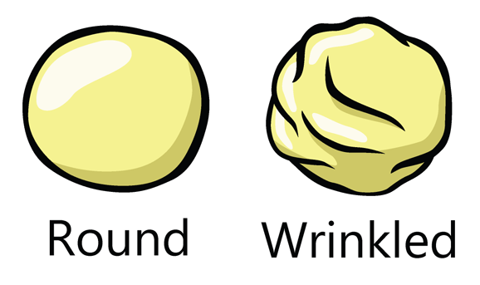
- Mendel crossed a smooth and a wrinkled pod shaped pea plant. Mendel collected 1000 offspring pea plants. Of the 1000 offspring, 500 were smooth and 500 were wrinkled. From past crosses, Mendel noticed smooth pea plants seem to show up more often than wrinkled. (Use B/b as the allele)

- What phenotype is dominant? _________
- What phenotype is recessive? _________
- What phenotype does the BB produce? ______________
- What phenotype does the Bb produce? ______________
- What phenotype does the bb produce? ______________
- What percent of the offspring has the dominant phenotype? _________
- What percent of the offspring has the recessive phenotype? _________
- What are the genotypes of the parents? _____ x _____
Mendel’s Data
- Mendel noticed there were two distance types of pea pods, inflated and constricted. Mendel crossed two constricted pea plants that had 820 offspring. Of the offspring, all 820 were constricted. When Mendel crossed the constricted pea plants with other pea plants, the majority of the offspring were inflated. (Use Z/z as the allele)
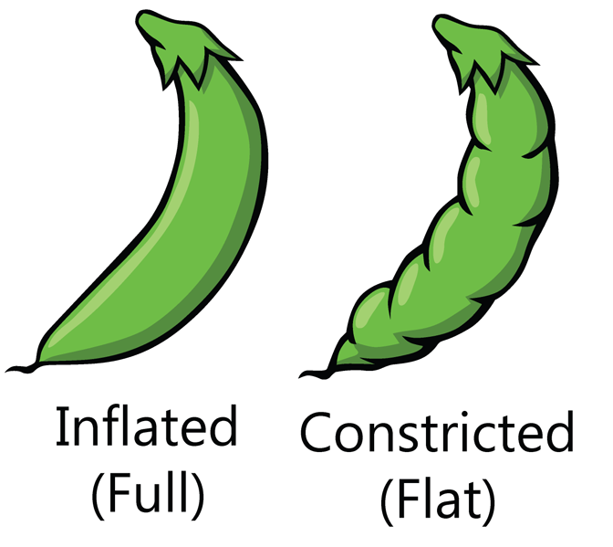

- What phenotype is dominant? _________
- What phenotype is recessive? _________
- What phenotype does the ZZ produce? ______________
- What phenotype does the Zz produce? ______________
- What phenotype does the zz produce? ______________
- What percent of the offspring has the dominant phenotype? _________
- What percent of the offspring has the recessive phenotype? _________
- What are the genotypes of the parents? _____ x _____

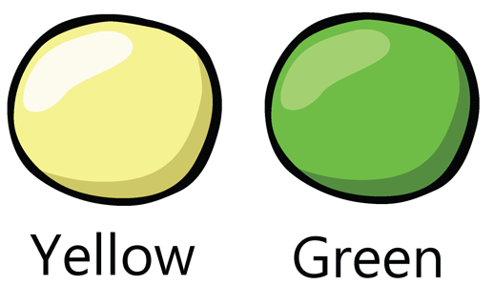
- Mendel noticed that the pea plants had two different colors of pea pods. One type was yellow while the other was green. When he crossed two yellow pea pod plants, all 400 of the offspring were yellow. When he crossed the two yellow parents with other pea plants, he only got yellow offspring. (Use Y/y as the allele)

- What phenotype is dominant? _________
- What phenotype is recessive? _________
- What phenotype does the YY produce? ______________
- What phenotype does the Yy produce? ______________
- What phenotype does the yy produce? ______________
- What percent of the offspring has the dominant phenotype? _________
- What percent of the offspring has the recessive phenotype? _________
- What are the genotypes of the parents? _____ x _____

Autosomal Recessive Pedigree
Autosomal inheritance follows simple Mendelian Genetics because the genes are located on the first 22 chromosomes. Autosomal recessive traits only show up when the individual is homozygous recessive.

Directions: Write the genotype below each circle and square in the pedigree. Shade in any carriers with half a circle or square. If you don’t know an allele in a genotype, place a ‘?’ in its place. Sometimes the ‘?’ will be the correct answer.
 |  |  |  | 
Pedigree #1 | Pedigree #2 |  | Pedigree #3 |  | Pedigree #4
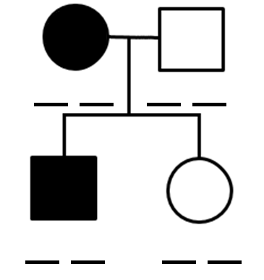 | 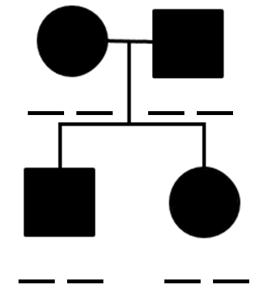 |  | 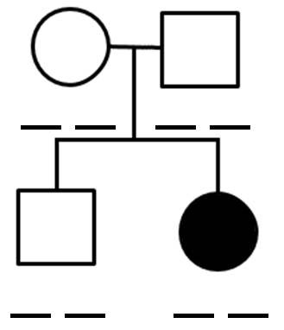 |  | 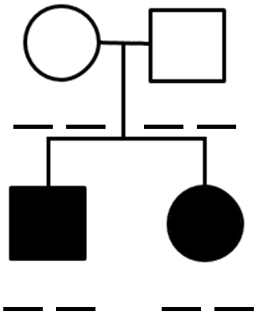

Pedigree #5
Directions: Complete the pedigree by placing the genotype on the line below each square or circle. Each line will have TWO letters. For carriers, fill their circle or square halfway.
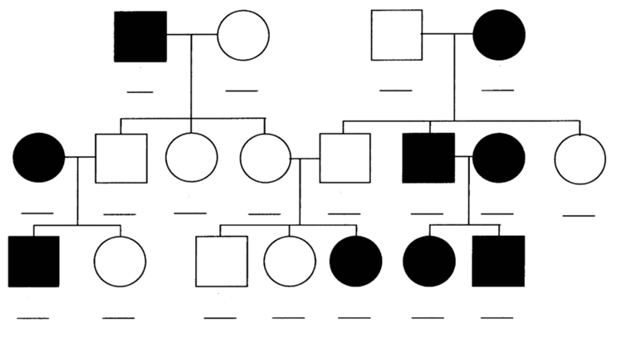

Autosomal Dominant Pedigree
Autosomal dominant disorders have AT LEAST one dominant allele. The genotypes can be homozygous dominant or heterozygous. In this type of pedigree, there are no carriers. Unaffected individuals are homozygous recessive.

Directions: Write the genotype of each person in the pedigree on the line. If you don’t know an allele in a genotype, place a ‘?’ in its place. Sometimes the ‘?’ will be the correct answer.
 |  |  | 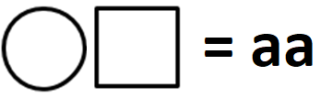
Pedigree #6 | Pedigree #7 | Pedigree #8 |  | Pedigree #9
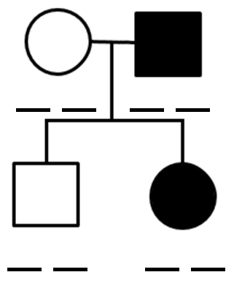 | 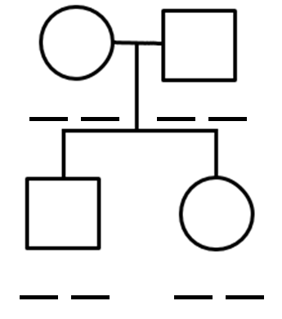 | 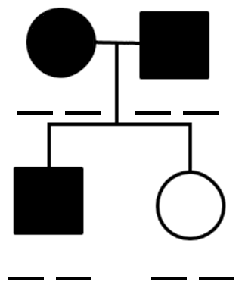 |  | 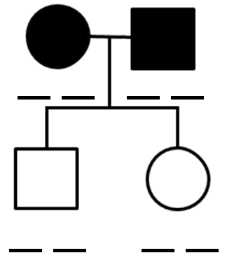

Pedigree #10
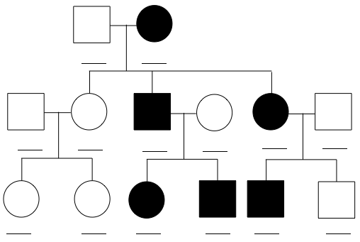
Directions: Complete the pedigree by placing the genotype on the line below each square or circle. Each line will have TWO letters. For carriers, fill their circle or square halfway.

