ICE CREAM SAVES THE WORLD!!
As you saw in the Ben and Jerry’s biography, https://www.youtube.com/watch?v=yQykGinvNrw
their company does A LOT of giving back. One of the many philanthropic campaigns that Ben and Jerry’s takes part in is “The Edible Social Mission.” Below you will find some of their latest flavors where a percentage of the profits go to support various causes. See examples below.

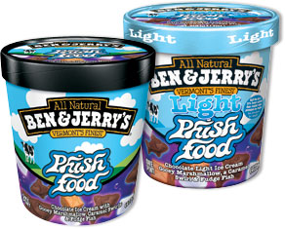
With a long track record of activism on behalf of family farms, Willie Nelson was the perfect sale of this flavor is donated to Farm Aid, whose mission is to build a vibrant family-farm choice to join The Grateful Dead, Phish, and The Dave Matthews Band on the roster of Ben & Jerry’s partners who combine music with a social conscience. A royalty from the centered system

Phish Food® (US)
Although legendary Vermont band Phish played their last concert in 2004, their unquenchable energy lives on through Ben & Jerry’s Phish Food® original and light ice creams. These flavors pay a royalty to the Waterwheel Foundation which is dedicated to the protection and preservation of Lake Champlain and its watershed. In 2013, royalties totaled $537,441.

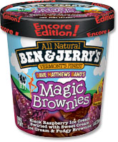
Dave Matthews Band’s Magic Brownies™ (US)
As the main course in our ongoing Lick Global Warming campaign, Dave Matthews Band’s Magic Brownies™ combines the spirit of Dave Matthews Band, the razzle of chocolate and raspberries, and the conscience of Mother Earth in one place. A portion of every sale of Dave Matthews Band’s Magic Brownies™ goes to Dave Matthews Band’s Bama Works Fund to support the work of nonprofit groups taking action against global warming. In 2013, this flavor produced royalties of $65,471 for Bama Works.

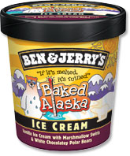
Baked Alaska — (Europe)
Legend has it that when the United States acquired Alaska they invented the dessert now known as ‘Baked Alaska,’ an ice cream cake topped with meringue and baked briefly in the oven. Now, a century later, Alaska itself is baking as global warming threatens Arctic environments. Ben & Jerry’s Baked Alaska flavor — sold in European markets — uses vanilla ice cream, marshmallow swirls, and white chocolate Polar Bears to put the spotlight on this predicament. Even better, we direct a portion of the sales of this flavor to support Ben & Jerry’s Climate Change College where young people learn how to become climate change activists.

Peace of Cake (EU — The Netherlands)
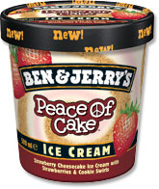
If you know Ben & Jerry’s, you know that we care as much about world peace as we do about our ice cream flavours. That’s the reason we support the War Child Foundation, which works to rehabilitate child soldiers in war-torn countries. Ben & Jerry’s donates 25 eurocents to Warchild from the sale of every pint of Peace of Cake that we sell in the Netherlands. To find out more about our Peace, Love & Ice Cream tour, or if you want to become a friend of Warchild yourself, visit www.benjerry.nl/warchild

One Sweet World (Europe)
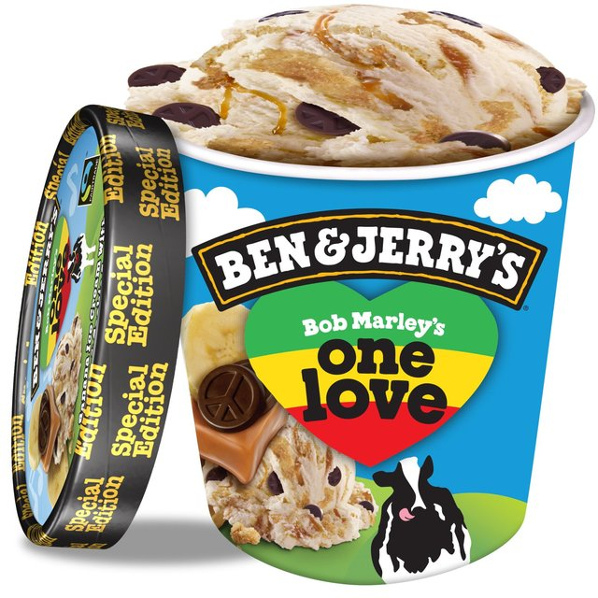
The trio includes One Sweet World, created as part of the luxury ice cream brand’s European social mission campaign of the same name, which holds the belief that “communities, just like ice cream, com in all flavors”. Proceeds go to Hope Not Hate, a charity that promotes inclusiveness in British communities. It is joined on shelf by Empower Mint—mint ice cream with chocolate brownies made at Greyston Bakery a social enterprise in Yonkers, New York, which uses baking t help people back into employment. The new final offering, One Love, is a combination of banana ice cream, caramel, cookie swirls, and chocolate peace signs. Proceeds go to the One Love Youth Camp in Jamaica, which supports young people through music, dance, and arts.

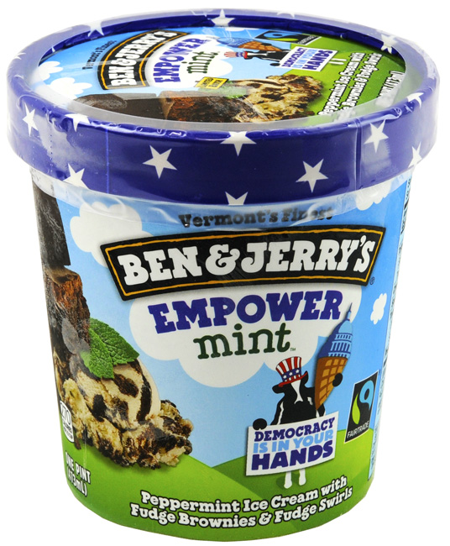

YOUR ASSIGNMENT: Create a new flavor to help a cause of your choice. Then you must create the packaging for your new flavor (that includes a clever new name).

Point Values  Except for Paper | 10-8 points | 5-8 points | 1-4 points | 0 points
Name | Ben and Jerry loves your name and wants to use it right away. | Clever name but not quite up to the Ben and Jerry’s standard. | Shop and Save could have created that name for their ice cream. | Do you know your name?
Cause | Your cause supports follows the lead of the current Ben and Jerry’s philanthropic campaigns. |  | Your cause is not unique and over done. | What cause?
Label and Packaging ** | WOW…you have ALL of the information that we need on the label! Ben and Jerry called and they want to buy your packaging ideas. | Ooops you left off a couple of things. Ben and Jerry called and they are interested in your packaging ideas! | Uh Oh! You left off more than three things! Ben and Jerry called and they want their packaging ideas back! Don’t break copyright laws! | Really? You call that a label? Ben and Jerry called, why did they get a lump of ice cream without a package?
Total ___/30

** Label must include the following:

- Name of ice cream in a font with special features like stroke, underline, 3D
- Ingredients in ice cream with a feature
- Graphic that shows the cause

