Balloons

I use balloons to introduce tossing, bouncing and catching. I also work on learning body parts, rote counting, more or less than, position words and more!

First you have to blow up the balloons. This is fine if you only have 22 but not something I want to do for more. I usually ask several of our TA’s to help by blowing up 10 balloons each until I have enough. Use garbage bags to store them for up to two weeks.

Remember to let the students know that the balloons might pop but please not to worry you have more balloons.

- Start by having the students follow your movements working on body part recognition and positional words- hold the balloon up high, down low, in the middle, to the left, to the right, touch your head, back, knee, etc.

- Tossing and catching with two hands. First, get out your pretend glue and glue your feet to the floor. This will encourage the students to try and stay in one place. Tell the students that when you give the go signal they will practice tossing and catching the balloon. Remind them not to let their balloon touch the floor. Have the students count how many times they can toss and catch the balloon with out dropping it.

- Bounce and catch the balloon and stay in your space. Have the students count while bouncing the balloon.

- Balloons in space. On the go signal the students will practice keeping the balloon up using their hand. Have the students use their elbows, knee, head, and shoulder. Just so you know the students are going to move around☺

- Balloon volleyball- Divide the class into two teams and have them sit in a line at the far ends of the playing area. Use mats, chairs or a low net to divide the playing area. Scatter the balloons on both sides. On your go signal the students will try and throw the balloons to the other side. On your stop signal the students will go back to their lines. Before playing again, have one student on each team count the balloons on their side. Ask the teams, who has more and who has less. Tell them the team with less is the winner because they have the cleanest room☺
You can also play Balloon Volleyball with each student using toothbrushes to hit the balloons☺

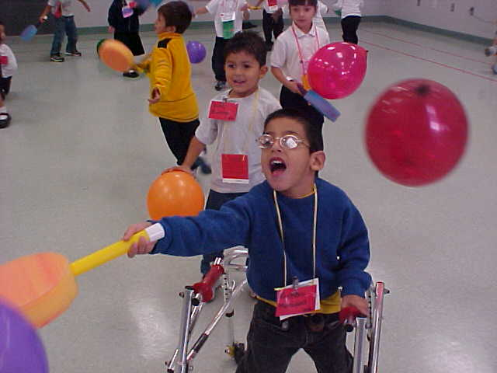
Pre-K TEKS- Physical Development 1A, 1B, 1C, 2A, 2B, 2C, 2D; Mathematics 1B, 1D, 3B; Language 1A, 1B, 1C
Kindergarten TEKS- Physical Education 1A, 1C, 1F, 1H, 5A, 6A, 6B, 7A, 7B, 7C

