Balloon Powered Race Cars
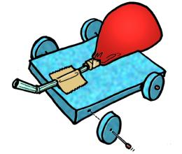
Objectives:
- to create a balloon powered race car for maximum speed and distance
- to learn how to use the formula Speed= Distance / Time
Materials:
- balloon, straw, various materials to construct the racers
Rules:
- The car must be powered by no more than 2 balloons.
- You can build the car out of anything we have available.
- The car must be capable of traveling at least 5 meters.
Procedure:
- You will build your car in class using my materials. (balloons, cardboard, straws, tape, glue, etc.)
- We will measure the distance your car travels and the time it takes to calculate the speed.
Data:

Team Member Names Distance Time Average Speed Instantaneous Speed

__________________ __________ ____ _________ _____________

__________________ __________ ____ _________ _____________

__________________ __________ ____ _________ _____________

__________________ __________ ____ _________ _____________

__________________ __________ ____ _________ _____________

__________________ __________ ____ _________ _____________

__________________ __________ ____ _________ _____________

__________________ __________ ____ _________ _____________

__________________ __________ ____ _________ _____________

__________________ __________ ____ _________ _____________

Conclusion:
- Who had the fastest car? Why do you think theirs was the fastest?

- Who had the slowest car? Why do you think it was the slowest?

