Balloon Powered Race Cars
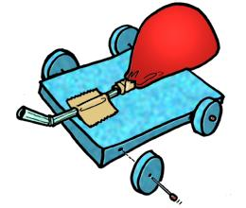
Objectives:
- to create a balloon powered race car for maximum speed and distance
- to learn how to use the formula Speed= Distance / Time
Materials:
- balloon, straw, various materials to construct the racers
Rules:
- The car must be powered by no more than 2 balloons.
- You can build the car out of anything we have available.
- The car must be capable of traveling at least 5 meters.
Procedure:
- You will build your car in class using my materials. (balloons, cardstock, notecards, straws, tape)
- We will measure the distance your car travels. The car that travels the farthest receives a 100, next 95 and so on.

Conclusion:
- Who had the best car? Why do you think theirs won?

- Who had the worst car? Why do you think it was the worst?

