AP Physics – Atwood Lab
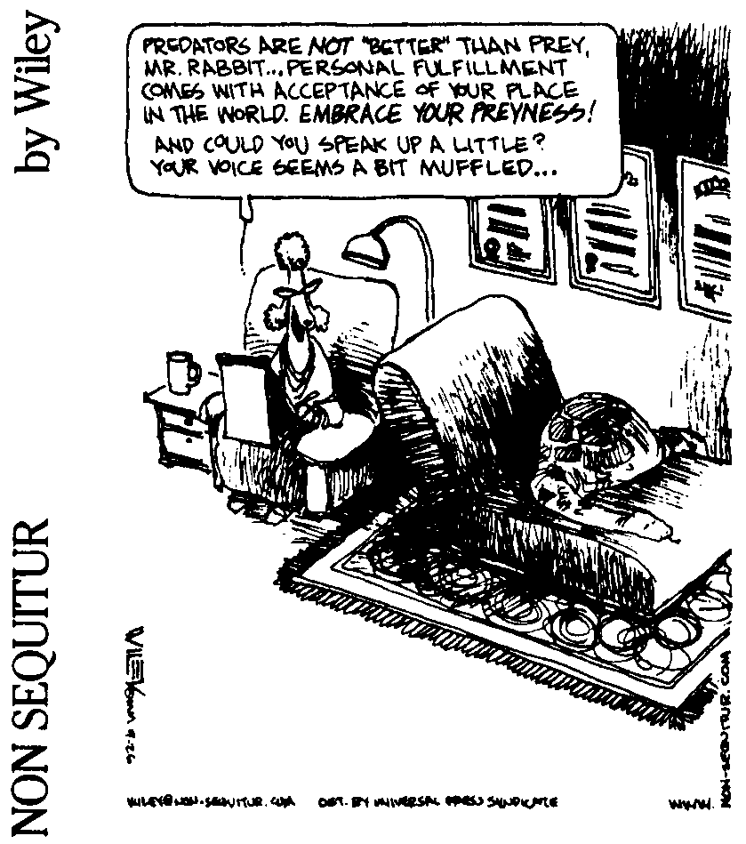

My job is to comfort the disturbed and disturb the comfortable -- Unknown

Rig up an Atwood machine using a low friction pulley, a ringstand, and a clamp as shown in the drawing below.

A light string should be run over the pulley. Attach a paper clip to the two bitter ends of the string. Add five large washers to the paperclips on each side. The masses must be balanced, and this may not happen. It could be that the large washers on one side could have a slightly different mass than the ones on the other side. Fix this by adding small paperclips to the smaller mass until it is equal in mass to the larger one. Once it is all set, the two masses should not move when released. Measure and record the mass on each side.

Take one small washer and add it to one of the paper clips tied onto the string. You now have a genuine Atwood machine. When released the system will accelerate.

What you need to do now is to use the thing to figure out the mass of the small washer.

Your pal, the Physics Kahuna, will be happy to provide you with suitable measuring devices – you have but to ask.

Do not measure the washer’s mass directly; the objective is to determine the mass by analyzing the motion of the thing when you release it.

Once you’ve calculated the mass of the small washer, feel free to actually measure it for comparison with your experimental value.

May the force be with you.

