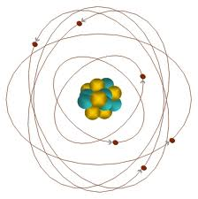
Study Guide
Atoms Quiz: Chapter 3.1

proton – positive (+), in nucleus, mass of 1 amu

neutron – no charge / neutral, in nucleus, mass of 1 amu

electron – negative (-), outside of nucleus in electron cloud, has almost no mass

atomic number - # of protons in the nucleus

mass number - # neutrons + # protons

electron cloud – area outside of nucleus that contains electrons; surrounds the nucleus

nucleus – center of atom – contains protons and neutrons

atom – smallest building block or smallest part of all matter

element – substance that cannot be broken down

isotope – atoms of the same element with different numbers of neutrons

Scientists:

Dalton – first experiments with atoms; tiny, solid ball model

Thomson – discovered the electron; muffin with berries model

Rutherford –discovered the nucleus; peach or apple model

Bohr- thought electrons travel around layers or shells; onion model

Present- Day- electrons travel in the electron cloud; cloud model

