Aperture Lesson
Kelly Moncure

SUBJECT: Digital Photography

GRADE LEVEL: 10- 12th

LESSON TOPIC: Camera Operations, Aperture

ACADEMIC CONTENT STANDARDS:
California Academic Standard

1.0 ARTISTIC PERCEPTION
Processing, Analyzing, and Responding to Sensory Information Through the Language and Skills Unique to the Visual Arts
Students perceive and respond to works of art, objects in nature, events, and the environment. They also use the vocabulary of the visual arts to express their observations.

2.0 CREATIVE EXPRESSION
Creating, Performing, and Participating in the Visual Arts
CTE Standard
Standard 8.0 Understand the key technical and technological requirements applicable to various segments of the Media and Design Arts Pathway.

LEARNING OBJECTIVES/OUTCOMES: Students will learn about the aperture component of camera operations by hands on practice and practical application. They will then answer questions related to aperture and what they saw when doing the aperture exercise and create a visual “diary” page.

LANGUAGE OBJECTIVES/OUTCOMES: Students will understand the vocabulary aperture and basic camera operations and be able to write about what they experienced firsthand.

INTRO ACTIVITIES:
- Background/Summary- This lesson is one of the first lessons of the year because it concerns basic camera operations. One of the most important things you should know about camera operations what aperture does and the effect that it has on your photograph. Before this lesson the students were shooting with the camera on “shutter priority” mode, which allows the camera operator to take control over how they are capturing speed, various light settings and blur. Students will now use the other part of the “exposure triangle”, aperture, to further understand how choosing that to shoot with can work with depth of field.
- Entry/Anticipatory: I will review what students have learned about the exposure triangle, and how shutter speed affects the photograph. I will then explain what aperture is, and show a short three minute video from Lynda.com to further explain the concept and have a visual about aperture. I will then set up a small still life and demonstrate what we are shooting outside. After shooting, I will show the students what the image will look like and let them know we are doing the same outside.

- THROUGH ACTIVITIES:

- Lecture- after showing the students the photographs, I will explain where the aperture is in the camera and what it does.
- I explain what they are going to be doing in teams of two- each will have a camera on a tripod and take photos of their still life, using the settings of f/1.8, f/8 and f/16.
- I will explain what the lens we will be using is- a fixed 50mm f/1.8- and how it differs from the usual 18- 140mm zoom lens we use in class.
- I show specifically what they will be creating- a visual diary of Aperture so that they can understand what it looks like, which will be created into their own Padlet.
- Guided practice
- Teacher will hand out a shot list directing students what is expected of them, as well as a visual of the final product they are creating. She will have the students read out loud the shot list and elaborate on specifics.
- Teacher will direct students on how to change the aperture on their cameras from f/1.8 to f/8 to f/16. She will direct them on how to change the ISO on their camera, from 400 to 200, according to the light conditions.
- Teacher will bring the students to the quad where she will once again go over what the apertures are, how to change the aperture, and how to set up the still life. One partner will shoot from left to right and the next will go from right to left.
- The teacher will help students put the cameras on tripods as needed and walk around to help as needed.
- Once the photographs are taken, the students will go back to the room to download their photographs. They will edit them in the iMac’s Photo application to crop or straighten horizons as needed.

Day Two
- Teacher will go over how to save the student work in Google Drive as a backup. Students will make a folder on the desktop and title it “Aperture”, drag all the photographs from the Photos application in there, and then drag that folder into their Google Drive. Once they are done with their project, they will drag the photos from their desktop into the trash.
- Teacher will have the students read out loud the project from the class website on Aperture, elaborating as they go along as needed.
- Teacher will go over how to create their own Padlet after they have read the instructions. They have created two previously, one on Shutter Speed and the other with a partner on the Elements and Principles of Art.
- Students will work independently on creating a Padlet on Aperture, showing examples of each aperture and writing the technical information from the Photos application of what the Aperture, Shutter Speed and ISO is, as well as a sentence describing how the photograph changes.

BEYOND ACTIVITIES:
- Independent practice – Students will work on completing their visual diary in Padlet.
- Assessment/Evaluation – Students will be assessed on the visuals, technical information and reflection, research, time on task, and teamwork.
- Closure – I assess whether the project was successful based on making sure all students participated and how thorough they were with the reflection.
- This project will lead into a longer assignment where they will each be creating and writing a children’s story using toys and using the aperture more in depth.

Shot list- APERTURE
Work with your partner to take photographs using Aperture priority
To switch your camera dial to Aperture priority, put your mode dial to “A”


For the D7100:
Use the FRONT dial to change the aperture. You’ll see the number on the top of the camera, indicated as an f/number. You may have to press the shutter release down halfway to get the numbers to appear.

For the D5300:
You will use the BACK dial to change the aperture and you will see the number represented on the back of your camera with a circle around it with an f/number. You may have to press the shutter release halfway to get the numbers to appear.

Make a still life of three separate objects separated as demonstrated in class (one close, one in the center, and one to the back towards the right side of the view finder). Make sure all subjects are separated at least a couple feet and that you can see all of them through your viewfinder.

Keep your camera on the tripod and take the SAME photograph of the still life, changing your aperture as you go. Make sure to keep your tripod at the same spot.

Take THREE photos of each set up, focusing on the subject in front the whole time.
Take a photo at f/1.8, then f/8, then f/16.

Change direction of the objects (from right to left) for your partner to shoot so you have different photos.

You will be taking these photos and uploading them onto a Padlet showing a side by side comparison and explaining what each looks like as compared to one another. You will include the aperture, shutter speed, and ISO for each one as the caption.
Aperture Self Evaluation
Name: Period:

Please complete your evaluation for the project & total the points below:

Classwork- 5 points
Time on task (not goofing off or distracting others) 0/1 point __________
Participated in class with a good attitude 0/1 point __________
Respectful to teacher 0/1 point __________
Not on cell phones while should be working 0/1 point __________
Not late to class on any day 0/1 point _________

Photographs – 5 points
One photo per aperture and all have subject in focus 0/3 points _________
Horizon lines are straight 0/1 point __________
No junk in the background 0/1 point __________

Padlet- 5 points
Each photograph has technical information of
Aperture, Shutter Speed, and ISO 0/1 point ___________
Each photograph has a sentence or more describing it 0/1 point ___________

Answered how changed camera to Aperture Priority 0/1 point __________
Answered what happens to photo when aperture changes 0/1 point _________
Answered why use Aperture priority and when best to use it 0/1 point _________

Written Work – 5 points
Title of Padlet Name and Aperture 0/1 point ___________
Has image for shallow depth of field from web 0/1 point ___________
Has write up about shallow depth of field photo chosen 0/1 point ___________
Has image for deep depth of field from web 0/1 point ___________
Has write up about deep depth of field photo from web 0/1 point ___________

Total points:____________/ 20

Please answer the following questions in COMPLETE SENTENCES (you will lose a point if missing):

- I was proudest of:

- I struggled the most on:

- I learned the most about:

Aperture Priority

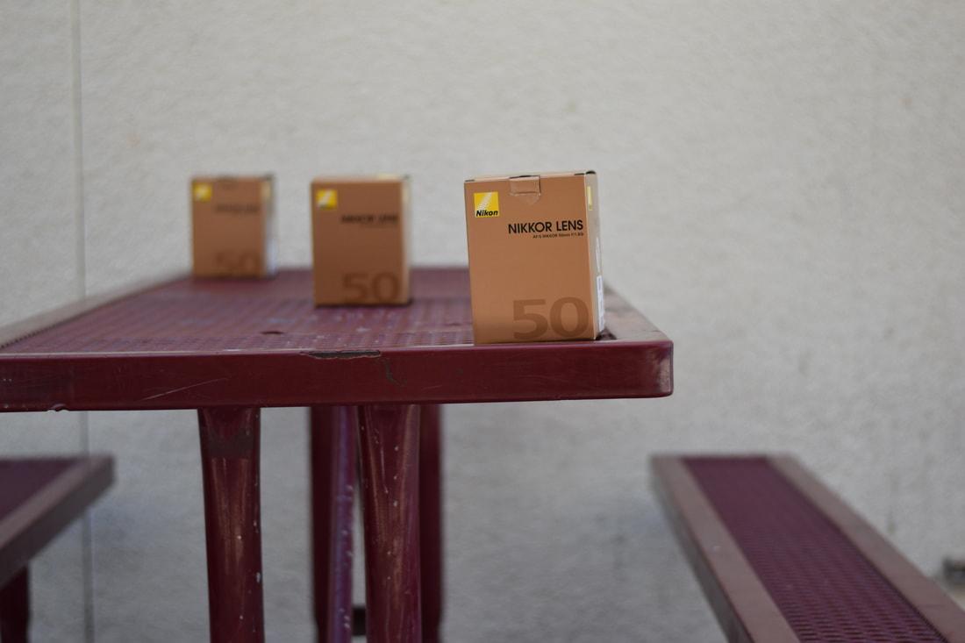
Aperture f/1.8, Shutter Speed 1/2000 of a second, ISO 200
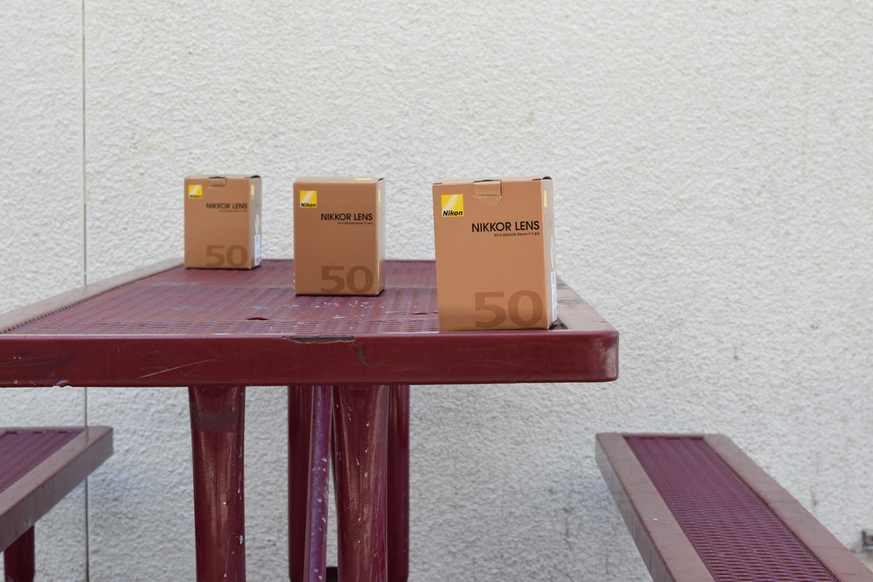
Aperture f/8, Shutter Speed 1/500th of a second, ISO 200
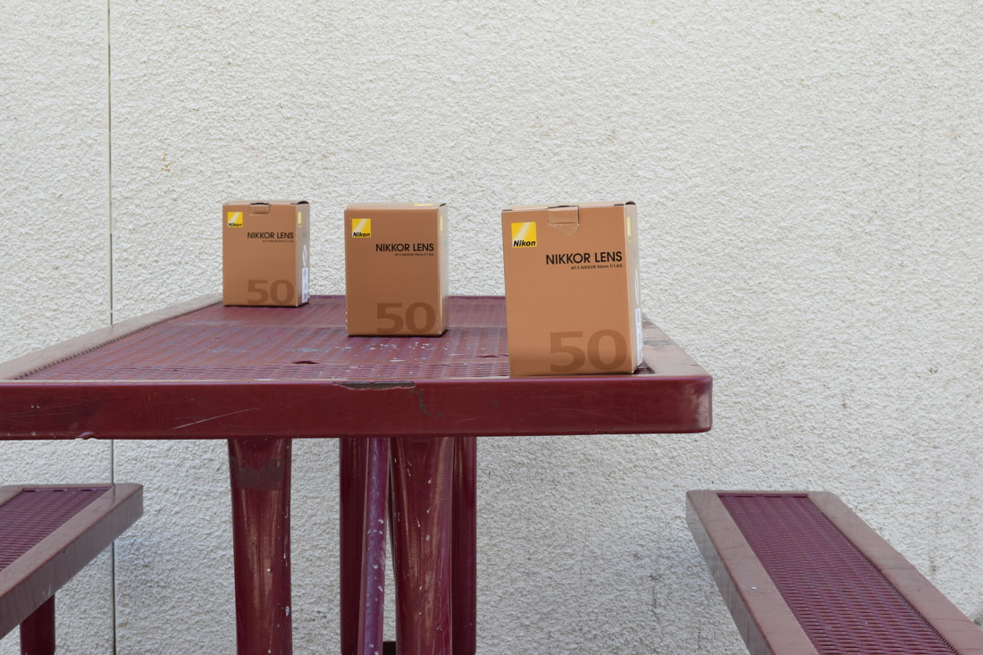
Aperture f/22, Shutter Speed 1/200th of a second, ISO 200

For this assignment, you will be shooting images of the same still life at three different apertures, uploading
them onto a Padlet along with technical information and a brief description of how each differs, and including an example from the web of a deep depth of field photo and a shallow depth of field photo with what you think the
​technical information should be, based on your notes and what you are learning. Here are the steps:

- Do any editing of your choice of the best photo of f/stop (f/1.8, f/8 and f/16). Artist's choice on editing, can be black and white, very colorful, etc.

2. Rename each edited one as lastname-firstname-shallowdepthoffield.jpg for the f/1.8 image
lastname-firstname-medium-depthoffield.jpg for the f/8 image
lastname-firstname-deep-depthoffield.jpg for the f/16 image.
3. Create a Padlet using the "streaming" format (so one image on top of one another).
4. Title your Padlet as "Aperture"
5. Under Padlet's description, write your first and last name.
6. Your padlet will have one best example of each aperture (f/1.8, f/8 and f/16) with the technical information (what the aperture, shutter speed and ISO is) and a sentence or two describing what you see in the photograph and how each photograph is unique to one another.
7. You will do further research on the web to find a photo example of shallow depth of field, and write why that image is shallow depth of field and what aperture you think it might be, based on the photograph.
8. You will do research on the web to find an example of a deep depth of field, and write why that image is deep depth of field and what aperture you think it might be, based on the photograph.

