Basic Art ___________ Portrait Unit – Annie Leibovitz__________ 2012

Student Name: ____________________________________ Period: ______

Who is Annie Leibovitz?
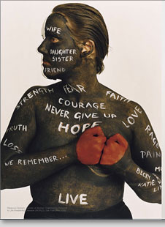
- Born on ______________________________
- Her Mother was a _________________________________________________
- Her Father was a __________________________________________________
- She attended the San Francisco Art Institute and wanted to become ___________________________________.

Biographical History of Annie Leibovitz:
- Annie lived in _________________________, where she first became interested in photography. Her father stationed there during the Vietnam War.
- What country did she live in 1969 when spending time on a kibbutz? __________
  - A kibbutz ___________________________________________________
________________________________, traditionally based on agriculture

- Who was Annie hired by in 1970? ___________________________________
- In 1973 she was named? ___________________________________________
- How many Rolling Stone’s covers is she accredited for? __________________

Name 5 Celebrities Annie has photographed:
- _________________________________________________________
- _________________________________________________________
- _________________________________________________________
- _________________________________________________________
- _________________________________________________________

- Her most famous portrait is of ____________________ and _________________
- What happened 5 hours after the photograph was taken? ____________________
_________________________________________________________________
- In 2005, American Society of Magazine Editors named it the best magazine cover from the past 40 years
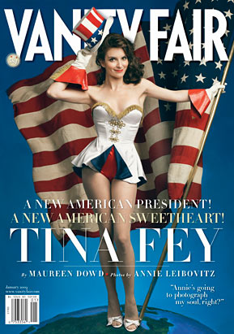
- At Vanity Fair she became know for her __________________, _____________, __________________ portraits of celebrities – often very ___________________
- She had her first museum show in 1991 at the ____________________________ in Washington D.C.
  - She was the only _______________________________________ (and only woman) to be featured in an exhibition by the institution
- She has been designated a “____________________” by the Library of Congress
- In 1996 Annie was chosen as the official photographer of the Summer Olympic Games in Atlanta.
- In 2008, her portrait of ________________________ wrapped in a bed sheet gained controversy, as concerned parents found the image to be “too racy” of their children’s Disney idol.

