Animal Farm Chapter 4
Word Detective
First read the sentence and try to figure out the meaning in context. Then use your thesaurus to find the mean and synonyms

1. Tractable: Bulls which had always been tractable suddenly turned savage, sheep broke down hedges and devoured the clover, cows kicked the pail over, hunters refused their fences and shot their riders on to the other side.
Your guess _____________________________________________________________
Synonyms/meaning ______________________________________________
_____________________________________________________________
Part of speech __________________

2. Shrewd: Pinchfield was smaller and better kept. Its owner was a Mr. Frederick, a tough, shrewd man, perpetually involved in lawsuits and with a name for driving a hard bargain.
Your guess ____________________________________________________
Synonyms/meaning ______________________________________________
_____________________________________________________________
Part of speech __________________
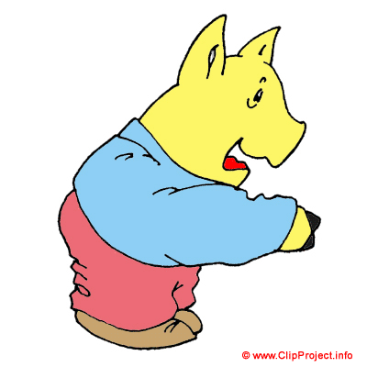
3. Contemptible: They could not understand, they said, how even animals could bring themselves to sing such contemptible rubbish.
Your guess ___________________________________________________
Synonyms/meaning ______________________________________________
_____________________________________________________________
Part of speech __________________
4. Irrepressible: Any animal caught singing it was given a flogging on the spot. And yet the song was irrepressible.
Your guess ____________________________________________________
Synonyms/meaning ______________________________________________
_____________________________________________________________
Part of speech __________________

5. Impromptu: An impromptu celebration of the victory was held immediately. The flag was run up and 'Beasts of England' was sung a number of times, then the sheep who had been killed was given a solemn funeral
Your guess ____________________________________________________
Synonyms/meaning ______________________________________________
_____________________________________________________________
Part of speech __________________
6. Unanimously: The animals decided unanimously to create a military decoration, 'Animal Hero, First Class,' which was conferred there and then on Snowball and Boxer.

Your guess ____________________________________________________
Synonyms/meaning ______________________________________________
_____________________________________________________________
Part of speech __________________
7. Posthumously: There was also 'Animal Hero, Second Class,' which was conferred posthumously on the dead sheep.
Your guess ____________________________________________________ Synonyms/meaning ______________________________________________ _____________________________________________________________ Part of speech __________________
8. Ignominious And so within five minutes of their invasion they were in ignominious retreat by the same way as they had come, with a flock of geese hissing after them and pecking at their calves all the way.
Your guess ____________________________________________________ Synonyms/meaning ______________________________________________ _____________________________________________________________ Part of speech __________________

Animal Farm Chapter 3
Word Detective
First read the sentence and try to figure out the meaning in context. Then use your thesaurus to find the mean and synonyms

1. Tractable: Bulls which had always been tractable suddenly turned savage, sheep broke down hedges and devoured the clover, cows kicked the pail over, hunters refused their fences and shot their riders on to the other side.
Your guess Obedient, well-mannered, polite, Submissive
Synonyms/meaning ______________________________________________
_____________________________________________________________
Part of speech Adjective

2. Shrewd: Pinchfield was smaller and better kept. Its owner was a Mr. Frederick, a tough, shrewd man, perpetually involved in lawsuits and with a name for driving a hard bargain.
Your guess Astute, sharp, perceptive, clever, cunning, insightful, intelligent
Synonyms/meaning ______________________________________________
_____________________________________________________________
Part of speech Adjective
3. Contemptible: They could not understand, they said, how even animals could bring themselves to sing such contemptible rubbish.
Your guess ___________________________________________________
Synonyms/meaning Disgraceful, shameful, despicable, loathsome, distasteful _____________________________________________________________
Part of speech Adjective
4. Irrepressible: Any animal caught singing it was given a flogging on the spot. And yet the song was irrepressible.
Your guess ____________________________________________________
Synonyms/meaning unmanageable, uncontainable, disorderly, unstoppable, relentless________________________________________
Part of speech Adjective

5. Impromptu: An impromptu celebration of the victory was held immediately. The flag was run up and 'Beasts of England' was sung a number of times, then the sheep who had been killed was given a solemn funeral
Your guess ____________________________________________________
Synonyms/meaning Unprepared, unrehearsed, unplanned, spontaneous, improvised
_____________________________________________________________
Part of speech Adjective
6. Unanimously: The animals decided unanimously to create a military decoration, 'Animal Hero, First Class,' which was conferred there and then on Snowball and Boxer.

Your guess ____________________________________________________
Synonyms/meaning undisputedly, indisputably 100%, all-agreed, undividedly
_____________________________________________________________
Part of speech Adverb
7. Posthumously: There was also 'Animal Hero, Second Class,' which was conferred posthumously on the dead sheep.
Your guess ____________________________________________________ Synonyms/meaning after death, post mortem, after someone has died _____________________________________________________________ Part of speech Adverb
8. Ignominious And so within five minutes of their invasion they were in ignominious retreat by the same way as they had come, with a flock of geese hissing after them and pecking at their calves all the way.
Your guess ____________________________________________________ Synonyms/meaning Humiliating, embarrassing, shameful, disgraceful, dishonorable _____________________________________________________________ Part of speech Adjective

