ANIMAL FARM SEVEN COMANDMENTS
The 7 Commandment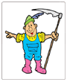 | How was it rewritten? Who broke it? How and Why?
1. Whatever goes upon two legs is an enemy.
2. Whatever goes upon four legs, or has wings, is a friend.
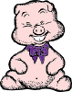
3. No animal shall wear clothes.
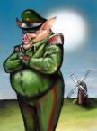
4. No animal shall sleep in a bed. _________________
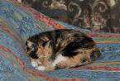
5. No animal shall drink alcohol. ___________________________
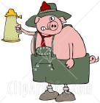
6. No animal shall kill any other animal. ___________________

7. All animals are equal. _______ ___________________________
_______________________________________
ANIMAL FARM SEVEN COMANDMENTS
The 7 Commandment | How was it rewritten? Who broke it? How and Why?
1. Whatever goes upon two legs is an enemy.  2. Whatever goes upon four legs, or has wings, is a friend.  3. No animal shall wear clothes.  4. No animal shall sleep in a bed. with sheets    5. No animal shall drink alcohol. to access. (Chapter 8)  6. No animal shall kill any other animal. without cause (Chapter 7)  7. All animals are equal. Some are more equal than others. (Chapter 9) | Wymper is always at the farm an intermediary between AF and people. The pigs do trade with people. They sell the timber to Fredrick. They will late try to walk on two legs.  2. The have a purge where many animals admit to false crimes and are executed. In general the animals are maltreated by the pigs. They are underfed and overworked.  3. Squealer wears a monocle, Napoleon wears a bowler hat, and Mollie wears ribbons. Later in the book the pigs will start to wear clothes  4. The commandment is altered and the pigs start to live in a house and sleep in beds. The pigs argue that sheets are the problem and use blankets. Aren’t blankets and beds made from animals? (Feathers, wool, etc)  The commandment is altered and the pigs find a box of whiskey and get drunk. In fact they plant barley in the pasture where the animals are supposed to retire. This is to make beer.  6. There are public confessions to false crimes and executions of animals. The commandment is altered. Which the pigs a side degree of freedom to kill for whatever they think is cause.  7. The pigs become the elitists and live in a house with all of its luxuries while most of the other animals are underfed and overworked

