Momentum Machine - How do ice skaters get themselves spinning faster?
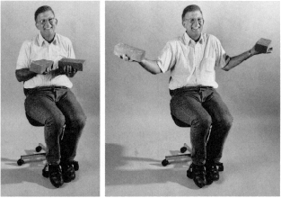
Materials:
Spinning Chair
2 heavy masses such as textbooks
2 heavier masses such as bricks
Stopwatch
Meter stick
Scale

Procedure:
- Sit in the chair with the light weight in each hand and your arms outstretched. Have your partner measure the distance from your sternum to your outstretched hand. Record this as your radius with outstretched hand.
- Have your partner start to rotate your chair slowly, then have that person let go and move away.
- Have the other partner count how many revolutions you make in 30 seconds. Record the number.
- Quickly pull in your arms and notice if you rotate faster. Record your observations below and have your other partner time how many times you now rotate in 30 seconds with your arms in.
- Once your not rotating, have your partner measure from your sternum to your outer arm and record this number as your radius with your arms in.
- Remain in the chair but with one textbook in each hand.
- Repeat the experiment with the textbooks. Notice if you rotate faster or slower. Record the number of revolutions in 30 seconds with your arms out and in.
- Remove the textbooks and replace them with the heavier mass.
- Repeat the experiment and notice if you rotate faster or slower compared to the previous experiment and record the number of revolutions in 30 seconds with your arms out and arms in.
- Weigh each of the items and record their masses.
Observations:
Observation with light masses:

Observation with textbooks:

Observation with heavier object:

Data
# Revs/30 sec Velocity = (2pi x Revs)/time Mass Radius Ang. Mom = (mVr)
Hands out / light masses ________ _____________ ____ _____ ________________
Hands in / light masses ________ _____________ ____ _____ ________________
Hands out / books ________ _____________ ____ _____ ________________
Hands in / books ________ _____________ ____ _____ ________________
Hands out / Weights ________ _____________ ____ _____ ________________
Hands in / Weights ________ _____________ ____ _____ ________________

Conclusion:
- In which trial did you or your partner spin the fastest (greatest velocity)? Why do you believe this is true?

- In which trial did you or your partner have the greatest momentum? Why do you believe this is true?

- Which law describes the above experiment? How does this law describe the experiment?

- What is the equation for angular momentum? Using this equation further describe the above experiment.

